PREPARATION, CHARACTERIZATION, AND IN VITRO DRUG RELEASE STUDIES OF CLOTRIMAZOLE-LOADED SODIUM ALGINATE-CARBOXYMETHYL CHITOSAN NANOPARTICLES
Dissertation submitted to
Mahatma Gandhi University, Kottayam
In partial fulfillment of the requirements for the award of the

Master of Science in PHARMACEUTICAL CHEMISTRY
By
NANDANA VIJEESH
(Reg No: 230011011002)



Under the Guidance of
Dr. LITTY SEBASTIAN
DEPARTMENT OF CHEMISTRY
BHARATA MATA COLLEGE, THRIKKAKARA
(Affiliated to Mahatma Gandhi University, Kottayam)
2023-2025



CERTIFICATE
This is to certify that the project report entitled “PREPARATION, CHARACTERIZATION, AND IN VITRO DRUG RELEASE STUDIES OF CLOTRIMAZOLE-LOADED SODIUM ALGINATE-CARBOXYMETHYL CHITOSAN NANOPARTICLES” is bona fide work carried out by NANDANA VIJEESH, an M.Sc. Pharmaceutical Chemistry student, in partial fulfillment of the requirements for the award of the degree of M.Sc. Pharmaceutical Chemistry of Mahatma Gandhi University under the guidance of Dr. Litty Sebastian.

Dr. Anu K John Dr. Litty Sebastian
Head of the department Assistant professor
Department of Chemistry Department of Chemistry
Bharata Matha college Bharata Matha college
Thrikkakara Thrikkakara

Place: Thrikkakara
Date:

CERTIFICATE

This is to certify that the Project Work Titled “PREPARATION, CHARACTERIZATION, AND IN VITRO DRUG RELEASE STUDIES OF CLOTRIMAZOLE-LOADED SODIUM ALGINATE-CARBOXYMETHYL CHITOSAN NANOPARTICLES” is a bona fide work of Ms. NANDANA VIJEESH carried out in partial fulfillment of the requirements for the award of the degree of M.Sc. Pharmaceutical Chemistry of Mahatma Gandhi University under my guidance. This project work is original and has not been submitted earlier for the award of any degree/diploma or assistantship of any other University/ Institution.

Place: Thrikkakara Dr. Litty Sebastian
Date: Assistant Professor
Department of Chemistry
Bharata Mata College
Thrikkakara

DECLARATION

I, hereby declare that the Project Work Titled “PREPARATION, CHARACTERIZATION, AND IN VITRO DRUG RELEASE STUDIES OF CLOTRIMAZOLE-LOADED SODIUM ALGINATE-CARBOXYMETHYL CHITOSAN NANOPARTICLES” submitted to Mahatma Gandhi University in partial fulfillment of the requirements for the award of degree of M.Sc. in Pharmaceutical Chemistry, is a record of original work done by me under the supervision of Dr. Litty Sebastian, Assistant Professor, Department of Chemistry, Bharata Mata College Thrikkakara, Cochin, Kerala.

Place: Thrikkakara NANDANA VIJEESH
Date:

ACKNOWLEDGEMENT

Inspiration and motivation have always played a key role in the success of any venture. I thank God Almighty for showering his blessings on me for the successful completion of my project work.
I express my heartfelt thanks to Dr. SOUMYA THOMAS, Principal, Bharata Mata College, Thrikkakara, for his constant encouragement for the completion of the project.
I pay my deep sense of gratitude to Dr. ANU K JOHN, Head of the Department, who gave valuable suggestions during the work.
I acknowledge my indebtedness and deep sense of gratitude to Dr. LITTY SEBASTIAN, Assistant Professor, Department of Chemistry, and my project guide, for immense help and guidance during this project.
I also acknowledge all other faculty members of the chemistry department and the lab assistants for their support and assistance.
I acknowledge the Central Instrumentation Facility of Bharata Mata College, Thrikkakara, for analysis, which is funded by DST- FIST (SR/FIST/College - 313/2016 dt. 08.02.2018), KSCSTE- SARD (23/2019/KSCSTE dt. 04.01.2019), DBT - STAR (HRD - 11011/22/2022 - HRD - DBT dt. 24.08.2022) and RUSA-SPD No. 149/2019/RUSA-SPD dtd. 30.10.2019
I thankfully acknowledge SAIF-STIC, and CUSAT for sample analysis.
I also acknowledge with a deep sense of reverence, my gratitude towards my family, who have always supported me morally as well as economically.
Any omission in this brief acknowledgment does not mean a lack of gratitude.

NANDANA VIJEESH

CONTENTS

CHAPTER 1: INTRODUCTION

1.1 Clotrimazole
1.2 Carboxy Methyl Chitosan (CMC)
1.3 Sodium Alginate

CHAPTER 2: AIMS AND OBJECTIVES

CHAPTER 3: MATERIALS AND METHODS

3.1 Materials
3.2 Methods

CHAPTER 4: RESULTS AND DISCUSSION

CHAPTER 5: CONCLUSIONS

CHAPTER 6: REFERENCE

CHAPTER 1
INTRODUCTION

Fungal diseases are a growing global health concern, and nearly a billion people are estimated to have skin, nail, and hair-related fungal infections, along with many cases of mucosal candidiasis. These infections have led to over 1.6 million deaths annually, which is comparable to deaths due to tuberculosis and malaria. the global differences in fungal disease patterns, including their rates and distribution, are shaped by environmental conditions, economic disparities, and the expanding population of vulnerable individuals.
Fungal infections typically arise as secondary illnesses and predominate in individuals with compromised body defenses from severe ailments such as HIV/AIDS, tuberculosis, cancer, or chronic lung diseases such as COPD. Common fungal pathogens that cause many of these infections include Aspergillus, Candida, Cryptococcus, Pneumocystis jirovecii, Histoplasma capsulatum, and Mucormycetes. Candida albicans is the primary causative organism for mucosal diseases, and Aspergillus fumigatus is responsible for allergic fungal diseases. Dermatophytes are responsible for superficial fungal infections, which are the fourth most common infection that affects around 40 million people globally. Antifungal agents like azoles, allylamines, flucytosine, morpholines, and griseofulvin are used in treatment.
Candidiasis is a fungal overgrowth that frequently affects area such as skin, intestines, mouth, and genital tract. The most common species involved is Candida albicans, which tends to thrive in moist regions and is responsible for nearly half of all candida infections. Many women are likely to experience a vaginal yeast infection at some point during their childbearing years, making it a widespread health concern. Other pathogenic Candida species include Candida tropicalis, Candida krusei, Candida glabrata, Candida lusitaniae, Candida parapsilosis, Candida kefyr, and Candida guilliermondii, among others. Treatment options against these include topical formulations, oral or intravenous antifungal medications, where the latter two are typically used for the treatment of systemic infections or when topical formulations are ineffective. These systemic treatments can have significant side effects and can also lead to drug resistance in various Candida species.
Topical formulation offers a lot of advantages over systemic treatments for localized candidiasis. As topical formulations are designed to treat localized infections on the skin surface by delivering drugs effectively into the stratum corneum, targeting the causative organism, also minimizing systemic exposure and reducing the risk of adverse effects. The patients often prefer topical treatments as they are simple to use and spare them the discomfort of invasive methods. Furthermore, they can achieve higher drug concentration at the site of infection compared to systemic administration, thereby improving the efficacy. However, topical formulation has notable disadvantages too. A major limitation is the low dermal bioavailability which can restrict the ability of the drug to penetrate into the skin. This results in variable drug levels at the infectious site and may require more frequent application. Additionally, some even cause skin irritation, allergic reactions, or even uncontrolled evaporation of the drug. Therefore, there is a need for novel tropical formulations to address the problems associated with the current ones.
Recently, nanoparticle-based drug delivery systems have been used to enhance topical formulations, enabling precise delivery of active drugs to infectious sites while improving skin penetration, minimizing irritations, and prolonging therapeutic effects. Various novel drug delivery systems have been developed to encapsulate antifungal agents and boost their efficacy. Examples of these advanced drug delivery systems include microemulsions (e.g., clotrimazole-loaded microemulsion gels), nanoemulsions (e.g., fluconazole nanoemulsions), niosomes (e.g., ketoconazole-loaded niosomes), dendrimers (e.g., polyamidoamine-based antifungal carriers), solid lipid nanoparticles (e.g., miconazole SLNs), liposomes (e.g., amphotericin B liposomes), ethosomes (e.g., fluconazole ethosomal gel), lipid nanoparticles (e.g., itraconazole-loaded LNPs), and polymeric nanoparticles (e.g., chitosan-based clotrimazole nanoparticles)
1.1 CLOTRIMAZOLE
Clotrimazole is a potent antifungal agent with broad-spectrum activity, frequently employed in the treatment of infections caused by Candida albicans and other fungal infections. It was discovered in the late 1960s and is now available globally as a generic medication under various trade names. While primarily known for its antifungal properties, it has also garnered interest for its potential applications in the treatment of metronidazole-resistant Trichomoniasis, to relieve its symptoms, and also displays activity against gram-positive bacteria. Clotrimazole is an antifungal drug that is synthetic in origin and can be prescribed not only for the treatment of candidiasis but also for skin infections due to dermatophytes, like ringworm, athlete's foot, and yeast infections in the vagina. Topical application can result in temporary discomfort, such as redness or itching. Oral administration may cause gastrointestinal disturbances, such as nausea and vomiting. In a minority of patients, around one in ten, there have been reported abnormal liver enzyme levels, so caution should be used in those with pre-existing liver disease.
clotrimazole has good solubility in solvents like acetone, chloroform, ethyl acetate, and methanol, but is poorly soluble in toluene, benzene, and ether. It is virtually insoluble in water and has a log P of 6.1 and pKa of 6.7. It is an azole class of antifungal agent and works by inhibiting the integrity of the fungal cell membrane. Clotrimazole is easily found over the counter in several preparations, such as creams, ointments, and vaginal tablets. Although it's primarily used for topical use, oral preparations usually need a prescription from a doctor.
1.1.2. CHEMICAL STRUCTURE AND MOLECULAR FORMULA
The molecular formula of clotrimazole is C₂₂H₁₇ClN₂, and its molecular weight is 344.8 g/mol. The chemical structure of clotrimazole consists of a central tetrahedral (sp3-hybridized) carbon atom attached to four aromatic rings. Among these, the imidazole ring plays an important role in facilitating the electron transfer, while the other three rings form a triphenylmethyl group. One of the aromatic rings carries a chlorin substituent at the c2 position. Computational studies suggest that the molecule adopts a distinct ‘propeller-like’ conformation. The structure of clotrimazole is illustrated in Figure 1
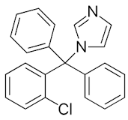

Figure 1: The Chemical Structure of Clotrimazole

1.1.3. SYNTHESIS
Clotrimazole, known chemically by the name 1-(o-chloro-α,α-diphenylbenzyl)imidazole, is produced via a nucleophilic substitution reaction between imidazole and 2-chlorobenzyl chloride in an organic solvent including acetone or ethanol under reflux conditions, with triethylamine used as the base for neutralizing the formed hydrochloric acid.

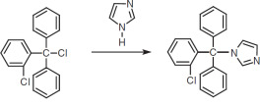
Figure 2: Synthesis of Clotrimazole

1.1.4. MODE OF ACTION
Clotrimazole’s mode of action is primarily by damaging the permeability barrier in the fungal cytoplasmic membrane. It inhibits the biosynthesis of ergosterol, a vital component in fungal cytoplasmic membrane, in a concentration-dependent manner by inhibiting the demethylation of microsomal cytochrome P450 (CYP450) depended-14-α-lanosterol. As a result of this inhibition, ergosterol synthesis is disrupted and replaced by abnormal sterols such as 14-α-methylsterol, compromising the membrane’s normal permeability and fluidity.
This results in decreased activity of membrane-bound enzymes involved in cell synthesis, increased cell wall leakiness, and leakage of cell contents. Moreover, since ergosterol plays a direct role in promoting fungal cell growth, its depletion leads to a dose- and time-dependent suppression of fungal proliferation. Clotrimazole generally exhibits fungistatic effects, but it can also exhibit fungicidal effects at higher concentrations.
Clotrimazole kills fungi mainly through disruption of ergosterol synthesis, a critical component of fungal cell membranes. In addition to its use in fungal inhibition, the drug has effects on various cellular processes. The drug is capable of interfering with the balance of calcium in the cells by blocking sarcoplasmic reticulum Ca²⁺-ATPase, lowering intracellular calcium and interrupting both calcium dependent potassium channels and voltage- gated calcium channels. These other cellular interactions result in pharmacological effects independent its antifungal activity.
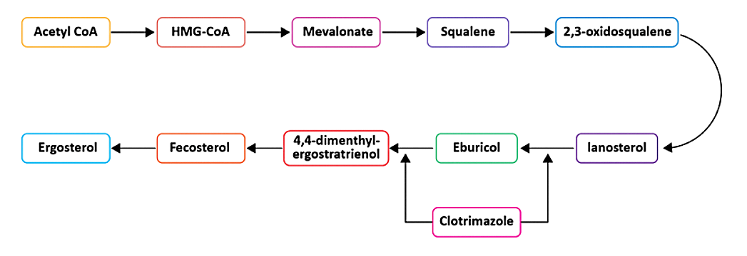

Figure 3: Clotrimazole targets the enzyme lanosterol 14α-demethylase responsible for the conversion of lanosterol to 4,4-dimethyl-ergostrienol, a common target of azole drugs

1.1.5. PHARMACOKINETICS
Clotrimazole has very poor oral bioavailability, even though it was the first oral azole that was approved for fungal infection, as most of the absorbed drug is metabolized in its first pass through the liver. Thus, currently, tropical formulations are used to treat fungal infections, which include cream, solutions, lotions, etc. Although it works, topical clotrimazole is only absorbed in small quantities—only a little through mucous membranes and less through the skin.
Clotrimazole has high lipophilicity (Log P ~6.1); it tends to accumulate in lipid-rich tissues even though the systemic distribution is limited after topical use. It is primarily metabolized in the liver by the cytochrome P450 enzyme, especially CYP3A4, into inactive metabolites. These metabolites are primarily eliminated through the bile into the feces, with only a small amount excreted in the urine.
Tropical formulations of clotrimazole’s efficacy are limited due to factors like poor aqueous solubility, low skin penetration etc, which can lead to suboptimal drug concentrations in infectious sites. this will demand frequent applications of the formulations in the infected area and can also lead to treatment failure. Additionally, conventional tropical formulations may also cause skin irritations or allergic reactions, limiting their usability; therefore, clotrimazole must be loaded into a suitable drug delivery system to increase its bioavailability. To further improve its efficacy, clotrimazole can be integrated into an assortment of sophisticated drug delivery systems such as nanogels, microemulsion systems, polymer-based nanoparticles, liposomal carriers, ethosomal systems, nanocapsules, and intricate 3D hybrid vesicular systems. The polymeric nanoparticle-based drug delivery systems have been popular as they address these limitations by enhancing clotrimazole’s topical bioavailability and therapeutic efficacy. They offer controlled drug release, prolonging the drug’s residence time at the site of infection and reducing the frequency of application. the polymer matrix can also protect the drug from degradation and minimize direct contact with the skin, reducing irritation. Polymers like sodium alginate and carboxy methyl chitosan (CMC) are said to be potential drug delivery systems based on recent research papers. Carboxy methyl chitosan (CMC) is a multifunctional excipient in clotrimazole formulations due to its ability to improve drug dissolution and enhance antifungal activities. Sodium alginate is a natural polysaccharide with extensive applications in controlled drug delivery systems due to its biocompatibility, biodegradability, and ease of gelation.

1.2 CARBOXY METHYL CHITOSAN (CMC)
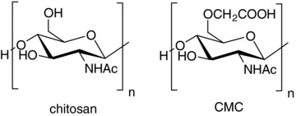
Chitosan is a partially deacetylated form of chitin, one of the naturally abundant polysaccharides found primarily in the exoskeletons of crustaceans. They are nontoxic, biodegradable, bio-renewable, and bioadhesive; thus, chitosan and its derivatives have applications in various fields like pharmaceuticals, biomedical, food industry, cosmetics, water treatment, agriculture, etc. However, these applications of chitosan suffer severe limitations due to their poor solubility in water and alkaline pH because of their very stable crystalline structure arising from the strong hydrogen bonds. This solution issue can be solved by depolymerization and chemical modifications. Chitosan can be easily carboxy methylated to improve its solubility in aqueous medium while its biodegradability and biocompatibility are preserved. Carboxymethyl chitosan shows improved solubility in aqueous media making it an attractive alternative for producing biocompatible materials and drug delivery systems.

Figure 4: Structure of chitosan and CMC

1.2.1. SYNTHESIS OF CMC
Carboxymethyl chitosan is synthesized by the carboxymethylation of chitosan, and specific derivatives like N-, O-, N,O-, N,N-carboxymethyl chitosan are formed. depending on the reaction conditions. Among these, O-CMC is the one that is mainly formed at room temperature or in a cold bath using an isopropanol/water suspension with monochloroacetic acid and sodium hydroxide. At elevated temperatures, the carboxymethylation also produces N-CMC and N,O-CMC. Additionally, N-CMC and N,N-CMC can be synthesized by reacting chitosan with glycolic acid, followed by reduction using sodium cyanoborohydride. Direct alkylation can also yield N-CMC.
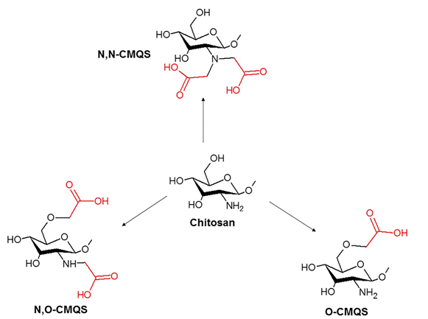
The degree of carboxymethylation influences the water solubility of CMC at different pH levels. Chemical modification of chitosan can control the polymer-drug interaction and enhance loading capabilities. Chemical modifications of chitosan typically occur at three main functional sites along the polymer chains - two hydroxyl groups and a single primary amine group.

Figure 5: Chemical structures of carboxymethyl chitosan derivatives of chitosan

1.2.2. CMC AS AN EXCIPIENT FOR CLOTRIMAZOLE
Carboxymethyl chitosan enhances the efficacy of clotrimazole through various mechanisms related to its physicochemical and biological properties. Clotrimazole’s water-insoluble nature and high lipophilicity limit its bioavailability and topical activity, which can be benefited by the incorporation of CMC as CMC improves the dissolution rate and also the synergistic antifungal activity. The water solubility of CMC is crucial for drug delivery, as it allows a better dispersion of the drug. When clotrimazole is mixed with CMC, especially high molecular weight chitosan drug molecules will disperse between the polymer chains, enhancing the particle wetting and preventing agglomeration. the process significantly improves the dissolution rate of clotrimazole, which has a low aqueous solubility. Apart from its solubility property, CMC also possesses synergistic antifungal activity, particularly in low pH conditions, particularly against Candida glabrata, where the combination of clotrimazole and CMC leads to a significant inhibition of fungal growth even at lower drug concentrations. This shows that CNC not only aids in drug delivery but also actively contributes to the antifungal effects. In addition, CMC is biodegradable, non-toxic, and biocompatible, which makes it a safe and effective excipient for use in topical drug formulations. It also increases the residence time at the site of infection and improves the overall therapeutic outcomes.

1.3. SODIUM ALGINATE
Sodium alginate is an anionic polysaccharide derived from brown algae and certain bacteria. Due to its versatile properties, it has wide pharmaceutical, food, and biomedical applications. It is a copolymer composed of β-D-Mannuronic acid (M) and α-L-Guluronic acid (G) residues linked together by (1-4) glycosidic linkage and arranged in a varying sequence of MM, GG, and MG blocks along the polymer chain.
The properties of sodium alginate, such as solubility and viscosity, depend on its molecular weight, the ratio of mannuronic to guluronic acids, and the arrangement of these blocks. Sodium alginate dissolves readily in cold water to form a viscous colloidal solution, but remains insoluble in organic solvents and becomes unstable in strongly acidic environments with a pH below 3. Sodium alginate has applications in the pharmaceutical industry due to its properties like biocompatibility, biodegradability, and nontoxicity. It serves as a matrix for controlled drug delivery and is employed as a thickening agent, a stabilizer, and a gelling agent in a variety of formulations. Recognized for its safety, it has been granted GRAS (Generally Recognized As Safe) status by the FDA for use in multiple applications.
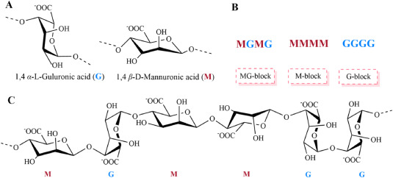

Figure 6: Structures of sodium alginate (A) monomers, (B) Blocks, (C) Chain conformations

1.3.1. EXTRACTION AND PREPARATION
Sodium alginate is not chemically synthesized but is extracted from brown seaweed such as Laminaria, Ascophyllum, and Macrocystis. The process begins with mechanically harvesting and drying the algae, except Macrocystis, which is processed wet. It is then soaked in a dilute acid, like hydrochloric acid, to remove neutral polysaccharides and minerals like calcium and magnesium. After this, the seaweed is treated with hot alkaline solution like sodium carbonate or sodium hydroxide, which dissolve the alginic acid and forms sodium alginate. This resulting solution is then filtered to remove undissolved plant matter, and sodium alginate is then precipitated from the solution by treating it with ethanol or calcium chloride. The final product is then washed, dried, and powdered for use. Further purification methods can be applied before converting it to salt or acid, as it's important to remove heavy metals, endotoxins, proteins, and polyphenols from alginate, especially when intended for pharmaceutical applications.

1.3.2 SODIUM ALGINATE AS AN EXCIPIENT FOR CLOTRIMAZOLE
Sodium alginate is one of the most popular excipients employed in pharmaceutical formulations because of its natural gel-forming ability, biocompatibility, mucoadhesive character, etc Its application in clotrimazole drug delivery is due to its ability to trap hydrophobic drugs within a controlled release matrix, allowing a prolonged release and local therapeutic effects. Clotrimazole is a poorly soluble drug in water and is highly lipophilic, so sodium alginate is a good candidate as it forms a protective aqueous matrix that allows a sustainable diffusion and improved topical bioavailability.
Sodium alginate can form crosslinks when exposed to divalent ions like calcium (Ca2+) ions, which makes the encapsulation of clotrimazole easier and controls its drug release kinetics. It has been seen through various studies that alginate systems extend the release of clotrimazole for significantly longer duration than traditional formulations and also sustain the therapeutic levels at the site of application for a prolonged period
Given the increasing prevalence of superficial fungal infections and the limitations associated with both systemic and conventional tropical antifungal therapies, there is a clear need for improved drug delivery strategies. Clotrimazole, while being effective, also suffers from low solubility and dermal bioavailability, making it an ideal candidate for formulation enhancement. The use of natural, biocompatible polymers such as carboxymethyl chitosan (CMC) and sodium alginate offers a promising approach for developing a controlled-release, nanoscale delivery system. Such a system can not only enhance drug penetration and retention at the site of infection but also reduce systemic toxicity and improve patient compliance. This study, therefore, aims to formulate and evaluate a polymer-based clotrimazole delivery system to address these therapeutic challenges.

CHAPTER 2
AIMS AND OBJECTIVES

AIM
To formulate and evaluate a clotrimazole-loaded delivery system using carboxymethyl chitosan (CMC) and sodium alginate, to improve entrapment efficiency, release characteristics, and antifungal activity for potential topical application.
OBJECTIVES
- To develop a delivery system containing clotrimazole using CMC and sodium alginate via ionic cross-linking with CaCl₂
- To determine the ideal drug-polymer ratio and CMC concentration for maximum encapsulation efficiency and formulation stability.
- To evaluate the formulated particles using:
Dynamic Light Scattering (DLS)
Fourier Transformation Infrared Spectroscopy (FTIR)
X-Ray Diffraction (XRD)
Differential Scanning Calorimetry (DSC)
SEM
TEM
Antifungal Activity
- To quantify the amount of clotrimazole encapsulated in the polymer matrix using UV-Visible spectroscopy.
- To perform an in vitro release study of encapsulated clotrimazole at pH 5.5 and evaluate the drug release profile over time.
- To asses and compare antifungal efficacy of formulated system and pure clotrimazole against Candida albicans using the agar well diffusion method.

CHAPTER 3
MATERIALS AND METHODS

3.1 Materials

Carboxymethyl chitosan (CMC) (degree of deacetylation >88%) was obtained from Swakit Biotech Private Limited, Bangalore. Sodium alginate was procured from Merck, while anhydrous calcium chloride was sourced from HiMedia. Clotrimazole (>98% purity) was supplied by TCI. Sodium dihydrogen phosphate monohydrate (Spectrochem) and sodium phosphate dibasic dihydrate (Oxford Lab Fine Chemicals Ltd.) were utilized for the buffer preparation. All solutions were prepared using double-distilled water, and HPLC-grade methanol (Merck) was used in all relevant procedures.

3.2 Methods

3.2.1 Preparation of Standard Solution and Calibration Curve for Clotrimazole
A standard calibration curve was plotted for the estimation of clotrimazole. For this, a stock solution was prepared by dissolving 0.005g (5mg) of clotrimazole in 250ml of methanol in a standard volumetric flask. This created a concentration of:
Concentration = $\frac{ 0.005g}{250ml}$ = 0.00002 g/ml = 0.02 mg/ml
From the stock solution, standard solutions were prepared to obtain concentrations ranging from 0.2mg% to 1.8mg%. for instance, to get 0.2mg%
Required volume = $\frac{ 0.002 x 10}{0.02 }$= 1 ml
Thus 1ml of the 0.02 mg/ml stock solution was added to a 10 ml volumetric flask and made up to mark using methanol. Similar dilutions were made for other concentrations

3.2.2 Preparation of Drug-Loaded Particles
0.300 grams of sodium alginate was dissolved in 100 mL of distilled water and stirred for 45 minutes until fully dissolved. The pH of the solution was adjusted to 5.1 using dilute hydrochloric acid (HCl). Separately, six concentrations of carboxymethyl chitosan (CMC) solutions were prepared by dissolving 300 mg, 150 mg, 100 mg, 60 mg, 50 mg, and 30 mg of CMC in 100 mL of distilled water. It was stirred overnight to dissolve the CMC. The pH of each solution was similarly adjusted to 5.4 using dilute HCl.
For the calcium cross-linker, 0.332 grams of calcium chloride (CaCl₂) was dissolved in 100 mL of distilled water to obtain a 3.32 mg/mL solution. To initiate nanoparticle formation, 1 mL of the prepared drug solution was added to 9 mL of the sodium alginate solution (pH 5.1), resulting in a 10 mL drug-loaded alginate mixture.
2 mL of the CaCl₂ solution was then added dropwise at a rate of 1 mL/min to the alginate solution while stirring at 480 rpm with a magnetic stirrer. This mixture was stirred for 45 minutes to allow cross-linking. Following this, 4 mL of the CMC solution of varying concentrations was added dropwise, and the reaction mixture was stirred for an additional 2 hours at ambient temperature to allow nanoparticle formation. The resulting CMC/ALG nanoparticles were collected by centrifugation at 12,000 rpm for 60 minutes at 4 °C using a high-speed refrigerated centrifuge. The supernatant was removed, and the nanoparticle pellet was washed with distilled water, followed by a second centrifugation for 15 minutes under the same conditions. The final supernatant was collected and made up to 50 mL with methanol, and the UV absorbance was measured using a UV-visible spectrometer.
3.2.3. Determination of Particle Size and Zeta Potential
Dynamic Light Scattering (DLS) is based on the principle that particles in suspension undergo Brownian motion, and when a laser beam passes through the sample, the scattered light fluctuates over time. These fluctuations are analyzed to calculate the hydrodynamic diameter of particle using the Stokes-Einstein equation.
The particle size and zeta potential of clotrimazole-loaded CMC/ALG nanoparticles were evaluated using dynamic light scattering (DLS) with a Litesizer 500 (Anton Paar) analyzer. Since lyophilization may induce particle aggregation, the particle size was measured after resuspending the centrifuged sample in methanol, followed by probe sonication for 5 minutes to ensure proper dispersion.

3.2.4. Entrapment Efficiency and Loading Capacity
Entrapment Efficiency was measured using the indirect method, in which the concentration of the free entrapped drug was measured, and the entrapped amount was calculated based on the difference between the total drug added and the free drug. The entrapment efficiency was calculated using the formula,

EE (%) = $\frac{total drug added-free drug}{total drug added}$ x 100

The concentration of both the encapsulated and free drug was determined using UV-Visible spectroscopy. Measurements were performed on a Shimadzu UV-2600i spectrophotometer within the wavelength range of 200–400 nm, following the construction of a calibration curve.
The loading capacity (LC) was defined as the amount of drug encapsulated per unit weight of the polymer matrix. To determine the loading efficiency of the drug-loaded system, 40 mg of the sample was dispersed in methanol, sonicated, and the volume was made up to 100 mL. An aliquot of 10 mL from this solution was further diluted to 50 mL, and the absorbance was recorded using a UV–Visible spectrophotometer. All measurements were performed in triplicate and the drug content was quantified from a standard calibration curve, and the loading capacity was calculated using the following equation:
LC(%) = $\frac{Amount of drug encapsulated}{Total mass of the delivery system}×100$

3.2.5. FT-IR spectroscopic analysis
FT-IR works on the principle that molecules absorb infrared radiation at specific wavelengths, causing characteristic vibrational transitions (stretching and bending of bonds). These absorptions provide a fingerprint of the molecule and help identify functional groups.
Fourier transform infrared (FT-IR) spectroscopy was performed using a Thermo Scientific Nicolet iS5 FT-IR Spectrometer, covering a spectral range of 4000–400 cm⁻¹ at room temperature. FT-IR spectra were recorded for carboxymethyl chitosan (CMC), sodium alginate, clotrimazole, and the clotrimazole-loaded CMC/sodium alginate hydrogel.
Additionally, FT-IR analysis was performed on the encapsulated system with varying concentrations of clotrimazole (1 mL of 5 mg/mL, 10 mg/mL, 20 mg/mL, and 40 mg/mL) to investigate the changes in interaction with concentration. Each sample was individually mixed with potassium bromide (KBr) and compressed into pellets for measurement.

3.2.6. XRD analysis
X-ray diffraction (XRD) is based on Bragg’s Law, where X-rays are diffracted by the crystal lattice planes of a material. The angle and intensities of these diffracted beams reveal information about the crystallinity and phase of the sample.
The powder X-ray diffraction (XRD) patterns of CMC, sodium alginate, clotrimazole, and clotrimazole-loaded CMC/sodium alginate particles were recorded using a Bruker D8 Advance diffractometer. The measurements were conducted over a 2θ range of 3°–70° utilizing CuKα (CuK𝛂, 𝝺 = 1.54 A ˚) radiation.

3.2.7. DSC Analysis
Differential scanning calorimetry (DSC) measures the difference in heat flow into a sample and reference as a function of temperature or time. It detects phase transitions such as melting, crystallization, or degradation, providing insights into thermal stability and crystallinity.
Differential scanning calorimetry (DSC) was performed using a Netzsch DSC 204 F1 Phoenix instrument. Approximately 1.5 mg of sample was heated from 30 °C to 350 °C at a rate of 10 K/min under a constant flow of nitrogen.

3.2.8. Scanning Electron Microscope
SEM uses a focused beam of high-energy electrons that interact with the surface of sample to produce secondary electrons. These electrons are detected to generate high-resolution images of surface morphology and texture.
The surface morphology of the clotrimazole-encapsulated CMC/sodium alginate hydrogel was analyzed using a JEOL JSM-6390 LA Scanning Electron Microscope.

3.2.9. TEM
TEM works by transmitting a beam of high-energy electrons through an ultra-thin sample. Variations in density, thickness, and composition cause differences in electron transmission, allowing visualization of the internal structure at the nanoscale.
Transmission electron microscopy (TEM) images were recorded using a JEOL JEM-2100 instrument equipped with a LaB6 electron source, operating at an accelerating voltage of 200 kV.
3.2.10. Antifungal Assay
To access the biological significance and ability of the sample, the antifungal activity was determined by Agar well diffusion method.

Materials Required
- Clotrimazole (standard antifungal agent; 10mg/ml stock in DMSO)
- Formulated sample (COLT1:1) – lyophilised clotrimazole encapsulated in CMC and sodium alginate.
- Test organism: Candida albicans (ATCC 10231)
- Culture medium: potato Dextrose Agar (PDA; HiMedia, India)
- Sterile distilled water, DMSO, and standard laboratory glassware

Procedure
Potato Dextrose Agar (PDA) was prepared by dissolving 39g of commercially available medium in 1000 mL of distilled water. The medium was sterilized by autoclaving at 121 ℃ at 15 lbs for 15 minutes. While still molten, the medium was poured into sterile 100 mm petri dishes (approximately 25-30 ml per plate) and is allowed to solidify.
An overnight growth culture of Candida albicans (ATCC 10231) was adjusted to a 0.5 McFarland standard to guarantee uniform seeding. The culture was then swabbed onto the surface of the PDA plates to create a confluent lawn.
Approximately 10 mm diameter wells were aseptically punched into the agar using a sterile cork borer. Different concentrations of clotrimazole and COLT 1:1 (245µg, 500µg, and 1000µg) were prepared from the respective stock solutions. Each concentration (in 100µL volume) was then introduced into the individual wells.
Plates were incubated at room temperature for 24 hours. After incubation, the zones of inhibition around each well were measured in millimetres using a digital caliper. The results were compared against a standard concentration of clotrimazole (100µg) to evaluate the relative antifungal activity

3.2.11. In Vitro Drug Release and Release Kinetics
3.2.11a. Preparation of Phosphate Buffer (pH 5.5)
To prepare 1 L of phosphate buffer at pH 5.5, 0.563 g of disodium hydrogen phosphate dihydrate (Na₂HPO₄·2H₂O) and 13.36g of sodium dihydrogen phosphate monohydrate (H₂NaPO₄·H₂O) were accurately weighed and dissolved in 400 mL of distilled water. The solution was then made up to 1000ml in a standard volumetric flask. The pH was confirmed and adjusted to 5.5 using a calibrated pH meter.
3.2.11b. Preparation of Standard Solution for Calibration Curve
A stock solution was prepared by dissolving 2mg of the drug in 20ml of methanol. This solution was transferred to a 100ml standard flask and made up to the mark with the prepared phosphate buffer (pH 5.5), giving a final concentration of 0.02mg/ml.
From this, 6 ml was pipetted into a 10 ml standard flask and made up to the mark with phosphate buffer, resulting in a working stock solution of 0.012mg/ml
Standard solutions were prepared by performing serial dilutions of the working stock solution (0.012 mg/mL), yielding final concentrations ranging from 0.12 mg% to 1.08 mg%. For each standard, aliquots ranging from 1 to 9 mL of the stock were diluted to a final volume of 10 mL using a phosphate buffer–methanol mixture (4:1 v/v). The absorbance of each diluted solution was then recorded using a UV-Visible spectrophotometer.
3.2.11c. In Vitro Drug Release Study
The in vitro release behaviour of clotrimazole from the sodium alginate–CMC-based delivery system was evaluated using the direct contact method. 2 mg of the clotrimazole-loaded formulation was dispersed in 1.5 mL of the release medium, consisting of methanol and phosphate buffer (pH 5.5) in a 1:4 ratio. The selected pH closely resembles the physiological pH of the human skin, making it suitable for assessing clotrimazole’s release in topical antifungal applications. The samples were incubated in an orbital shaker at 37 ± 0.5 °C and agitated at 200 rpm to simulate physiological conditions. At predetermined time intervals, the dispersions were subjected to centrifugation at 10,000 rpm for 5 minutes in a cooling centrifuge maintained at 4 °C. 1 mL of the supernatant was carefully withdrawn and replaced with an equal volume of release medium to maintain sink conditions. The concentration of clotrimazole released was determined using UV–Visible spectrophotometry at λmax ≈ 198 nm, based on a previously established calibration curve in the same medium. All experiments were conducted in triplicate, and results are expressed as mean ± standard deviation.
CHAPTER 4
RESULTS AND DISCUSSION

4.1. Evaluation Of Clotrimazole's Encapsulation Efficiency in Sodium Alginate – CMC System

Encapsulation of clotrimazole in sodium alginate and CMC system was tested using series of formulations with different CMC concentrations. The process aimed to maximise encapsulation efficiency and physicochemical stability of the particles.

4.1.1. Calibration curve of Clotrimazole in Methanol

A calibration curve for clotrimazole in methanol was developed using standard solutions at concentrations between 0.2mg% and 1.8mg%. the absorbance was determined to be linear with the concentrations, with the absorbance ranging from 0.1660 for 0.2mg% to 1.0262 for 1.8 mg%, demonstrating a high linear correlation and allowing reliable intrapolation for the unknown samples.

Label no | Volume of Stock Solution taken and made up to 10 ml  (ml) | Concentration of the Standard solution  In mg% | Absorbance measured
C1 | 1 | 0.2 | 0.1660
C2 | 2 | 0.4 | 0.2779
C3 | 3 | 0.6 | 0.4042
C4 | 4 | 0.8 | 0.5640
C5 | 5 | 1.0 | 0.6100
C6 | 6 | 1.2 | 0.7070
C7 | 7 | 1.4 | 0.8495
C8 | 8 | 1.6 | 0.9533
C9 | 9 | 1.8 | 1.0262

Table 4.1.1. Calibration curve data

Figure 4.1.1. Calibration curve of clotrimazole in methanol

4.1.2. Encapsulation efficiency (EE%)

For the first encapsulation study, the concentration of clotrimazole used was 20mg/ml in methanol. Suitable dilutions were prepared for the above solution to determine drug content after encapsulation. The encapsulation efficiency (EE%) for 6 samples (N300, N150, N100, N60, N50, N30), all with different CMC concentrations, was found.

Sample name | Absorbance | mg% | mg | %encapsulation
N300 | 0.3181 | 0.24817 | 0.0024817 | 89.51940538
N150 | 0.3627 | 0.27233 | 0.0027233 | 88.49909202
N100 | 0.4019 | 0.29357 | 0.0029357 | 87.60209468
N60 | 0.7872 | 0.50229 | 0.0050229 | 78.78753326
N50 | 0.2449 | 0.20852 | 0.0020852 | 91.119388488
N30 | 0.5827 | 0.39151 | 0.0039151 | 83.46594028

Table 4.1.2. EE% of clotrimazole (20 mg/mL) in various CMC concentrations

Among all the concentrations, N50 showed the highest encapsulation of 91.12% indicating that the 50 mg/ml concentration (0.100g in 200 ml) of CMC was ideal for the entrapment of clotrimazole. Conversely, N60 and N30 exhibited reduced encapsulation efficiencies of 78.79% and 83.47%, respectively, which means that both over and underestimation of CMC concentration can be detrimental to the drug entrapment ability.
To maximise the encapsulation efficiency, more studies were performed using different concentrations of clotrimazole with a constant concentration of CMC being 50 mg/mL (i.e., 0.100g in 200 ml). the purpose was to find the drug concentration that produces the maximum % encapsulation.
Two concentrations of clotrimazole, 20 mg/mL and 40mg/mL, were tested by using the same formulation protocol. The concentration of 20 mg/mL was calculated to be 24.21 mg, and that of 40 mg/mLto be 44.48mg using the calibration curve

Concentrations of the drug | Absorbance | mg% | mg | %encapsulation
20 mg/mL | 0.2449 | 0.20852 | 0.0020852 | 91.119388488
40 mg/mL | 0.2808 | 0.22796 | 0.0022796 | 94.87448146

Table 4.1.3. Effect of drug concentration (20 mg/mL vs. 40 mg/mL) on EE%
These results show that 40 mg/mL clotrimazole gave the maximum encapsulation efficiency, and this was used as the drug concentration of choice for further preparation.

4.1.3. Repeatability and Optimization at 40 mg/mL Drug Concentration
Similar to the 20 mg/mL studies, 6 formulations with varying concentrations of CMC were prepared for 40 mg/mL clotrimazole drug concentrations. To establish reproducibility and to see the effects of different concentrations of CMC at 40 mg/mL clotrimazole, the process was repeated twice using different batches.

First set (W-series)
The concentration of 40 mg/mL was calculated to be 44.48 mg using the calibration curve as the absorbance was measured to be 1.5020.

Sample name | Absorbance | mg% | mg | %Encapsulation
W300 | 0.1095 | 0.13517 | 0.0013517 | 96.96079864
W150 | 0.1785 | 0.17255 | 0.0017255 | 96.12033592
W100 | 0.1854 | 0.17628 | 0.0017628 | 96.03646952
W60 | 0.1625 | 0.16388 | 0.0016388 | 96.3152747
W50 | 0.2808 | 0.22796 | 0.0022796 | 94.87448146
W30 | 0.3473 | 0.26399 | 0.0026399 | 94.06437252

Table 4.1.4. EE% using 40 mg/mL clotrimazole – first set (W - Series)

The maximum encapsulation was determined for W300 (300 mg/100 mL) with 96.96%, which implies that a 1:1 proportion of sodium alginate and CMC was ideal.

Second set (F-Series)
The process was done again in an attempt to confirm. The drug content was established to be 39.95 mg using the calibration curve at absorbance 1.3350.

Sample name | Absorbance | mg% | mg | %Encapsulation
F300 | 0.1590 | 0.16198 | 0.0016198 | 95.94563476
F150 | 0.3405 | 0.2603 | 0.002603 | 93.48468162
F100 | 0.4313 | 0.30949 | 0.0030949 | 92.25345414
F60 | 0.3931 | 0.2888 | 0.002888 | 92.077132559
F50 | 0.4086 | 0.2972 | 0.002972 | 92.56107329
F30 | 0.2242 | 0.1973 | 0.001973 | 95.06157389

Table 4.1.5. EE% using 40 mg/mL clotrimazole – second set (F - series)

Once again, F300 (300 mg/100mL) had the maximum encapsulation. where CMC and alginate were kept in a 1:1 proportion (300 mg/100mL). The rise in encapsulation with polymer concentration is presumably because the increased availability of polymer chains creates a denser matrix that traps the hydrophobic clotrimazole within, preventing its diffusion.

4.1.4. Comparative Study at 300 mg/100 mL CMC Concentrations

Various concentrations of clotrimazole (5,10,20,40 mg/mL) with the concentration of CMC being constant at 300 mg/100mLwere also tested by using the same formulation protocol to find the effect of drug concentration on encapsulation.

Concentrations of drug | Absorbance | mg% | mg | %encapsulation
5 mg/mL | 1.1482 | 0.69785 | 0.0069785 | 88.88773885
10 mg/mL | 1.2017 | 0.72683 | 0.0072683 | 46.35409594
20 mg/mL | 0.8366 | 0.52905 | 0.0052905 | 78.14971606
40 mg/mL | 0.1590 | 0.16198 | 0.0016198 | 95.94563476

Table 4.1.6. Effect of drug concentration on encapsulation at fixed CMC concentration (300 mg/100mL)

Here, too highest encapsulation efficiency was seen in 40 mg/mL drug concentration, which was 95.94%, suggesting that higher drug concentration could promote stronger hydrophobic interactions in the polymer matrix and thus improve entrapment.
Thus, these results show that both the drug and the polymer concentrations significantly influence the encapsulation efficiency; the highest efficiency, exceeding 95% was consistently achieved using 40mg/mL clotrimazole with 300 mg/100mL CMC in a 1:1 ratio with sodium alginate. These findings support the potential of this formulation for effective topical antifungal drug delivery.

4.2. Dynamic Light Scattering Analysis (DLS)
Dynamic light scattering (DLS) was performed to analyze the particle size distribution (PSA) and zeta potential (ZP) of developed drug delivery systems at different concentrations of CMC(30-300 mg/mL), with the concentration of drug constant at 40 mg/mL. These physicochemical properties play a pivotal role in assessing the stability and applicability of formulation for dermal drug delivery.
The vesicle size determined at different concentrations showed obvious differences. The lowest mean particle size was at 300 mg/mL concentration with a mean PSA of 630.7 ± 48.4. This was followed by a progressive increase in particle size at 150 mg/mL (1705.9 ± 131.4) and 100 mg/mL (1210.4 ± 62.6). Interestingly, the size reduced again at 50 mg/mL (992.5 ± 66.7) while at 30mg/ml, the size was moderate but higher than 300 mg/mL (1411.1 ± 73.8). These variations could be due to the varying drug-polymer interactions, particle aggregations, or polymer saturation at certain concentrations.
Zeta potential analysis showed that 300 mg/mL concentrations also had the highest negative surface charge with ZP of -30.8 ± 0.5 mV, which indicates an excellent colloidal stability. With increasing negative zetapotential values (usually greater than -30 mV), repulsive forces between the particles increase, which prevents aggregation and thus enhances dispersion stability. Other concentrations showed relatively weaker electrostatic repulsion with comparatively lesser negative values, i.e., -20.4 ± 4.0 mV at 150 mg/mL and -24.9 ± 3.5 mV at 100 mg/mL. The 30 mg/mL sample also showed a strong negative ZP of -33.6 ± 0.3 mV, which indicates its good stability in spite of the larger particle size.
Interestingly, the 300 mg/mL concentration was selected as a working concentration for further analysis from initial encapsulation studies based on its highest encapsulation efficiency. The DLS supports this choice as the formulation at 300 mg/mL showed the best particle size and great zeta potential, thus being the most stable and competent candidate for drug delivery. From a formulation perspective, smaller particle size facilitates greater drug penetration through the stratum corneum, and strong zeta potential promotes physical stability when the product is stored or applied. Thus, 300 mg/mL comes out as the most suitable candidate for the in vitro drug release studies.

Formulation | CMC: Sodium alginate | Average vesicle diameter (nm) | PSA (nm)  (Mean ± SD) | ZP (mV)  (Mean ± SD)
300 | 1:1 | 630.7 | 630.7 ± 48.4 | -30.8 ± 0.5
150 | 2:1 | 1410.1 | 1705.9 ± 131.4 | -20.4 ± 4.0
100 | 3:1 | 1376.5 | 1210.4 ± 62.6 | -24.9 ± 3.5
60 | 5:1 | 2226.5 | 2226.5 ± 193.2 | -24.3 ± 0.6
50 | 6:1 | 992.5 | 992.5 ± 66.7 | -28.3 ± 1.1
30 | 10:1 | 1411.1 | 1411.1 ± 73.8 | -33.6 ± 0.3

Table 4.2. Summary of PSA and ZP results of formulation presented as Mean ± SD (n = 3)

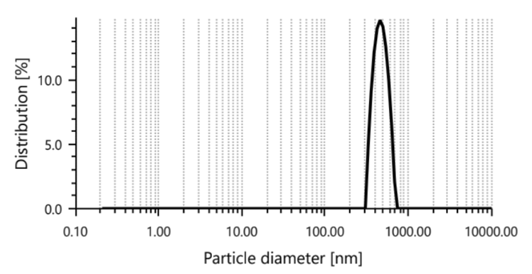
Figure 4.2. Particle size distribution of formulation 300

4.3. Fourier Transform Infrared Spectroscopy (FTIR)

Clotrimazole-excipient interaction has an important role in the release of the drug from the formulation. FTIR spectroscopy was performed to analyse the molecular interactions between clotrimazole, carboxymethyl chitosan (CMC), sodium alginate, and the drug-loaded system. The structural characteristics of these components determine the stability, compatibility, and drug-polymer interaction within the formulation. The FTIR spectra of clotrimazole, CMC, sodium alginate, and the drug-loaded system are provided in the figure. The clotrimazole spectrum exhibits characteristic peaks at 3083 cm‐¹, 3111cm‐¹, and 3165cm‐¹, corresponding to the aromatic C-H stretching. The peaks at 1565 cm‐¹, 1584 cm‐¹, and 1646 cm‐¹ represents the C=C between the imidazole and benzene rings. The additional peaks at 1276 cm‐¹ and 1304 cm‐¹ is due to the C-N stretching, and the peaks at 842 cm‐¹ and 863 cm‐¹ confirms the presence of C-Cl bonds.
In contrast, spectra for CMC and sodium alginate exhibit characteristic peaks at 3438 cm‐¹ and 3423 cm‐¹, indicating strong hydrogen bondings, and at 1617 cm‐¹ and 1418 cm‐¹, showing the asymmetric and symmetric COO‐ stretching bands, respectively. However, the FTIR spectrum of the drug-loaded system exhibits significant changes. Shifting and the broadening of the band at 3404 cm‐¹ (O-H stretching band) suggest the formation of hydrogen bonding between clotrimazole and the polymer matrix. The disappearance of the reduced intensities of the peaks at 1565 cm‐¹and 1646 cm‐¹ (C=C), along with the COO‐ peaks of sodium alginate, confirms the molecular interaction and successful encapsulation of the drug. Retention of peaks at 939 cm‐¹(C-Cl) and at 1276 cm‐¹(C-N) indicates that the drug is chemically intact. These findings confirm the successful incorporation of clotrimazole into the polymer matrix, leading to potential stabilisation of the drug in an encapsulated state.
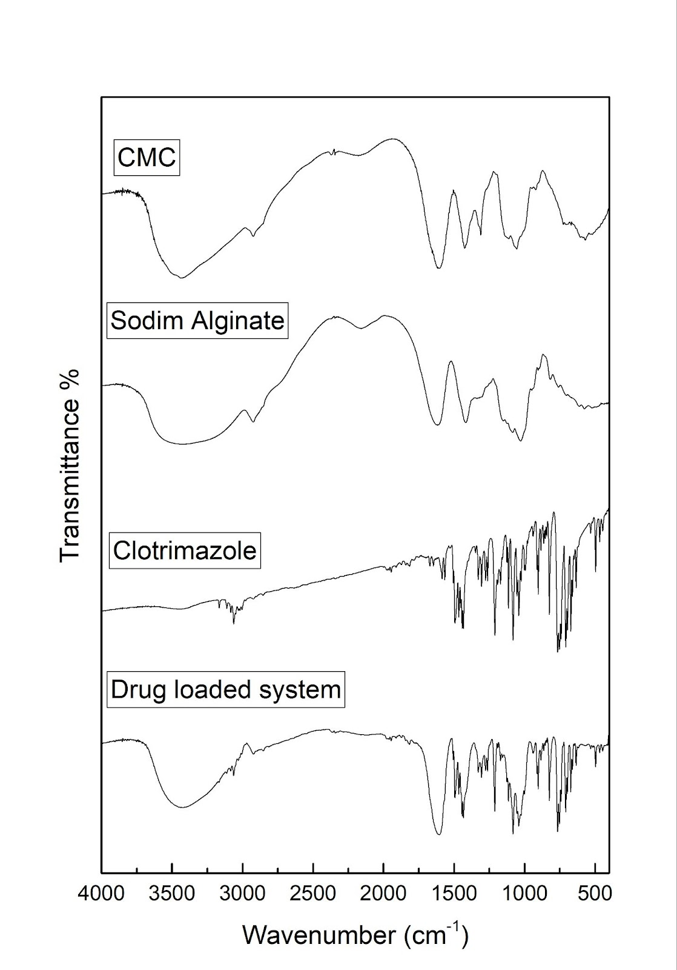

Figure 4.3.1: FTIR spectrum of CMC, Sodium alginate, Clotrimazole, and drug-loaded system

Additionally, FT-IR analysis was performed on the encapsulated system with varying clotrimazole drug concentrations (1 mL of 5 mg/mL, 10 mg/mL, 20 mg/mL, and 40 mg/mL) to analyse the changes in interaction with concentration. Spectra were studied over the range of 4000-400 cm‐¹. In the formulation containing 40 mg of clotrimazole, the characteristic peaks for aromatic C-H stretching (3063 cm‐¹), C=C stretching of the imidazole ring (~1599-1506 cm‐¹ ), and aromatic ring bending (900-700 cm‐¹) can be observed, confirming the presence of clotrimazole. These peaks coexisted with the broad O-H/N-H stretching around 3400 cm‐¹ and C-O-C stretching bands between 1200-1000 cm‐¹, showing the CMC and sodium alginate polymers. Retention of these distinct peaks indicates successful drug encapsulation. In the 20 mg formulation, similar clotrimazole peaks were observed with reduced intensity, showing a moderate drug loading and partial surface exposure. The 10 mg and 5mg formulations displayed progressively diminished clotrimazole intensities, and the 5 mg formulation showed primarily polymer-related bands and minimal drug-specific signals. Overall, FTIR spectra confirmed successful encapsulation of clotrimazole in the polymeric nanoparticle system. Higher drug-loaded system (40 mg) retained distinct drug peaks.
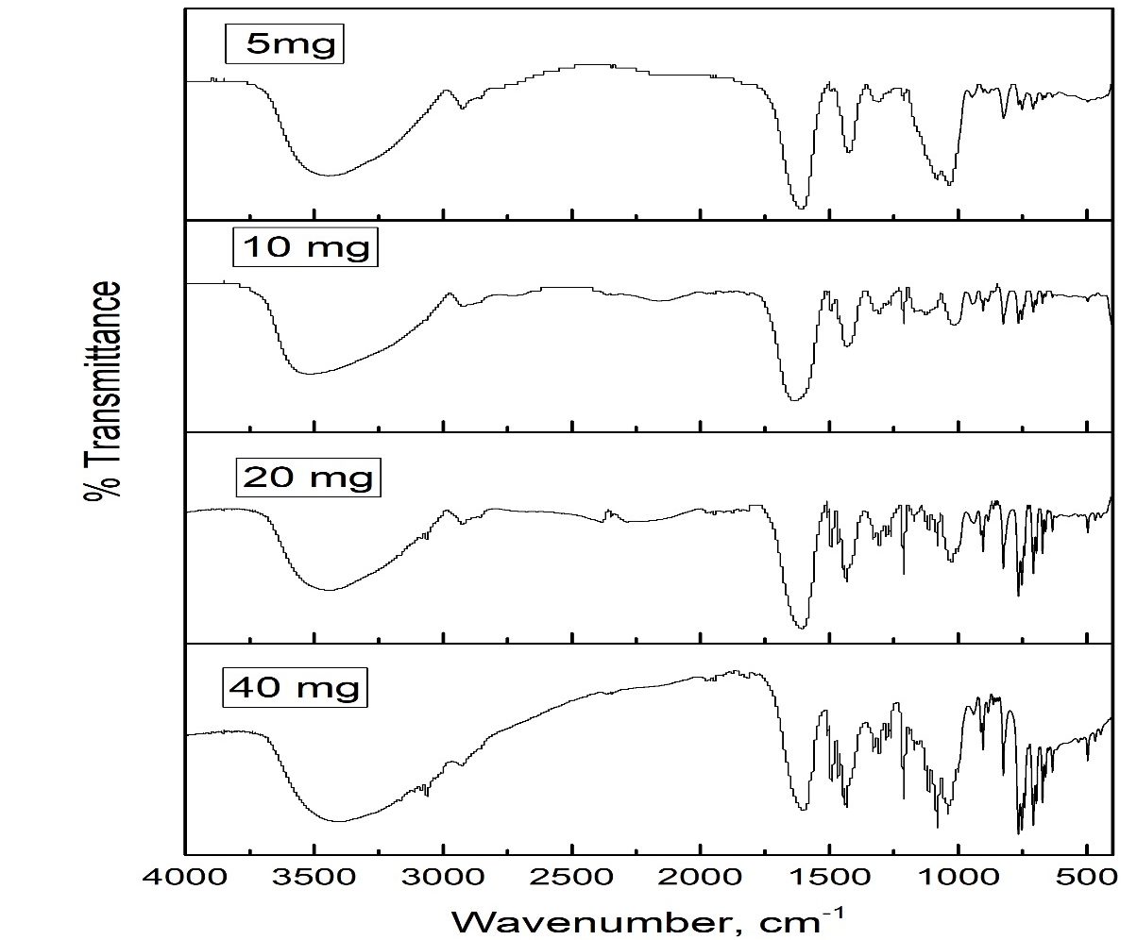

Figure 4.3.2 : FTIR spectrum of encapsulated systems with varying clotrimazole drug concentrations (1 mL of 5 mg/mL, 10 mg/mL, 20 mg/mL, and 40 mg/mL)

4.4. X-Ray Diffraction (XRD)
XRD studies were performed to assess the crystalline or amorphous nature of clotrimazole, sodium alginate, CMC (carboxymethyl chitosan), and the drug-loaded system. The crystalline nature of a drug significantly imparts stability, solubility, and bioavailability, while amorphization can enhance the dissolution and drug release. The X -ray diffractograms for clotrimazole, CMC, sodium alginate, and the drug-loaded system are given in Figure4.4. The XRD pattern of pure clotrimazole exhibited intense, sharp peaks at 9.4°, 12.6°, 18.8°, 19.6°, 20.9°, and 24.6°, confirming its highly crystalline nature. The presence of these well-defined peaks confirms a highly ordered molecular arrangement that is characteristic of a crystalline drug. The XRD diffractogram of sodium alginate displays a broader pattern with no sharp peaks, indicating its amorphous characteristics. This suggests that sodium alginate lacks a well-ordered crystalline structure and can facilitate better drug dispersion and enhance solubility. The CMC diffractogram, however, exhibited distinct peaks at, 27.4°, 31.8°, and 45.5°, suggesting a semi-crystalline nature. The presence of some degree of crystallinity indicates that CMC has an ordered structure while still allowing for drug-polymer interaction. However, the diffractogram of the clotrimazole-loaded system (colt 1:1) showed a marked reduction in peak intensity compared to pure clotrimazole. While some peaks (9.4°, 12.6°, 18,7°) were still visible, but intensities significantly lowered, and several other characteristic peaks of clotrimazole completely disappeared. This reduced crystallinity by the drug-loaded system confirms a successful encapsulation and partial amorphization, which is favourable for improving drug solubility and release.

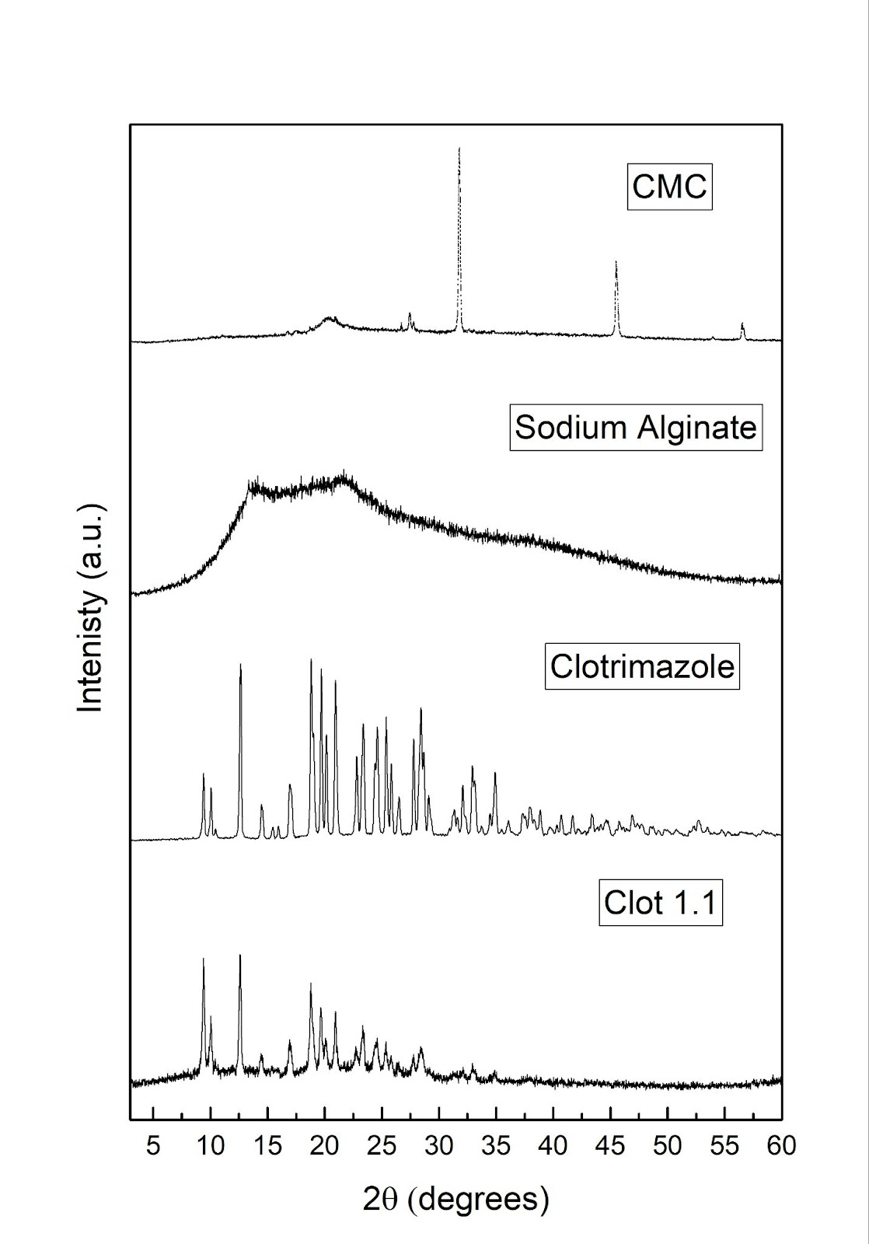

Figure 4.4: X Ray diffractograms of CMC, sodium alginate, clotrimazole, and clotrimazole loaded system (colt 1:1)

4.5. Differential Scanning Calorimetry (DSC)
Differential scanning calorimetry is the most commonly used thermal analysis technique that provides detailed information about physical and energetic properties used to characterise pharmaceutical solids. DSC studies were performed to analyse the thermal behaviour and the possible interactions of clotrimazole and the drug-loaded system (clotrimazole encapsulated in CMC and sodium alginate) as shown in the figure. By comparing the thermograms, the crystalline nature of the drug, any phase transitions, and entrapment-induced changes can be identified. The DSC thermogram of clotrimazole displays two distinct thermal events, the first endothermic peak at 143.5° (onset: 140°C, end: 150°C) which corresponds to the melting point of clotrimazole that confirms its crystalline nature and the second thermal event at 278.4°C (onset: 264.8°C, end: 291.8°C) with an enthalpy change of 177 J/g which indicates a degradation or decomposition of the drug. In contrast the DSC thermogram of the drug loaded system exhibits significant changes that is, in the first thermal event the melting point of clotrimazole is at 144.8v (onset: 139.4°C, end: 283.6°C) appears with a lower enthalpy change (-179.7 μVs/mg), indicating a partial loss of crystallinity due to encapsulation and the second thermal event occurs at 255.0°C (onset: 222.4°C, and end: 283.6°C) with an enthalpy change of 319.8 μVs/mg which suggest a different degradation profile compared to the pure drug. This reduction in the intensity of the characteristic clotrimazole melting peak indicates a successful entrapment and a transformation from a more crystalline nature to a partial amorphous form, which could enhance the solubility and bioavailability of the drug. Overall, DSC results complement the XRD results.
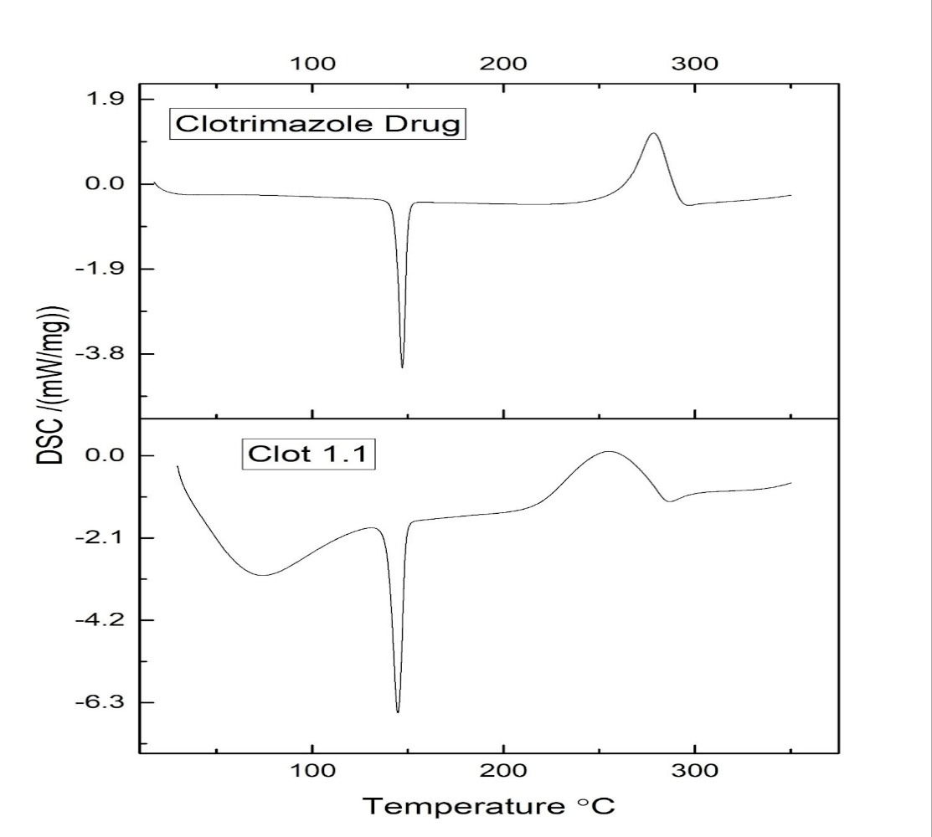

Figure 4.5: Differential scanning calorimetry (DSC) diffractograms of clotrimazole and clotrimazole-loaded system (colt 1:1)

4.6. Surface Morphology (SEM)
Scanning Electron Microscopy (SEM) is an advanced imaging method frequently utilized to analyze the surface texture and structure of materials with great resolution. SEM differs from conventional light microscopes in that it utilizes a focused beam of electrons to scan the sample's surface and generate images with much higher resolution. The resolution of SEM ranges from one nanometer to several nanometres. SEM images of the clotrimazole loaded in CMC and sodium alginate are given below (Figure 4). The SEM images of the formulation show irregular, rough, and porous surfaces. The porous and uneven texture indicates efficient encapsulation of the drug within the CMC-Sodium alginate system. The absence of smooth crystalline surfaces aligns with the XRD and DSC results, further confirming the crystalline to amorphous transition of clotrimazole in the encapsulated system.
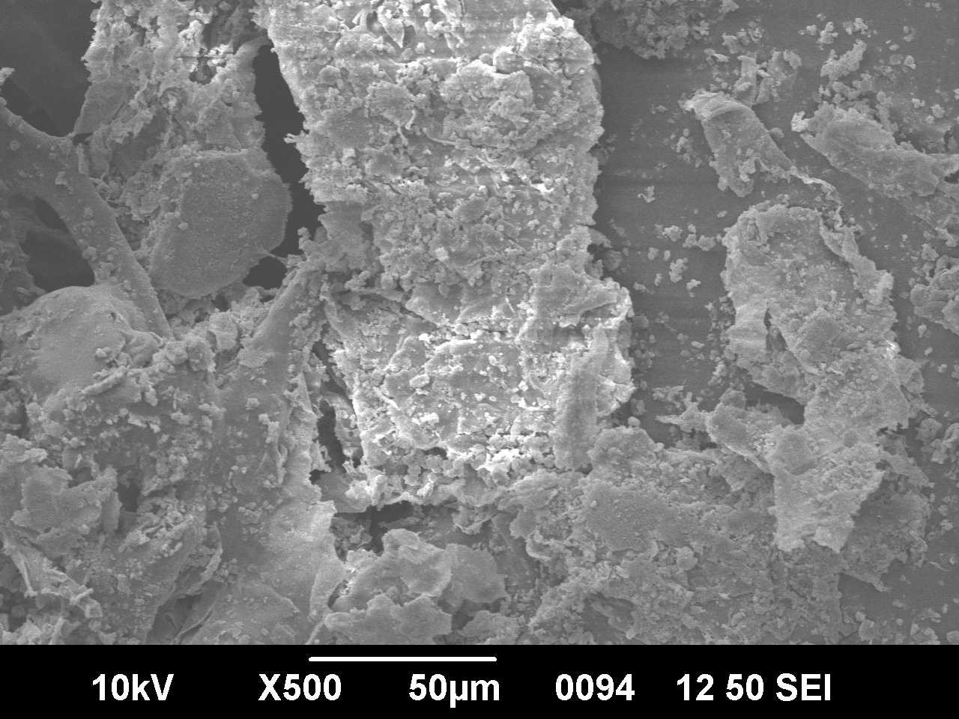
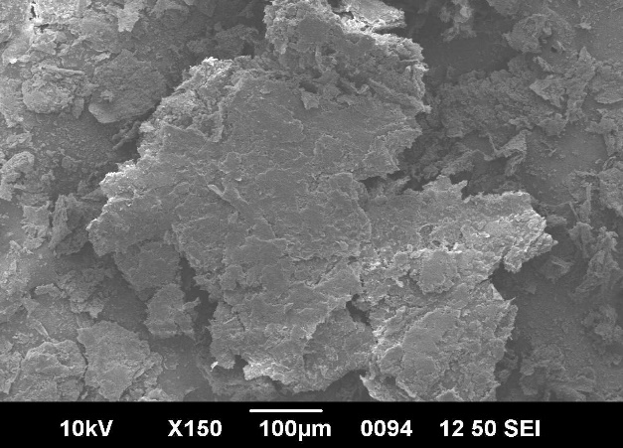
- (b)
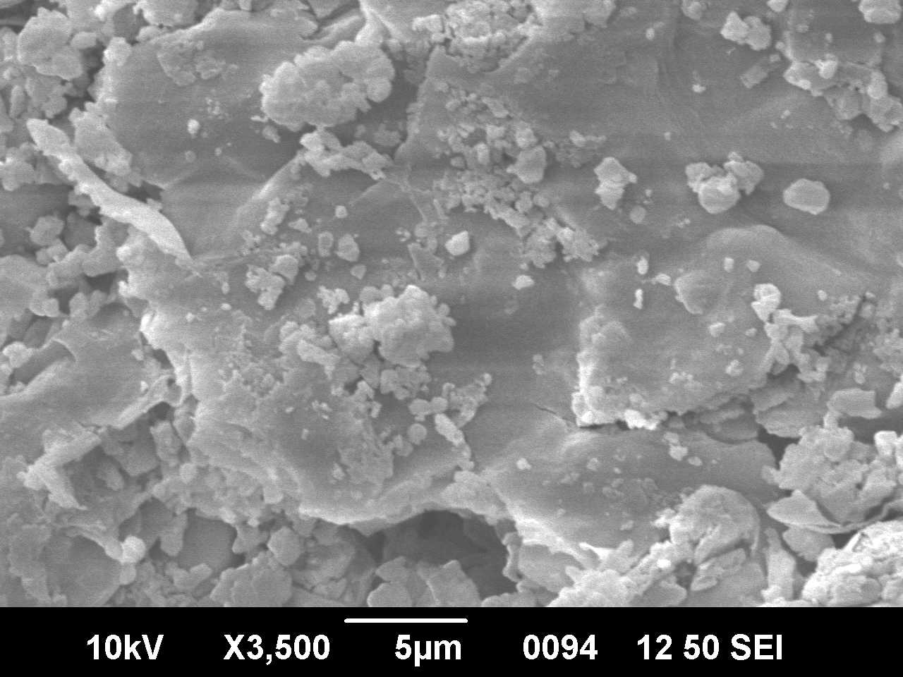
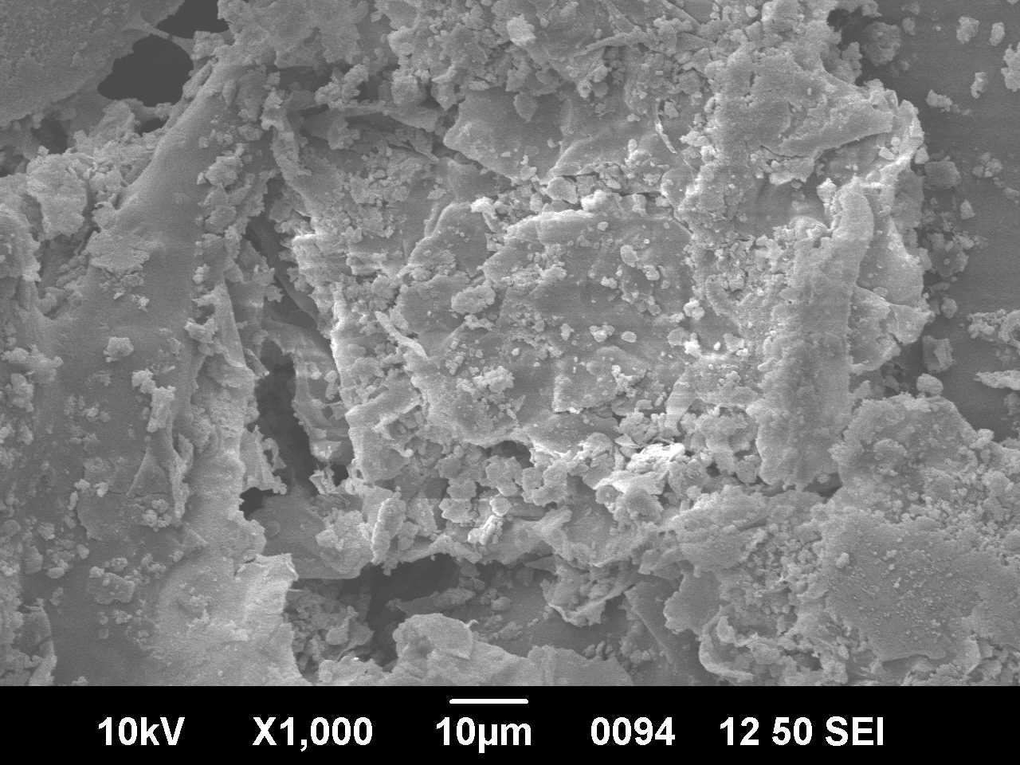
(c) (d)
Figure 4.6: Scanning electron microscopy (SEM) images of the clotrimazole-loaded system

4.7.Transmission Electron Microscopy(TEM)
Transmission electron microscopy (TEM) is one of the widely used techniques for imaging the internal structure of solids. TEM produces images by transmitting a beam of high-energy electrons through the sample. This method facilitates the observation and investigation of structures from the microscale to the nanoscale. Image contrast usually comes from atomic weight differences, crystal structure, or thickness variations in the sample. In contrast to SEM, TEM images are more difficult to interpret since they capture internal structural information instead of merely surface details.. TEM images of the clotrimazole-loaded system are given below (Figure 5).
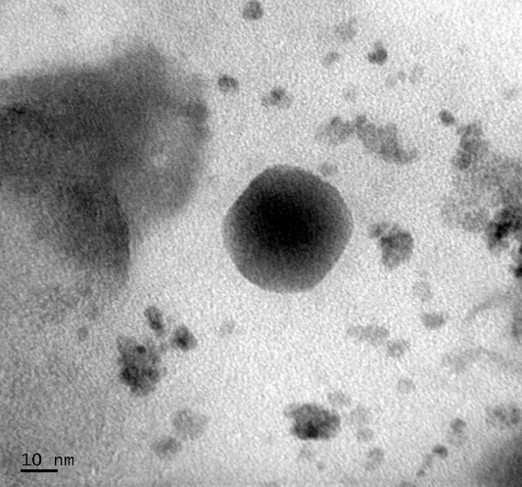
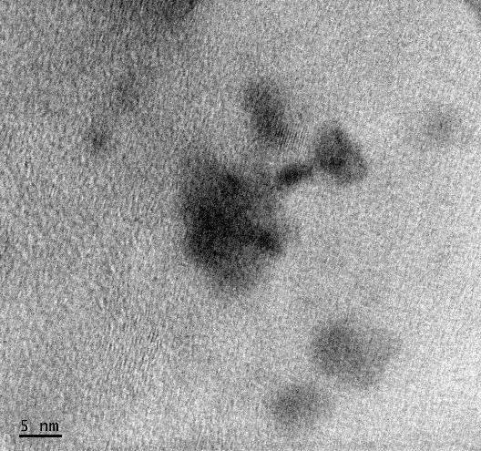
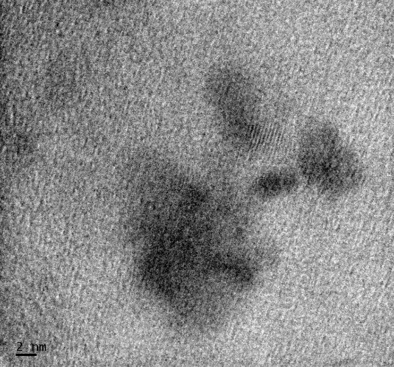
- (b)

(c)
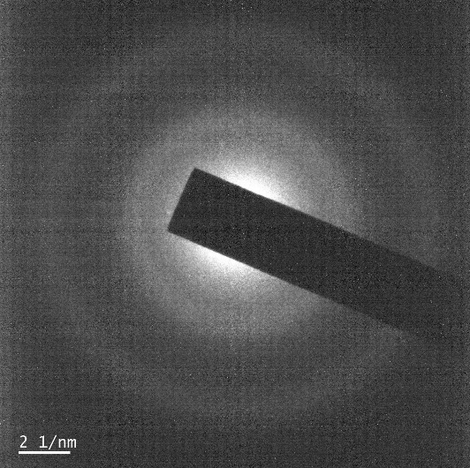
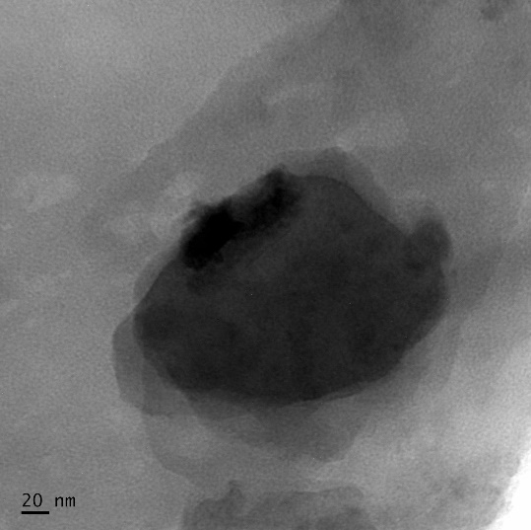
(d) (e)
Figure 4.7: Transmission electron microscopy (TEM) images of the clotrimazole-loaded system

4.8. Antifungal Assay
The antifungal efficacy of the pure drug (clotrimazole) and the drug-encapsulated system (COLT 1:1) was assessed against Candida albicans (ATCC 10231) using the agar well diffusion method. The zone of inhibition was measured after overnight incubation and compared across different concentrations (250µg, 500µg, and 1000µg)
Results:
Organism: Candida albicans

Sample | Concentration  (μg) | Zone of inhibition (mm)
CLOT Drug | Clotrimazole(100µg) | 28
CLOT Drug | 250 | 30
CLOT Drug | 500 | 32
CLOT Drug | 1000 | 35

Table 4.8: Antifungal assay of varying concentrations of pure clotrimazole drug sample

Sample | Concentration  (μg) | Zone of inhibition (mm)
CLOT 1:1 | Clotrimazole(100µg) | 28
CLOT 1:1 | 250 | 31
CLOT 1:1 | 500 | 33
CLOT 1:1 | 1000 | 34

Table 4.8: Antifungal assay of varying concentrations of the drug encapsulated sample (COLT 1:1)
The results revealed that the COLT1:1 formulation exhibits comparable antifungal activity to the pure drug across all tested concentrations. At lower concentrations (250µg and 100µg), the formulated system slightly outperformed the pure clotrimazole, possibly due to the enhanced retention or controlled release at sites of diffusion. At the higher concentration (1000µg), the pure drug showed a marginally larger zone of inhibition.
These findings indicate that the clotrimazole remains biologically active after encapsulation within the polymer matrix of CMC and sodium alginate. The preserved antifungal activity supports the effectiveness of formulations for potential tropical applications against Candida albicans. Also, the slightly slower release at higher concentrations may be advantageous for sustained antifungal effects.
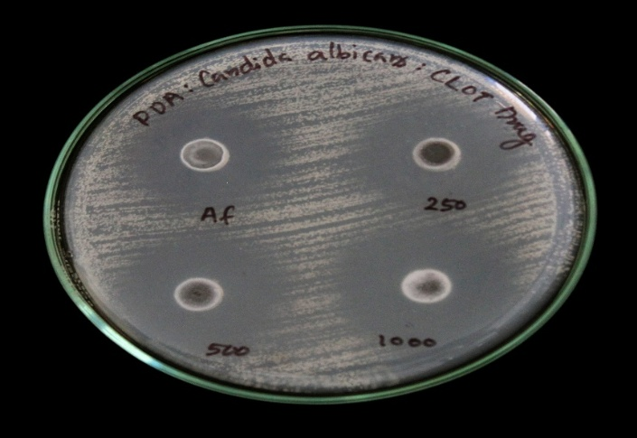
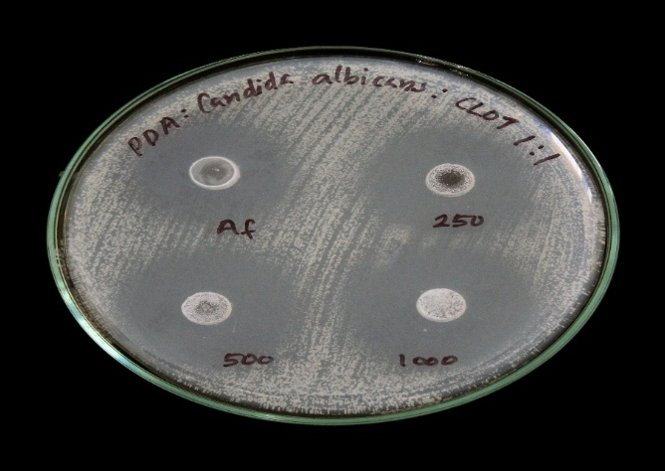

Fig 4.8 (a) PDA for pure clotrimazole drug (b)PDA for drug encapsulated system (COLT
1:1)

4.9. Loading Capacity

A-Absorbance | B*-Concentration in moles/litre = A/22511.314 | C- Concentration in micromoles/ L = B x 10⁶ | D*- Concentration in micrograms/ml = Cx 50 x 344.837/1000micrograms/mL | E- Concentration in micrograms in the 100 mL stock = Dx 10 | F- Concentration in mgs=E /1000 | %Loading Capacity = F/40 x100
0.6888 | 0.00003059794733 | 30.59794733 | 527.5652181 | 5275.652181 | 5.275652181 | 13.18913045
0.5146 | 0.00002285961628 | 22.85961628 | 394.142075 | 3941.42075 | 3.94142075 | 9.853551874
0.3587 | 0.00001593420979 | 15.93420979 | 274.7352551 | 2747.352551 | 2.747352551 | 6.868381378

Table 4.9. Loading Capacity

*Epsilon = 22511.314(from methanol calibration graph), Molecular weight of clotrimazole is 344.837.
The loading capacity of the clotrimazole-loaded polymeric system was determined to be 13.19%, 9.85%, and 6.87% for the three independently prepared samples. The mean loading capacity was calculated as 9.97 ± 3.17%, indicating a moderately high degree of drug entrapment within the polymer matrix. The observed variability across replicates may be attributed to slight inconsistencies during dispersion, or dilution steps. Nonetheless, the overall data suggest efficient encapsulation of clotrimazole within the polymeric carrier. The relatively high loading values also correlate well with the observed drug release profiles, further confirming successful drug incorporation.
4.10. In Vitro Drug Release and Release Kinetics
4.10.1. Calibration Curve of Clotrimazole in PBS of pH 5.5
The calibration curve was constructed by plotting the absorbance value of standard solutions against their respective concentrations. The data obtained is given below :

Label no | Volume of Stock Solution taken and made up to 10 ml  (ml) | Concentration of the Standard solution  In mg% | Absorbance measured
C1 | 1 | 0.12 | 0.2163
C2 | 2 | 0.24 | 0.3186
C3 | 3 | 0.36 | 0.4621
C4 | 4 | 0.48 | 0.5962
C5 | 5 | 0.60 | 0.6312
C6 | 6 | 0.72 | 0.7571
C7 | 7 | 0.84 | 0.8526
C8 | 8 | 0.96 | 0.9767
C9 | 9 | 1.08 | 1.1273

Table 4.10.1. Calibration curve data
Figure 4.10.1: The calibration curve for clotrimazole in methanol and phosphate buffer of pH 5.5 (1:4)

The calibration graph plotted showed a good linearity between concentration and absorbance in the range used (0.12 – 1.08 mg%). The linearity of the data implied that the chosen solvent system (methanol–phosphate buffer) and pH conditions were suitable for the analysis. The calibration curve for clotrimazole in methanol and phosphate buffer of pH 5.5 (1:4) is given above.

4.10.2. In Vitro Drug Release Studies
The in vitro study is a critical evaluation method used to understand the release profile of clotrimazole from formulated sodium alginate-carboxymethyl chitosan (SA-CMC) nanoparticles. This analysis helps in determining the efficiency of the drug delivery system in providing sustained and controlled drug release over time. By monitoring the cumulative drug release from multiple batches (Sample A, B, C), the study aims to assess the reproducibility and stability of the formulation. The drug release data is given below:
Table 4.10.1: Drug Release Data – Absorbance values for Samples A, B, and C at various time intervals
Time Intervals | Cumulative Time in Minutes | Cumulative Time in Hours | Sample name | Absorbance | Sample name | Absorbance | Sample name | Absorbance
5 mins | 5 | 0.08 | A1 | 0.809 | B1 | 0.5195 | C1 | 0.497
5 mins | 10 | 0.17 | A2 | 0.334 | B2 | 0.4083 | C2 | 0.3563
5 mins | 15 | 0.25 | A3 | 0.5841 | B3 | 0.2991 | C3 | 0.3408
15 mins | 30 | 0.5 | A4 | 0.3359 | B4 | 0.5167 | C4 | 0.3346
15 mins | 45 | 0.75 | A5 | 0.3853 | B5 | 0.6294 | C5 | 0.6144
15 mins | 60 | 1 | A6 | 0.3085 | B6 | 0.5511 | C6 | 0.5276
30 mins | 90 | 1.5 | A7 | 0.5637 | B7 | 0.5668 | C7 | 0.5929
30 mins | 120 | 2 | A8 | 0.5442 | B8 | 0.3381 | C8 | 0.4854
1 hr | 180 | 3 | A9 | 0.5307 | B9 | 0.8437 | C9 | 0.6769
1 hr | 240 | 4 | A10 | 0.656 | B10 | 0.5636 | C10 | 0.5256
2 hr | 420 | 7 | A11 | 0.7692 | B11 | 0.4889 | C11 | 0.6062
2 hr | 540 | 9 | A12 | 0.5024 | B12 | 0.7065 | C12 | 0.5489
4 hr | 780 | 13 | A13 | 0.6299 | B13 | 0.8549 | C13 | 0.6299
6 hr | 1240 | 18 | A14 | 0.6679 | B14 | 0.4063 | C14 | 0.4011
6 hr | 1600 | 24 | A15 | 0.4959 | B15 | 0.9068 | C15 | 0.3401
24 hr | 3040 | 48 | A16 | 0.5084 | B16 | 0.6456 | C16 | 0.457
24 hr | 4480 | 72 | A17 | 0.7622 | B17 | 0.6753 | C17 | 0.523
24 hr | 5920 | 96 | A18 | 0.4576 | B18 | 0.3832 | C18 | 0.4878

Based on the calculated loading capacity of the clotrimazole-loaded polymeric system, which was found to be 13.19% using the formula:
LC(%) = $\frac{Amount of drug encapsulated}{Total mass of the delivery system}×100$
the following cumulative percentage drug release (%CDR) values for Samples A, B, and C were determined and are presented below in Tables A, B, and C, respectively. Based on the loading capacity, a 2 mg sample of the drug-loaded system is estimated to contain 263.8 µg of drug (calculated as 2 × 13.19/100).

% Cumulative Drug Release Calculation For Sample A
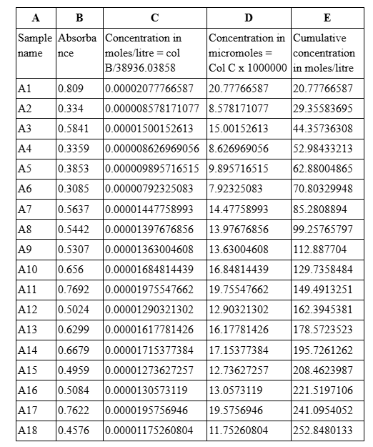

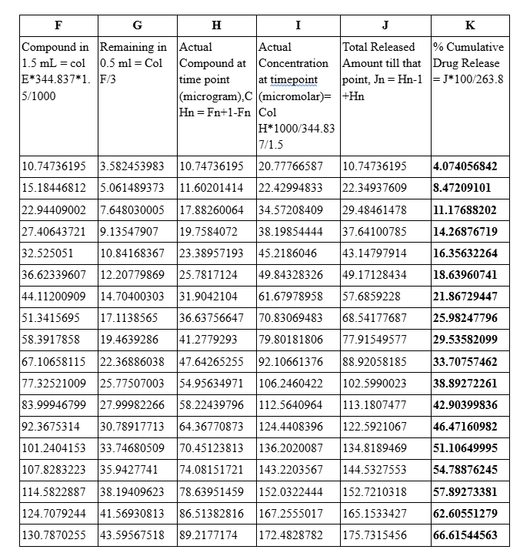

Table A : % Cumulative Drug Release Calculation-Sample A

% Cumulative Drug Release Calculation For Sample B
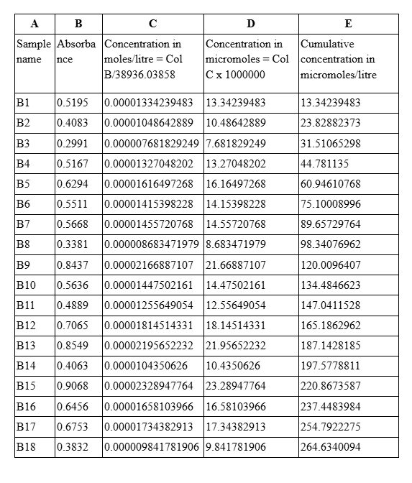

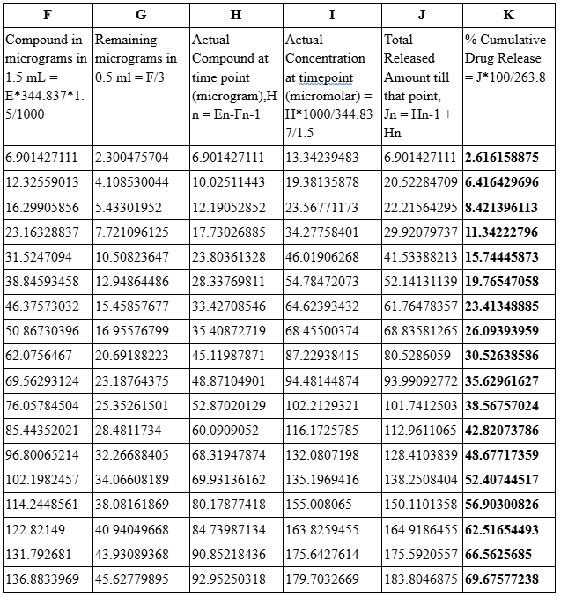
Table B : % Cumulative Drug Release Calculation-Sample B

% Cumulative Drug Release Calculation For Sample C
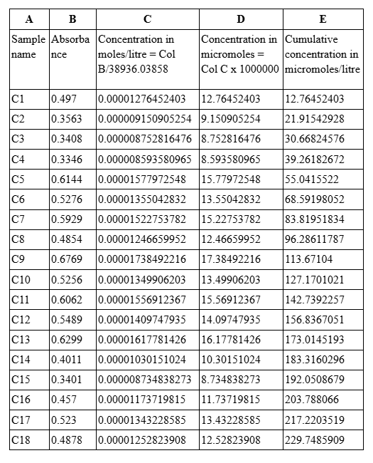

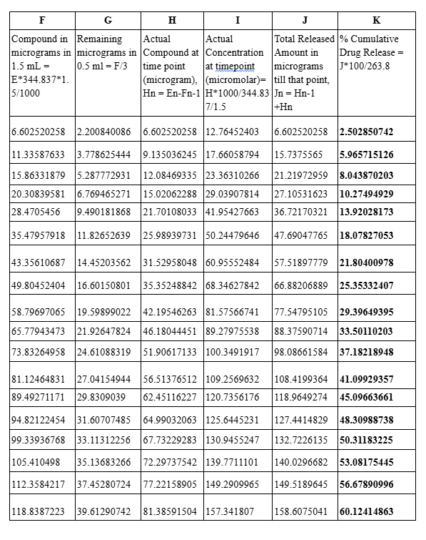
Table C : % Cumulative Drug Release Calculation-Sample C

Time (Hours) | %CDR -Sample A | %CDR -Sample B | %CDR -Sample C | %CDR  Mean | SD | SEM
0.08 | 4.074056842 | 2.616158875 | 2.502850742 | 3.064355486 | 0.8762604089 | 0.5059091829
0.17 | 8.47209101 | 6.416429696 | 5.965715126 | 6.951411944 | 1.336089264 | 0.7713914965
0.25 | 11.17688202 | 8.421396113 | 8.043870203 | 9.214049446 | 1.710311448 | 0.9874487748
0.5 | 14.26876719 | 11.34222796 | 10.27494929 | 11.96198148 | 2.067780493 | 1.193833624
0.75 | 16.35632264 | 15.74445873 | 13.92028173 | 15.34035437 | 1.267299917 | 0.7316759483
1 | 18.63960741 | 19.76547058 | 18.07827053 | 18.82778284 | 0.8591964273 | 0.4960572886
1.5 | 21.86729447 | 23.41348885 | 21.80400978 | 22.3615977 | 0.9115138399 | 0.5262627608
2 | 25.98247796 | 26.09393959 | 25.35332407 | 25.80991388 | 0.3993264485 | 0.2305512325
3 | 29.53582099 | 30.52638586 | 29.39649395 | 29.81956693 | 0.6160744694 | 0.3556907607
4 | 33.70757462 | 35.62961627 | 33.50110203 | 34.27943097 | 1.173843256 | 0.6777187197
7 | 38.89272261 | 38.56757024 | 37.18218948 | 38.21416078 | 0.9083802008 | 0.5244535535
9 | 42.90399836 | 42.82073786 | 41.09929357 | 42.2746766 | 1.018762494 | 0.5881828
13 | 46.47160982 | 48.67717359 | 45.09663661 | 46.74847334 | 1.806253393 | 1.042840883
18 | 51.10649995 | 52.40744517 | 48.30988738 | 50.60794416 | 2.093779682 | 1.208844263
24 | 54.78876245 | 56.90300826 | 50.31183225 | 54.00120098 | 3.365425695 | 1.943029431
48 | 57.89273381 | 62.51654493 | 53.08175445 | 57.8303444 | 4.717704649 | 2.723768049
72 | 62.60551279 | 66.5625685 | 56.67890996 | 61.94899708 | 4.974428229 | 2.871987477
96 | 66.61544563 | 69.67577238 | 60.12414863 | 65.47178888 | 4.877431919 | 2.815986631

Table 2: Percentage Cumulative Drug Release (%CDR)
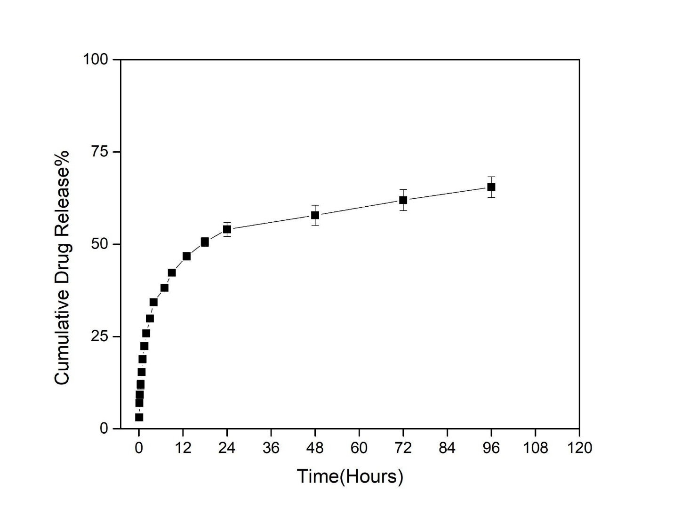
Figure 4.10.1: In vitro cumulative percentage drug release (%CDR) profile of clotrimazole-loaded SA–CMC nanoparticles over 96 hours for Samples A, B, and C

The in vitro drug release study of clotrimazole-loaded sodium alginate–carboxymethyl chitosan (SA–CMC) nanoparticles was carried out over a 96-hour period to assess the release behavior of the encapsulated drug. The cumulative percentage drug release (%CDR) from the three independently prepared samples (Sample A, B, and C) demonstrated a consistent and reproducible release pattern, with low variability across replicates.
An initial burst release was observed during the first 2 hours, where approximately 18.82% of the drug was released. This phase is likely due to the rapid desorption of surface-associated or weakly bound clotrimazole from the nanoparticle surface. Following this, a sustained and gradual release phase was evident, attributed to the diffusion-controlled release of the drug entrapped within the SA–CMC matrix.
The cumulative drug release steadily increased over time, reaching 65.47 ± 2.91% at 96 hours. This extended release behavior is desirable for antifungal therapy, as it may help maintain therapeutic drug concentrations at the site of action over prolonged durations, potentially reducing dosing frequency and enhancing patient compliance.
The combination of sodium alginate and carboxymethyl chitosan likely contributed to the controlled release behavior due to their gel-forming ability, biocompatibility, and interaction with clotrimazole through ionic or hydrogen bonding. These results suggest that the SA–CMC nanoparticulate system is an effective carrier for the sustained release of clotrimazole and holds promise for localized or systemic antifungal applications.

CHAPTER 5
CONCLUSIONS

The present study successfully formulated and evaluated clotrimazole-loaded sodium alginate-carboxymethyl chitosan (CMC) nanoparticles for enhanced topical antifungal delivery. Optimization studies revealed that a 1:1 ratio of sodium alginate to CMC, using 40 mg/mL clotrimazole, achieved the highest encapsulation efficiency (EE%) of 95.94%. The average loading capacity (LC%) of the polymeric system was found to be 9.97 ± 3.17%, with the sample reaching 13.19%, indicating effective drug entrapment.
Dynamic Light Scattering (DLS) analysis confirmed that the optimal formulation had a particle size of 630.7 ± 48.4 nm and a zeta potential of -30.8 ± 0.5 mV, reflecting high colloidal stability and suitability for dermal delivery. FTIR, XRD, and DSC studies confirmed successful encapsulation of clotrimazole with evident drug-polymer interactions, partial amorphization, and reduced crystallinity, features beneficial for improving solubility and controlled release. SEM and TEM imaging showed an irregular, porous structure supporting effective drug entrapment.
In vitro release studies demonstrated sustained release over 96 hours, with the cumulative drug release (CDR%) reaching up to 68.54 in sample A and comparable values in other replicates, highlighting the reproducibility and controlled release potential of the system.
Furthermore, antifungal assay against Candida albicans showed that the encapsulated formulation (COLT 1:1) retained potent antifungal activity, comparable to the pure drug. The slight enhancement at lower concentration suggests improved diffusion or sustained retention at the site of application.
In conclusion, the clotrimazole-loaded sodium alginate-CMC nanoparticles demonstrated excellent encapsulation efficiency, controlled release, good physical stability, and preserved antifungal activity. This result suggests that this delivery system offers a promising strategy for the tropical treatment of fungal infections, addressing limitations of conventional formulations.

CHAPTER 6
REFERENCES

- Carbone, C., Teixeira, M. D. C., Sousa, M. D. C., Martins-Gomes, C., Silva, A. M., Souto, E. M. B., & Musumeci, T. (2019). Clotrimazole-Loaded Mediterranean Essential Oils NLC: a synergic treatment of candida skin infections. Pharmaceutics, 11(5), 231. https://doi.org/10.3390/pharmaceutics11050231
- Bolla, P. K., Meraz, C. A., Rodriguez, V. A., Deaguero, I., Singh, M., Yellepeddi, V. K., & Renukuntla, J. (2019). Clotrimazole loaded ufosomes for Topical delivery: Formulation development and In-Vitro Studies. Molecules, 24(17), 3139. https://doi.org/10.3390/molecules24173139
- Bongomin, F.; Gago, S.; Oladele, R.O.; Denning, W.D. Global and Multi-National Prevalence of Fungal Diseases—Estimate Precision. J. Fungi 2017, 3, 57.

- Santos, S. S., Lorenzoni, A., Ferreira, L. M., Mattiazzi, J., Adams, A. I., Denardi, L. B., Alves, S. H., Schaffazick, S. R., & Cruz, L. (2012). Clotrimazole-loaded Eudragit® RS100 nanocapsules: Preparation, characterization and in vitro evaluation of antifungal activity against Candida species. Materials Science and Engineering C, 33(3), 1389–1394. https://doi.org/10.1016/j.msec.2012.12.040

- Grimling, B., Karolewicz, B., Nawrot, U., Włodarczyk, K., & Górniak, A. (2020). Physicochemical and Antifungal Properties of Clotrimazole in Combination with High-Molecular Weight Chitosan as a Multifunctional Excipient. Marine Drugs, 18(12), 591. https://doi.org/10.3390/md18120591

- Mourya, V., & Tiwari, N. N. I. (2010). Carboxymethyl chitosan and its applications. Advanced Materials Letters, 1(1), 11–33. https://doi.org/10.5185/amlett.2010.3108
- R. Khlibsuwan, W. Khunkitti and T. Pongjanyakul, Alginate-
poloxamer beads for clotrimazole delivery: Molecular interactions, mechanical properties, and anticandidal activity, International Journal of Biological Macromolecules(2020),
https://doi.org/10.1016/j.ijbiomac.2020.01.217

- Sachan, N. K., Pushkar, S., Jha, A., & Bhattcharya, A. (2015). Sodium alginate: the wonder polymer for controlled drug delivery. Journal of Pharmacy Research, 1191–1199.
https://www.researchgate.net/profile/Dr_Nikhil_Sachan/publication/40773276_Sodium_alginate_The_wonder_polymer_for_controlled_drug_delivery/links/09e41508a791f0506d000000.pdf

- Sharma, R.; Malviya, R.;Singh, S.; Prajapati, B. A Critical Review on Classified Excipient Sodium-Alginate-Based Hydrogels: Modification, Characterization, and Application in Soft Tissue Engineering. Gels 2023, 9, 430.
https://doi.org/10.3390/gels9050430

- Debebe D, Gabriel T, Brhane Y, Temesgen A, Nigatu M, Marew T, Comparative in vitro evaluation of brands of clotrimazole cream formulations marketed in ethiopia, Journal of Drug Delivery and Therapeutics. 2018; 8(1):17-22
DOI: http://dx.doi.org/10.22270/jddt.v8i1.1546

- Patel VP, Dama-siya HM, Kapupara P, Ashara KC. Temperature-dependent in situ gel of clotrimazole: an experimental study. Folia Med (Plovdiv) 2019;61(2):266-76.
doi: 10.2478/folmed-2018-0073

