From Mill Spices- Ecommerce Website

A Project Work
submitted to
MAHATMA GANDHI UNIVERSITY, KOTTAYAM
submitted in partial fulfillment of the requirements for the award of the degree of
Integrated M.Sc. Computer Science
in
ARTIFICIAL INTELLIGENCE AND MACHINE LEARNING
by
UTHARA SAJEEV
223143010020
Under the supervision of
Dr. John T Abraham
Head of Department
Department of Computer Science
Bharata Mata College

DEPARTMENT OF COMPUTER SCIENCE
BHARATA MATA COLLEGE
THRIKKAKARA, KOCHI-21, KERALA
March,2025


CERTIFICATE
This is to certify that this Project work entitled ”From Mill Spices-E commerce website”, is the bonafide record of work carried out by Uthara Sajeev (223143010020) in partial fulfillment of the requirements for the the award of the degree of
Integrated M.Sc Computer Science in Artificial Intelligence and Machine
Learning of Mahatma Gandhi University at the Department of Computer Science, Bharata Mata College, Thrikkakara during the academic year 2024-25.
Mrs. Neetha T.P Dr. John T Abraham
Project Guide Head of the Department
Name and Signature of External Examiner:
Date:
DECLARATION
I declare that the work presented in this Project titled “From Mill Spices-E commerce website”, represented my ideas in my own words and where others ideas or words have been included, I have adequately cited and referenced the original sources. I also declare that I have adhered to all principles of academic honesty and integrity and have not misrepresented or fabricated or falsified any idea/data/fact/source in my submission. I understand that any violation of the above will be cause for disciplinary action by the University and can also evoke penal action from the sources which have thus not been properly cited from whom proper permission has not been taken when needed.
Name: Uthara Sajeev Date:
Reg No. 223143010020 Place: Thrikkakara
ACKNOWLEDGEMENT
First of all, I express my gratitude to the Almighty, who blessed me with the zeal and enthusiasm to complete this project work successfully. I am extremely thankful to my supervisor Mrs. Neetha T.P, Lecturer, Computer Science Department, Bharata Mata college, Thrikkakara for their motivation and tireless efforts to help me to get deep knowledge of the project work and supporting me throughout the life cycle of my Integrated MSc Computer Science in Artificial Intelligence and Machine Learning Project work. Especially, the extensive comments, healthy discussions, and fruitful interactions with the supervisor had a direct impact on the final form and quality of MSc. Project work.
I am also thankful to Dr. John T Abhraham, Head of the Computer Science Department, for his fruitful guidance through the early years of chaos and confusions. I wish to thank the faculty members and supporting staff of Computer
Science Department for their full support and heartiest co-operation. This project would not have been possible without the hearty support of my friends. My deepest regards to my Parents for their blessings, affection and continuous support. Also, Last but not the least, I thank to the GOD, the almighty for giving me the inner willingness, strength and wisdom to carry out this project work successfully.
Uthara Sajeev

ABSTRACT
From Mill Spices is an e-commerce website developed to bring traditional, organic food products directly to consumers through a modern digital platform. It serves as a bridge between rural producers and customers, offering a seamless online shopping experience. It is a family-founded brand, initiated by my brother, focused on delivering pure, organic, and traditionally processed food products. Our offerings include a curated selection of spices, pickles, homemade cookies, and raw ingredients—all sourced directly from rural villages in Kerala. The goal is to connect local spice farmers with customers, ensuring access to chemical-free, freshly milled products.
To expand the brand’s reach and make these goods more accessible, we are developing a modern e-commerce website. The platform is being built using FastAPI for the backend, and React with Vite, TypeScript, and Tailwind CSS on the frontend. This combination ensures a responsive, fast, and mobile-friendly user experience. The site includes key features such as a visually clean homepage with featured products and categories, an organized product catalog, search functionality, detailed product pages, user login and registration, a cart, and a smooth checkout process.
Looking ahead, we plan to introduce a mobile application and a subscription-based spice delivery service to further enhance customer convenience. From Mill Spices is built on values of sustainability and healthy living. We actively promote eco-friendly practices through sustainable packaging and work to minimize waste across the supply chain. By blending tradition with technology, we aim to support rural communities and provide consumers with a reliable platform for purchasing high-quality, homegrown food products.

Contents
ABSTRACT iv
List of Figures viii
List of Tables ix
1 INTRODUCTION 1
1.1 Objective 1
1.2 Motivation 2
1.3 Scope 4
2 REQUIREMENT ANALYSIS AND SPECIFICATION 5
2.1 Requirement Analysis 5
2.1.1 Existing System 7
2.1.2 Proposed System 8
2.2 Requirement Specifications 8
2.2.1 Functional Requirement 9
2.2.2 Non Functional Requirement 11
2.3 Feasibility Study 13
2.3.1 Operational Feasibility 13
2.3.2 Technical Feasibility 14
2.3.3 Economic Feasibility 14
2.4 Project Planning And Scheduling 14
2.4.1 Project Planning 15
2.4.2 Project Scheduling 16
3 SYSTEM SPECIFICATION 17
3.1 Hardware Requirements 17
3.2 Software Requirements 17
3.3 Tools 18
4 SYSTEM DESIGN 23
4.1 Input Design 24
4.2 Users Of The System 27
4.3 Modularity Criteria 27
4.4 Architectural Design 29
4.5 Data Flow Diagram 30
4.6 Use Case Diagram 33
4.7 Database Design 35
4.8 Tables Design 37
5 SYSTEM DEVELOPMENT 42
6 SYSTEM TESTING 45
6.1 Testing Techniques 45
6.1.1 Unit Testing 46
6.1.2 Integration Testing 46
6.1.3 System Testing 46
6.1.4 Acceptance Testing 47
6.1.5 Validation Testing 47
6.1.6 Output Testing 47
7 SYSTEM IMPLEMENTATION AND MAINTENANCE 48
7.1 System Implementation 48
7.1.1 Implementation Methods 48
7.2 System Maintenance 49
8 CONCLUSION AND FUTURE SCOPE 50
8.1 Conclusion 50
8.2 Future Enhancement 51
9 SCREENSHOTS 53

Bibliography 53

List of Figures

4.1 Basic DFD symbols | 31
4.2 Level 0 (Context Diagram) . . . . . . . . . . . . . . . . . . . . . . . . . . . . . . . . . . . . . . . . . . . . . . . | 31
4.3 Level 1: User side. . . . . . . . . . . . . . . . . . . . . . . . . . . . . . . . . . . . . . . . . . . . . . . . . . . . . . . . | 32
4.4 Level 2: Admin Side . . . . . . . . . . . . . . . . . . . . . . . . . . . . . . . . . . . . . . . . . . . . . . . . . . . . . | 32
4.5 Use Case Diagram. . . . . . . . . . . . . . . . . . . . . . . . . . . . . . . . . . . . . . . . . . . . . . . . . . . . . . . . . . | 34
9.1 First Page (Admin/Login). . . . . . . . . . . . . . . . . . . . . . . . . . . . . . . . . . . . . . . . . . . . . . . . 48
9.2 User Login Successful . . . . . . . . . . . . . . . . . . . . . . . . . . . . . . . . . . . . . … . . . . . . . . . . .49
9.3 Products Display. . . . . . . . . . . . . . . . . . . . . . . . . . . . . . . . . . . . . . . . . . . . . . . . . . . . . . . . .49
9.4 Cart Page . . . . . . . . . . . . . . . . . . . . . . . . . . . . . . . . . . . . . . . . . . . . . . . . . . . . . .. . . . . . . . .50
9.5 Cart Page. . . . . . . . . . . . . . . . . . . . . . . . . . . . . . . . . . . . . . . . . . . . . . . . . . . . . . . . . . . . . . .50
9.6 Admin Login. . . . . . . . . . . . . . . . . . . . . . . . . . . . . . . . . . . . . . . . . . . . . . . . . . . . . . . . . . . . | 51
9.7 Admin Login Successful . . . . . . . . . . . . . . . . . . . . . . . . . . . . . . . . . . . . . . . . . . . . . . . . . . | 51
9.8 Admin Dashboard . . . . . . . . . . . . . . . . . . . . . . . . . . . . . . . . . . . . . . . . . . . . . . . . . . . . . . . . . | 52
9.9 Order Summary. . . . . . . . . . . . . . . . . . . . . . . . . . . . . . . . . . . . . . . . . . . . . . . . . . . . . . . . . | 52

Chapter 1

INTRODUCTION

From Mill Spices is a simple and reliable online platform where you can shop for a range of homemade products including fresh spices, traditional pickles, and delicious cookies. Each item is carefully prepared and securely packed to ensure it reaches you with its full flavor and quality. The website is designed to be user-friendly, allowing visitors to explore detailed product pages, view clear images and descriptions, and easily add items to their cart. Whether you're looking for everyday cooking essentials or a taste of homemade comfort, our platform brings the feel of local village kitchens right to your doorstep.
For administrator, the website includes a dedicated backend where they can add new products, update existing ones, manage product catalogs, and handle user accounts. Customers can register and log in to track orders and manage their profiles. From browsing products to placing an order, every step is made simple and smooth. Whether you're a returning customer or a first-time visitor, From Mill Spices offers a clean, secure, and satisfying shopping experience rooted in tradition and built for today’s convenience.

1.1 Objective
- Deliver a Seamless Shopping Experience: Create an intuitive and easy-to-navigate platform where users can view detailed product pages, use the cart system, and enjoy a smooth checkout process.
- Promote Packaging and Delivery Standards: Maintain airtight, hygienic packaging practices to preserve freshness and ensure quality during delivery.
- Implement Secure User Management: Enable user registration and login systems with secure data handling to ensure a safe and personalized shopping experience.
- Empower Admin Control and Efficiency: Provide admin tools to add new products, manage catalogs, update inventory, and oversee user accounts with ease.
- Build a Digital Bridge for Traditional Food: Use modern web technology to bring homemade, village-based food culture online, making it accessible to a wider audience.
- Implement Secure User Management: Enable user registration and login systems with secure data handling to ensure a safe and personalized shopping experience.
- Ensure Product Authenticity and Quality: Offer carefully prepared homemade spices, pickles, cookies, and raw food items made using traditional methods and real ingredients.

1.2 Motivation
Creating an eCommerce website for From Mill Spices is more than just building an online store — it’s about preserving tradition, supporting family entrepreneurship, and meeting the growing demand for authentic, homemade food and natural spices in a digital world. This platform brings together the essence of rural kitchens and the convenience of modern technology, offering a meaningful and scalable opportunity for growth.
– Rising Demand for Homemade Products: Consumers today are increasingly seeking natural, preservative-free, and authentic food options, making homemade items like pickles, cookies, and spices more popular than ever.
– Support for Local and Family Entrepreneurship: This website serves as a launchpad for my brother’s business dreams, empowering him to take a traditional skillset and turn it into a successful, sustainable venture.
– Customer Convenience: With features like product details, a cart system, and secure login, customers can browse and shop with ease from the comfort of their homes.
– Digital Reach and Brand Building: A strong online presence helps From Mill Spices reach a wider audience, build brand trust, and compete with larger commercial players.
– Scalability and Growth Potential: The website can grow alongside the business, expanding to include more products, customers, and locations over time.
– Enhanced Shopping Experience: Secure packaging, easy navigation, and detailed product information create a satisfying user experience that encourages repeat customers.
– Operational Control: Admin features allow full control over products, user management, and inventory updates — making it efficient and easy to manage.
– Preserving Tradition in a Modern Way: By digitalizing local food practices, this platform helps keep traditional flavors alive for the next generation, while making them more accessible to today’s consumers.
By addressing these key motivations, the From Mill Spices website becomes more than just a shop — it becomes a story of values, trust, growth, and family. It’s a step toward building something lasting, rooted in tradition but open to the future.

1.3 Scope
From Mill Spices eCommerce website covers the complete digital journey of selling and managing homemade food products and spices online. The platform is designed to support both customers and administrators through a secure, organized, and user-friendly system.
For customers, the website allows browsing of various product categories such as spices, pickles, cookies, and raw items. Users can view detailed product descriptions and images, add items to a cart, and securely place orders. They can also register and log in to manage their profiles, view order history, and leave reviews. For admin, the system includes features to add new products, manage product catalogs, update stock, and oversee user accounts. Admins can also control pricing, manage orders, and ensure smooth backend operations.
The website emphasizes secure packaging, authentic homemade quality, and a simple digital experience that connects rural food traditions with modern eCommerce functionality. It is also built to support the entrepreneurial journey of the founder, enabling future expansion and brand growth.
Chapter 2

REQUIREMENT ANALYSIS
AND SPECIFICATION

2.1 Requirement Analysis
Requirement analysis, also known as requirement engineering, is the process of defining and documenting user expectations for a new or updated system. For the From Mill Spices website, this process played a crucial role in understanding what the users needed and how the system should function to support the business goals. We collected information from agents, engaged with stakeholders, and gathered all necessary system details to design an effective and user-friendly eCommerce platform for homemade pickles, spices, cookies, and raw ingredients.
- Understanding user requirements: We interacted with potential customers and stakeholders to gather their needs and expectations. This helped in identifying key features such as simple navigation, detailed product info, bulk ordering, and mobile responsiveness.
- Defining system objectives: The main goal was to build a platform that highlights authenticity, ensures smooth shopping and checkout experiences, and supports the mission of delivering quality homemade products directly to users.
- Analyzing Existing Systems: We studied other homemade food and spice websites to understand their strengths and weaknesses. This helped us identify areas for improvement in user interface, product presentation, and mobile usability.
- Feasibility Study: We assessed the technical, economic, and operational feasibility of building the website. The study showed the project was manageable, cost-effective, and scalable for future enhancements.
- System design: Based on the requirements, we planned a clean layout with categories, product detail pages, a shopping cart, and an admin panel. The design ensured simplicity, responsiveness, and ease of use for both customers and admins.
- Implementation Planning: The website development was structured in phases, starting with the main storefront, followed by admin features and additional functionalities like user registration and search filters.
- Testing and Evaluation: We tested the website thoroughly to ensure proper functionality across devices and browsers. User feedback was collected to make improvements and fix any issues before final deployment.
- Documentation: Detailed documentation was prepared for managing products, orders, and system updates. This will support future maintenance and help anyone involved in operating the website.
In conclusion, the requirement analysis process provided a strong foundation for building the From Mill Spices website. It ensured that the system aligns with user needs, supports business goals, and delivers a reliable and engaging experience for customers. Through a structured and iterative process, system analysts contribute significantly to the continuous improvement of technology solutions in a dynamic and ever-evolving technological landscape.

2.1.1 Existing System
Many current online platforms that offer spices, pickles, and similar traditional food items face a range of issues that affect both product reliability and customer experience. These challenges expose weaknesses in quality assurance, transparency, and user engagement.
- Authenticity Concerns: Most platforms do not provide enough evidence or background about where the products come from or how they are made, making it hard for customers to trust their authenticity.
- Compromised Product Quality: Some sellers are known to mix high-grade ingredients with low-quality ones to increase profit, which affects purity and customer satisfaction.
- Use of Chemical Preservatives: Instead of natural methods, artificial preservatives are often used to extend shelf life, raising health concerns for consumers looking for clean and safe food.
- Subpar Packaging Practices: Many websites focus only on sales and neglect safe, hygienic packaging. Loose or poorly sealed packs can lead to spoilage or contamination.
- No Reliable Homely Food Options: There are very few online stores that specialize in genuine, homemade food items made with care and traditional recipes, leaving a gap in the market.
- Neglect of Eco-Friendly Packaging: Environmentally sustainable packaging is often ignored; plastic and non-recyclable materials are commonly used, contributing to waste.
- Weak Admin Control and Oversight: In many platforms, administrators lack effective tools to manage products, monitor user activity, or respond to customer issues efficiently. This can result in outdated listings, unaddressed complaints, and overall poor system maintenance.
- Security and Trust Issues: Absence of a robust user verification system may lead to security concerns, with users and administrators having uncertainties about the authenticity of transactions and user
details.

In conclusion, current platforms selling traditional food products often prioritize profit over quality and user trust. These flaws highlight the demand for a more reliable, transparent, and user-centered alternative in the digital food marketplace.

2.1.2 Proposed System
The proposed system is designed to resolve the common issues found in current online platforms and deliver a trustworthy, healthy, and user-friendly experience for customers seeking homemade spices, pickles, and traditional products.
- Authentic Product Sourcing: All items will be genuinely homemade or sourced directly from verified local producers, with details provided about their origin and preparation methods.
- High-Quality Packaging: Products will be packed using airtight and hygienic materials to ensure freshness, safety, and longer shelf life during delivery.
- Chemical-Free Products: No artificial colors, preservatives, or harmful additives will be used, promoting a healthier lifestyle through natural ingredients.
- Clear Product Information: Every listing will include well-described details, nutritional facts (if available), preparation insights, and high-resolution images.
- Admin Control Panel: Admins will have full control to manage products, monitor user activity, respond to queries, and maintain system efficiency.
- Eco-Friendly Approach: Wherever possible, packaging and materials used will be eco-conscious, reducing environmental impact.
- Customization and Bulk Orders: Users will have options to choose product sizes or order in bulk based on their needs.
The proposed system aims to overcome the drawbacks of the existing system by introducing custom features and improvements.

2.2 Requirement Specifications
a car rental website involves outlining the functional and non-functional requirements that the system must fulfill. The purpose of this document is to define the requirements for the development of a car rental website that allows users to rent vehicles online. It covers functional requirements, design constraints, user roles, and technical specifications.

2.2.1 Functional Requirement
Functional requirements define what the system should do to support both customers and administrators. These requirements describe how the platform behaves in response to user actions and how it handles essential e-commerce operations.
User Registration and Authentication:
- User Registration: Customers can create an account using their email address and password.
- Login: Registered users can securely log in using their chosen credentials.
- Secure Input Validation: The system validates user input during registration to prevent duplicate accounts and ensure accurate information.
User Roles and Permissions:
- Visitors or Guest Users: Can browse the website, view product details.
- Registered Users: Can place orders, manage their profile and addresses.
- Administrator: Have full control over product listings, orders, customer data, and reports.
Shopping and Checkout flow:
- Cart Management: Users can select a vehicle, choose rental dates, and complete the booking by providing payment details
- Checkout Process: Customers can enter shipping information, select a preferred payment method, and finalize their purchase.
- Order Confirmation: After placing an order, customers receive a confirmation notification.
Payment System:
- Cash on Delivery (COD) Option: Customers can conveniently pay for their orders in cash upon delivery, promoting trust and ease for first-time buyers.
- Secure Order Processing: Orders are processed through a reliable system that ensures accuracy and timely fulfillment.
- Invoice Generation: A physical or digital invoice is generated and provided to the customer with their order.
User Account Management:
- Account Creation and Login: Customers can sign up and log in securely to access their personal shopping space.
- Cart Interaction: Logged-in users can add products to their cart, view selected items, and adjust quantities as needed.
- Order Placement: Users can complete their purchase through a simple and guided checkout process.
- Basic User Access: After logging in, users can navigate their account to view order confirmations and track the status of placed orders.
Administrative Features:
- Order Oversight: Admins can view and manage all incoming orders, process cancellations, and update order statuses.
- Product Catalog Management: Admins can add, update, or remove products, including price and inventory control.
- Reporting and Analytics: The system provides detailed reports on orders, revenue, customer activity, and stock trends.

2.2.2 Non Functional Requirement
Non-functional requirements define the overall characteristics of the E-commerce Website , outlining how the system should perform and behave beyond its specific functionalities. This specification serves as a comprehensive guide for the development of a E-commerce Website, ensuring that all necessary features and requirements are considered in the project.
Performance:
- Scalability: The system must handle a growing number of users and ordering without performance degradation.
- Response Time: Pages should load within 3 seconds under normal conditions.
Security:
- Data Protection: All user data, including payment and user details, must be securely stored and transmitted.
- Authentication: Implement multi-factor authentication for increased security.
- Compliance: The system must comply with General Data Protection Regulation or other relevant data protection regulations.
Usability:
- Responsive Design: The website should be fully responsive and usable on all devices (desktop, tablet,mobiles).
- User-Friendly Interface: The interface should be intuitive and easy to navigate for users of all technical levels.
- Accessibility: The website should be accessible to users with disabilities, adhering to Web Content Accessibility Guidelines (WCAG) 2.1 guidelines.
Reliability:
- Uptime: The system should have a minimum uptime of 99.9
- Backup: Regular backups should be taken to ensure data can be restored in case of a failure.
Maintenance:
- Modularity: The system should be modular to allow for easy updates and maintenance.
- Documentation: Comprehensive documentation should be provided for both users and administrators.
Design Constraints:
- Branding: The design must adhere to the company’s branding
guidelines.
- Cross-Browser Compatibility: The website should be compatible with all major browsers (Chrome, Firefox, Safari, Edge).
Testing and Quality Assurance:
- Unit Testing: All components must undergo unit testing.
- Integration Testing: Testing to ensure all system components work together as expected.
- User Acceptance Testing: End-user testing to validate the system meets their needs.
Deployment and Delivery:
- Staging Environment: A staging environment should be used for testing before deployment to production. Deployment Plan: Clear deployment plan outlining the steps to move the system from development to production.

2.3 Feasibility Study

2.3.1 Operational Feasibility
- Assessment of the practicality and viability of implementing the proposed system.
- Valuation of existing resources and infrastructure to support system operations.
- Consideration of user acceptance and adaptability to the new system.
- Examination of potential challenges in integrating the system into daily operations.
- Analysis of the system’s compatibility with existing processes and workflows.
- Assessment of the availability and readiness of required technology and
tools.
- Identification of any potential barriers to successful system implementation
- Evaluation of the overall impact on day-to-day operations and workflow
efficiency.
- Examination of the long-term sustainability and scalability of the proposed system.
All operational aspects regarding this project are considered carefully and thus operational feasilbility is accomplished. This project passes all these tests and thus it is feasible...

2.3.2 Technical Feasibility
The technical feasibility of the project assesses its viability from a technological standpoint. It involves evaluating whether the proposed system can be successfully implemented using available technology and resources. This includes analyzing hardware and software requirements, compatibility with existing systems, and the capability to meet performance benchmarks. Technical feasibility considers factors such as infrastructure, development tools, and the availability of skilled personnel, ensuring that the project aligns with current technological capabilities for successful implementation.

2.3.3 Economic Feasibility
The economic feasibility of our project involves carefully reviewing all financial components to determine whether it is cost-effective and sustainable. This includes evaluating the total development cost, implementation expenses, and future operational costs against the expected benefits and income the project may generate. The analysis covers the initial funding required, day-to-day running costs, potential earnings, and areas where expenses can be reduced. This financial assessment helps guide smart resource management and ensures that the project remains within budget while offering a worthwhile return, confirming its economic practicality and long-term sustainability.

2.4 Project Planning and Scheduling
Software project management is the structured process of planning, organizing, and overseeing the development of software systems. It is a specialized area within project management focused on guiding software projects through various stages, including initiation, execution, and completion. Effective software project management helps minimize risks, control costs, and ensure the successful delivery of reliable and functional software solutions.

2.4.1 Project Planning
Project planning is concerned with identifying the activities, milestones and deliverables produced by a project. A plan must be drawn up to guide the development towards the project goals.
A plan drawn up at the start of a project should be used as the driver for the project. This initial plan is not static but must be modified as the project progresses and better information becomes available.
Types Of Plan
- Quality Plan: A quality plan for a car rental website outlines the procedures, standards, and quality assurance activities necessary to ensure the website meets the required quality standards and customer expectations.
- Validation Plan: A validation plan for a car rental website outlines the steps and criteria to ensure that the website functions as intended, meets user needs, and complies with all relevant regulations and standards.
- Configuration Management Plan: This plan details how changes to the website’s system such as updates, upgrades, and infrastructure adjustments will be managed and documented. It ensures stable performance and helps avoid conflicts during future modifications.
- Maintenance Plan: The maintenance plan anticipates the activities, schedules, and procedures necessary to ensure the website remains functional, secure, and up-to-date.
- Staff Development Plan: This plan is focused on improving the capabilities and expertise of the team managing the website. It includes training programs and learning opportunities to help the team stay current with technology trends and effectively handle both existing duties and upcoming changes.

2.4.2 Project Scheduling
Project scheduling refers to the process of organizing, planning, and coordinating tasks to ensure that the development of the From Mill Spices E-commerce platform is completed efficiently and on time. This schedule helps keep the project on track by setting clear timelines, allocating resources wisely, and staying within the planned budget. A well-structured schedule enables the team to identify potential delays, manage workloads effectively, and ensure that the website is launched successfully while meeting user and business expectations.
Chapter 3

SYSTEM SPECIFICATION

3.1 Hardware Requirements
The hardware requirements for a car rental website depend on various factors, including the scale of the website, expected traffic, security needs, and the complexity of the features.
- Processor: At least a dual-core processor with a minimum clock speed of 2.0 GHz to handle server-side processes smoothly.
- RAM: Minimum 4GB RAM to ensure the platform can handle multiple user requests without performance lag.
- Storage: At least 100 GB of SSD storage for faster read/write speed, especially for hosting product images, videos, and databases.
- Internet Connection: Stable high-speed internet with at least 100 Mbps bandwidth to ensure quick data transmission and uninterrupted service.

3.2 Software Requirements
Creating a E-commerce Website involves a comprehensive software stack that includes front-end, back-end, databases, and tools for development, testing, and deployment.
- Front-End Development: The frontend is built using React with Vite for fast module bundling and development. Tailwind CSS is used for responsive and utility-first UI styling. TypeScript ensures robust type-checking and code reliability.
- Back-End Development: The backend is powered by FastAPI, a lightweight Python web framework ideal for building high-performance APIs. Uvicorn serves as the ASGI server to run the application efficiently in both development and production environments.
- Database: The system uses MongoDB, a NoSQL document-based database, to manage product details, user accounts, and order data. Its flexible schema allows for scalability and easy handling of unstructured data.
- Media Handling: Cloudinary, a third-party media management platform, is integrated to store and deliver optimized images and videos. It is used to convert and embed files from sources like Google Drive for seamless frontend rendering.
- Operating System: Development and deployment are supported on Windows 10 or later.
- Web Browser: The platform is compatible with all modern browsers including Google Chrome, Mozilla Firefox, Microsoft Edge, and Opera for smooth user experience.
- Server: The backend is hosted using Uvicorn, optionally behind Nginx as a reverse proxy for performance and security.
- Other Tools: Optional tools like Postman are used for API testing.

3.3 Tools
1. React
React is a key technology used in the frontend development of the eCommerce website. It enables the creation of responsive and interactive user interfaces through a component-based architecture. Each feature—such as product listings, the shopping cart, and the checkout process—is developed as an individual component that updates efficiently when data changes, ensuring a smooth and fast user experience. This modular approach improves development speed and maintainability, as the user interface is broken down into manageable parts. React’s virtual DOM also plays a crucial role in performance optimization, minimizing unnecessary changes to the actual DOM. Additionally, with features like React Router and hooks, it becomes easier to manage application state and navigation without page reloads, contributing to a seamless and efficient shopping experience. React also empowers developers to follow a declarative programming style, allowing the interface to automatically reflect the application state without manually updating the DOM. This approach helps in maintaining a consistent UI across different scenarios, such as when a user adds or removes products from the cart. Furthermore, React’s ecosystem supports numerous third-party libraries and development tools that improve testing, performance monitoring, and UI state management.

2. Tailwind CSS
Tailwind CSS is a utility-first CSS framework used to style the website directly within component files. It provides a wide range of utility classes that help developers build responsive layouts and visually appealing elements without writing custom CSS. This results in a consistent and clean design across the site, which is important for maintaining brand identity and usability. Tailwind allows for rapid UI development by enabling inline styling within HTML-like syntax. Its responsive grid system and predefined spacing utilities make it easy to create flexible layouts that adapt to different screen sizes. Built-in features like theming, dark mode, and animation classes also enhance the design without requiring complex configurations. In addition to speeding up development, Tailwind CSS promotes design consistency by encouraging the reuse of utility classes instead of reinventing styles. This results in fewer style conflicts and a more maintainable codebase. Tailwind’s mobile-first responsive design philosophy also ensures that the eCommerce platform delivers a smooth experience across a wide range of devices.

3. TypeScript
TypeScript is used to add static typing to JavaScript, enhancing code safety and readability. It allows developers to define strict types for variables, functions, and components, reducing the likelihood of runtime errors. In an eCommerce context, where data accuracy is critical, TypeScript ensures that structures like product details, user accounts are well-defined and validated during development. With features like auto-completion, type inference, and real-time error checking, TypeScript improves development efficiency and maintainability. It is particularly beneficial for collaborative projects, as it makes the codebase easier to understand and reduces bugs caused by incorrect data handling. Interfaces and custom types also act as self-documenting code, improving overall clarity. TypeScript not only reduces bugs during development but also enhances scalability by enforcing robust coding patterns. This is especially useful as the eCommerce application grows in complexity. Its ability to integrate with modern frontend frameworks like React ensures that developers can write clean, efficient, and future-proof code. TypeScript's tooling support in modern IDEs further enhances the developer experience by offering smart suggestions and code navigation features.

4. FastAPI
FastAPI is the backend framework used to develop the API services that power the application. Built on Python, FastAPI is known for its high performance and ease of development. It supports asynchronous request handling and uses Python type hints for automatic validation and documentation, which helps streamline development and debugging processes. FastAPI is particularly suitable for eCommerce platforms due to its support for modern features like OAuth2 authentication, input/output validation, and automatic Swagger UI documentation. It provides reliable performance for handling API calls related to product data, user operations, order management, and more, making it an efficient choice for backend services. FastAPI’s ability is to handle asynchronous operations efficiently makes it well-suited for high-traffic eCommerce scenarios, such as handling multiple customer checkouts simultaneously. Its automatic generation of OpenAPI and JSON Schema documentation simplifies API consumption for frontend developers and third-party integrations. Additionally, FastAPI's strong focus on performance and security ensures a robust backend infrastructure for sensitive data handling, such as login credentials and payment information.

5. MongoDB
MongoDB is a NoSQL database used to store and manage data in a flexible document-based format. Unlike relational databases, it allows for dynamic schemas, which is ideal for an evolving eCommerce platform. Data such as product listings, user profiles, and order histories are stored as individual documents in collections, allowing for efficient retrieval and updating.MongoDB supports indexing, aggregation, and filtering capabilities that are essential for delivering real-time features like product search, category filtering, and personalized user dashboards. Its compatibility with FastAPI ensures smooth integration and fast response times. Additionally, MongoDB’s scalability allows the application to handle growing data volumes as more users and products are added to the system. MongoDB’s document model aligns naturally with the JSON format used in modern web applications, making it a developer-friendly choice for handling data in an eCommerce setting. It supports horizontal scaling through sharding, which allows the application to remain performant under heavy load. MongoDB also includes built-in features like replication and backup, which enhance data reliability and ensure business continuity.

Chapter 4

SYSTEM DESIGN

System design refers to the detailed process of planning and building a software system, focusing on structuring all components and workflows necessary to meet business goals. It starts with gathering and analyzing requirements and continues through system architecture definition, implementation, deployment, and ongoing maintenance. The first step involves understanding and documenting what the eCommerce platform needs to achieve, including functional and non-functional requirements. This foundation guides all future design decisions and technology choices. Once requirements are clear, the system design defines how different modules interact and what technologies will be employed to create a scalable, efficient, and secure website.

Key Components:
- User Interface (UI): The platform ensures seamless accessibility across desktops and mobile devices. The frontend is developed using React for dynamic user experiences, styled with Tailwind CSS for consistent and responsive design, and enhanced with TypeScript to improve code reliability.
- Authentication and Authorization: Customers can register, log in, and securely manage their accounts. Role-based access control is implemented to differentiate between Admins, Registered Users, and Guests, with secure token-based session management ensuring privacy and security.
- Product Catalog and Browsing: Users can explore a wide range of products, filter items by categories, price, and availability, and view detailed product pages featuring images, descriptions, pricing, and customer reviews.
- Shopping Cart and Checkout: Customers can add or remove products from their cart, adjust quantities, and proceed to checkout smoothly. The system currently supports Cash on Delivery, with plans to integrate online payment gateways securely.
- Inventory Management: The backend maintains real-time tracking of stock levels for each product, preventing overselling and managing availability efficiently.
- Order and Payment Processing: The system records order details and manages payment status. While online payment options are planned, the initial launch supports COD to build customer trust.
- Notification System: Customers receive email updates for order confirmations, shipping notifications, and promotional offers, keeping them informed throughout their shopping journey.
- Admin Dashboard: Administrators have access to comprehensive tools to manage users, products, orders, and view sales analytics. They can update product listings, monitor inventory, and generate reports to track platform performance.
- Reporting and Analytics: The platform collects data on sales trends, customer behavior, and inventory status to provide actionable insights for business growth and decision-making.

4.1 Input Design
Input design is an essential part of any eCommerce website as it directly influences how smoothly users can interact with the platform and how accurately data is collected. Well-structured input fields not only improve the overall user experience but also ensure data validation and consistency across various modules like account creation, product browsing, checkout, and admin operations. Below is the refined input design strategy implemented in this project.
User Registration and Login:
- Email/Username Field: A standard input field that allows users to sign up or log in using their email. Email format validation ensures correctness, while the backend checks for uniqueness during registration.
- Password Field: Secure input fields that enforce strong passwords (minimum 8 characters, including a mix of uppercase, numbers, and symbols). Includes options to toggle visibility and confirm the password to avoid entry errors.
- Validation & Feedback: Real-time feedback is provided using visual cues (e.g., green/red borders), tooltips for password rules, and error messages such as “Email already exists” or “Passwords don’t match.”
Check Out and Order Form:
- Customer Details: Fields to collect name, mobile number, address, and pin code. Built-in validation checks for input format, especially for phone numbers and postal codes.
- Order Summary: Read-only fields display the product details and total amount before final submission. Users can still go back and make edits if needed.
- Availability Filter: A toggle or checkbox to view only in-stock items. These filters update the product list in real time without reloading the page.
- Payment Mode Selection: Radio buttons to choose between payment methods (currently Cash on Delivery), with plans to integrate online gateways.
- Accessibility: Make sure input fields are accessible (e.g., keyboard navigable, screen reader compatible).
Booking Form:
- Personal Information: Fields for first name, last name, email, and phone number. Implement validation for each (e.g., phone number formatting).
- Car Selection: A read-only field that shows the selected car. Include a button to change the selection if needed.
- Payment Information: Fields for credit card number, expiration date, CVV, and billing address. Use secure input with masking for sensitive data.
User Profile Management:
- Password Change: Offers fields to enter current password, new password, and confirm the new one. Input rules ensure password strength and match checking.
- Edit Details: Logged-in users can update their personal information. Inputs are prefilled with current data and include validation for updated entries.
Admin Dashboard Inputs:
- User Management: Forms to search, edit, or delete user accounts, with fields for filtering by name, email, or role.
- Product Management: Admins have access to forms to add or update product details like title, description, category, price, quantity, and image URLs (linked via Cloudinary).
- Order Tracking: Inputs to search orders using customer name, date, or order ID. Admins can update order status.
Feedback and Support:
- Contact Form: Fields for name, email, subject, and message, with validation to ensure all fields are completed correctly. Feedback: A text area for users to leave feedback, with options for rating services (e.g., star rating system).
By focusing on clear, user-friendly forms with robust validation and security features, you can ensure that users find it easy to interact with the platform view products , products details and make order, while administrators can efficiently manage the system.

4.2 Users Of The System
In a E-commerce website, different types of users interact with the system. Here’s an overview of the primary users of the system:
Administrators
- Secure Admin Access: A login system ensures that only authorized administrators can access the backend, maintaining tight control over operations.
- Product Management: Admins can add, edit, or remove items such as spices, pickles, cookies, and raw products. This includes managing stock levels, pricing, product descriptions, and categories.
- User Account Oversight: Admins can view and manage user profiles, verify user details, and take actions like disabling suspicious accounts to maintain platform integrity.
- Review and Feedback Monitoring: Admins can approve, reject, or respond to customer reviews and feedback to ensure product credibility and customer satisfaction.
- Customer Communication Tools: Built-in tools allow admins to handle customer queries, resolve complaints, and manage order-related communication directly through the platform.
Users
- User Registration and Login: Customers can create personal accounts with email and password, enabling them to make orders, save favorites, and leave reviews.
- Effortless Product Browsing: A clean, responsive interface lets users easily browse different product categories, filter by price or popularity, and view detailed product pages.
- Smooth Ordering Experience: Users can add items to the cart and place orders through a straightforward and intuitive checkout process.
- Customer Support Integration: Users can contact the support team directly through contact forms for assistance with orders, products, or general inquiries.

4.3 Modularity Criteria
Modularity plays a vital role in developing a scalable and maintainable eCommerce platform like From Mill Spices. It focuses on structuring the application into independent, manageable units that work together seamlessly. Each module is responsible for a specific aspect of the system, ensuring that the platform remains organized, flexible, and easy to expand.
- Component-Based Structure: The system is divided into dedicated modules such as product catalog management, order processing, user accounts, payment handling, and review systems. Each module works independently while communicating through clear interfaces.
- High Reusability: Common logic such as form validation, product filtering, or user authentication is encapsulated in reusable components that can be shared across the site or integrated into future projects.
- Future Scalability: As the business grows, modules like payment gateways or product categories can be updated or extended without impacting other parts of the system.
- Simplified Maintenance: Issues can be traced and resolved within individual modules without disturbing the functionality of the overall application.
- Encapsulated Logic: Each module contains only the necessary data and logic required for its task, preventing unnecessary dependencies and making debugging more straightforward.
- Uniform Standards: Consistent code structure and naming conventions are followed across all modules, ensuring readability and ease of collaboration.
- Performance Optimization: Modular components are fine-tuned individually for performance, ensuring smooth interactions even as traffic or inventory scales.
- Security: Each module should adhere to security best practices to protect against vulnerabilities.
Advantages of Modular Design:
- Easier Development: Breaking the platform into smaller components makes it easier to design, test, and launch features.
- Streamlined Updates: Developers can work on enhancements or bug fixes within a module without disrupting the rest of the application.
- Reuse Across Projects: Modules such as user login, product cards, or cart functionality can be repurposed for mobile apps or future product lines.
- Team Collaboration: Modularization allows multiple developers or teams to work on different parts of the site at the same time, improving efficiency.
Implementation Strategies:
- Defined Interfaces: Standardized data flow between modules helps ensure smooth communication and minimal dependency.
- Reusable Code Blocks: Frequently used functions or utilities are centralized, reducing redundancy and simplifying updates.
- Technology-Specific Modularity: React components, FastAPI route handlers, Tailwind utility classes, and MongoDB schemas are organized in dedicated folders to maintain a clean and modular architecture.

4.4 Architectural Design
Architectural design is essential in defining the structure and organization of software systems. According to IEEE, architectural design is “the process of defining a collection of hardware and software components and their interfaces to establish the framework for system development.” For a software solution like From Mill Spices, the architectural design ensures that all components work together efficiently to deliver a seamless user experience.
- Integration Rules: Guidelines on how components are combined and interact to form the complete system.
- Connections: The communication pathways that coordinate interactions between different components.
- Components: Individual modules or services that perform specific functions such as product management, user authentication, or payment processing.
- Semantic Models: Frameworks that help designers understand and predict the overall behavior and properties of the system.
The architectural style chosen for the platform sets the foundation for consistent development and maintainability.
Architectural Decisions:
- Model-View-Controller (MVC): This design pattern is highly suitable for the eCommerce platform, as it separates the data (Model), user interface (View), and control logic (Controller). Such separation simplifies management, improves code organization, and supports scalability when adding new features like product filtering or order tracking.
- Microservices Architecture: For enhanced scalability and flexibility, the system can be divided into smaller, independently deployable services. For example, user accounts, inventory management, payment gateways, and order processing can each function as standalone microservices. This modularity allows teams to develop, update, and scale individual services without impacting the entire application.

4.5 Data Flow Diagram
A Data Flow Diagram (DFD) is a graphical representation that illustrates how data moves through a system or process. It highlights the flow of information between different entities, processes, and data stores, providing a clear view of system inputs and outputs. Unlike flowcharts, DFDs focus solely on the movement of data and do not include control flows such as loops or decision points. DFDs are a core component of structured analysis and serve as an effective tool for visualizing the key steps and data exchanges within a software system. By mapping out how data travels and transforms through the system, DFDs help in understanding, designing, and communicating the overall workflow of the application. Using DFDs makes it easier to identify system boundaries, clarify requirements, and detect potential inefficiencies or redundancies early in the development process.
Advantages of DFD:
- Data Flow Diagrams (DFDs) provide a clear understanding of how a system operates and define its boundaries.
- DFDs give a detailed breakdown of the interactions between different parts of the system.
- They offer a visual representation of system components and data movement, making complex processes easier to grasp.
- They serve as an important part of the system’s documentation for reference during development and maintenance
- Because of their simplicity and clarity, DFDs can be understood by both technical experts and non-technical stakeholders alike
Levels of DFD:
- DFD uses hierarchy to maintain transparency thus multi-level DFD’s can be created.
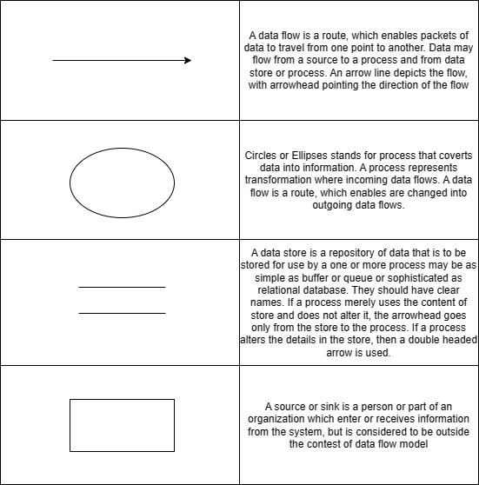
Figure 4.1: Basic DFD symbols
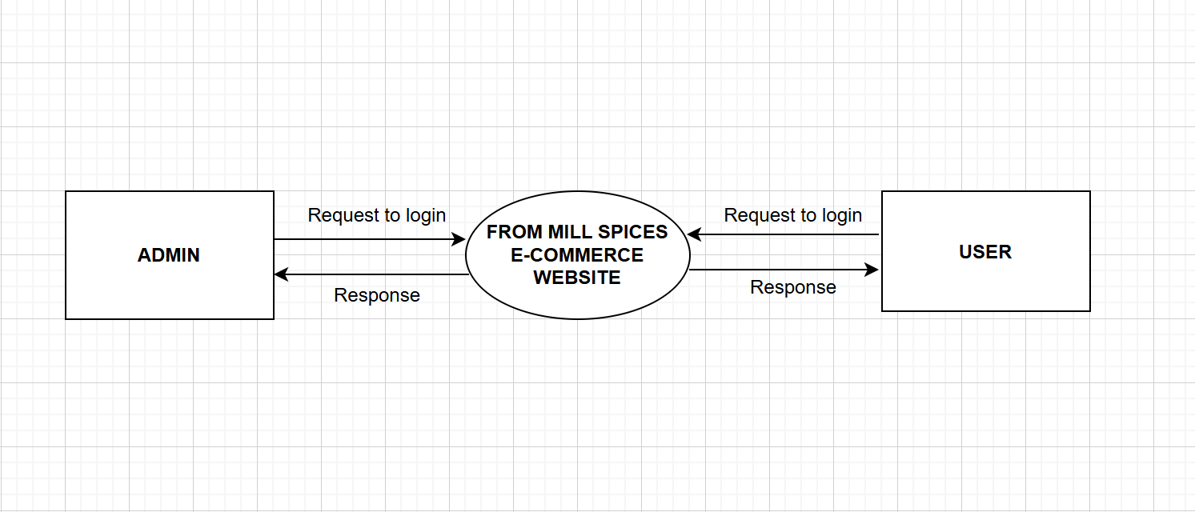
Figure 4.2: Level 0 (Context Diagram)

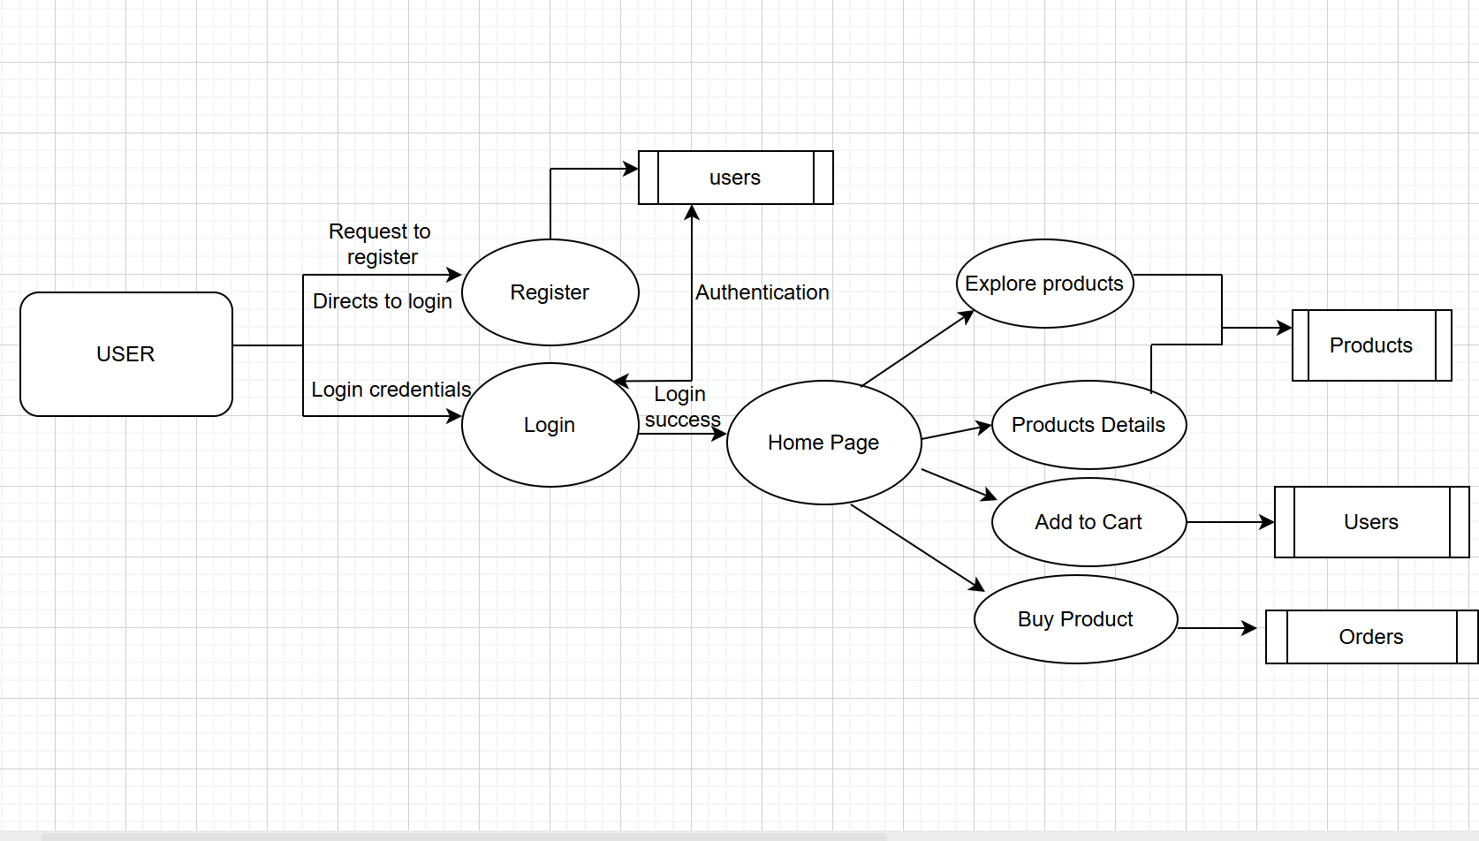
Figure 4.3: Level 1 : User side

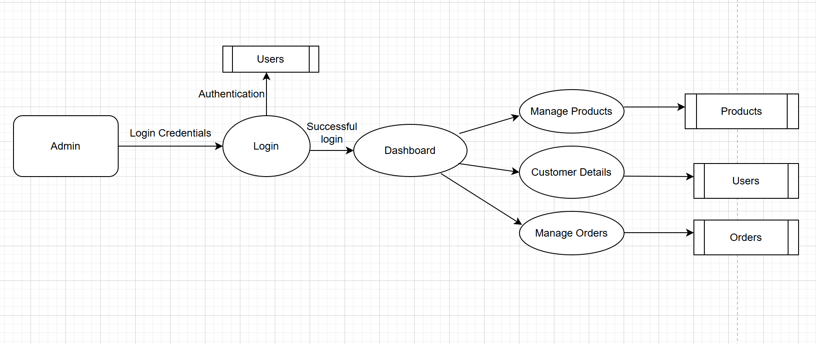

Figure 4.4: Level 2 : Admin Side

4.6 Use Case Diagram
A use case diagram is a graphical representation that shows how users interact with a system. It is used during the planning and analysis phase of development to outline what features the system offers and who can access them. In this case, the system is From Mill Spices, an eCommerce website for selling homemade pickles, spices, cookies, and raw food items. Each use case describes a specific function of the website, and each actor represents a role that interacts with those functions, such as customers and admins.
Actors:
An actor represents a role that an outsider takes on when interacting with the business system. For instance, an actor can be a customer, a business partner, a supplier, or another business system. Every actor has a name.
Use Cases:
A use case defines a specific goal that a user wants to accomplish by interacting with the system or application. In modeling tools like Visual Paradigm, you can break down a use case further by creating a sub-diagram—such as a sequence diagram—to show the detailed interaction between the user and the system. Additionally, you can describe the steps involved in the use case using the Flow of Events editor, which outlines how the interaction unfolds from start to finish.
Relationships:
A line between actor and use case represents communication. Typically, bidirectional (e.g., Actor initiates a use case, a use case sends information to an actor).
Benefits of Use Case Diagrams:
- Enhanced Communication: Facilitate clear communication between stakeholders and developers about system functionalities.
- Improved Requirements Gathering: Help identify and document user needs and expectations.
- Efficient Design: Guide the design of the application to meet user
requirements effectively.
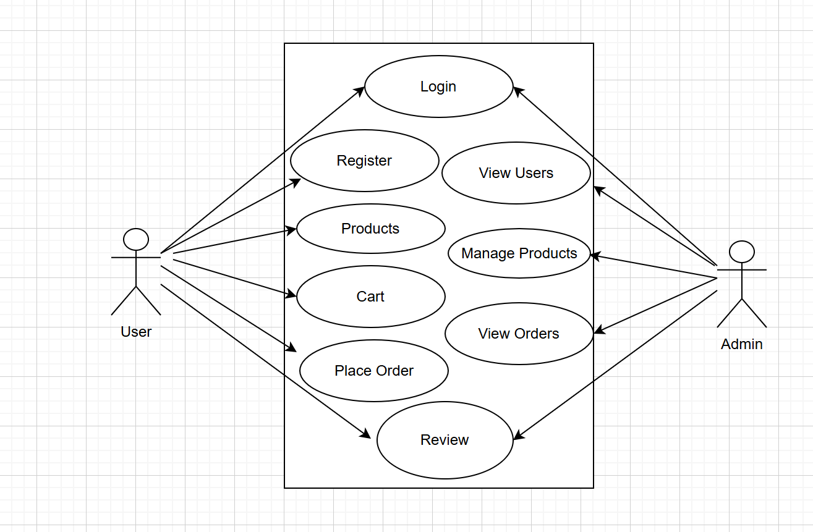
Figure 4.5: Use Case Diagram

4.7 Database Design
Database design is a structured approach used to plan, create, implement, and maintain data management systems within an organization. A well-designed database ensures ease of maintenance, enhances data accuracy, and reduces storage costs. The role of the database designer is to determine how data elements are related and identify what information needs to be stored. The key goal of database design in a DBMS (Database Management System) is to create both logical and physical models of the database. The logical design focuses on understanding the data requirements without considering how or where the data will be physically stored. It deals with what data is needed and how different data elements relate to one another .On the other hand, the physical design translates the logical model into actual storage structures using hardware and DBMS software. It involves deciding how data will be stored on disk, how it can be accessed efficiently, and how to optimize performance.
Ultimately, organizing data in a database aims to achieve three main goals:
- Ensure data accuracy and consistency
- Support efficient data access and updates
- Optimize storage and system performance
- Data Integration: Data integration involves combining data from different sources into a unified view, making it accessible and usable across an organization. In the context of a car rental website, data integration ensures that all the data generated by various systems (e.g., customer bookings, payment processing, car inventory management) is seamlessly combined and available for analysis, reporting, and decision-making.
- Data Integrity: Data integrity refers to the accuracy, consistency, and reliability of data throughout its lifecycle. In the context of a car rental website, maintaining data integrity is crucial to ensure that all information, such as customer details, car availability, bookings, and payments, is accurate and trustworthy.
- Data Independence: Data independence is a concept in database management systems (DBMS) that refers to the separation of data from the applications that use the data. This separation allows changes to be made to the database’s structure without affecting the way data is accessed by applications.
- Normalization: Minimizing redundancy and ensuring data integrity through normalization techniques.
- Data Type Selection: Choosing appropriate data types (text, integer, etc.) for efficient storage and retrieval.
- Data Security: Implementing access controls, encryption, and authentication to safeguard user privacy.
Benefits:
- Improved Performance: Faster and more responsive user experience due to efficient data handling.
- Enhanced Scalability: The ability to accommodate future growth without performance degradation.
- Data Integrity: Minimized redundancy and data inconsistencies for accurate and reliable information.
Normalization
First Normal Form (1NF):
- Eliminates Repeating Groups: Each data cell contains a single atomic value, preventing the storage of duplicate information within a cell.
- Unique Identifiers: Every row in a table is uniquely identified by a primary key, which can be a single column or a combination of columns.
Second Normal Form (2NF):
- Dependency on Full Primary Key: All non-key attributes (columns) are fully dependent on the entire primary key, not just a portion of it.
- Eliminates Partial Dependencies: This ensures data integrity and prevents inconsistencies. A column shouldn’t depend on another non-key attribute but only on the primary key.
Third Normal Form (3NF):
- Dependency on Primary Key Only: All non-prime attributes (columns that are not part of the primary key or a candidate key) are solely dependent on the primary key.
- Eliminates Transitive Dependencies: This prevents situations where a non-key attribute depends on another non-key attribute, which in turn depends on the primary key.

4.8 Mongo DB Database Design
This database structure is optimized for an eCommerce website selling homemade food products. It is designed for fast querying, easy product management, and future scalability, supporting features like new categories, offers, and customer data.
1.Cart
- _id: Unique ID
- product: Name of the product (e.g., Cardamom, Black Pepper)
- quantity
2.Order
- _id: Unique ID
- userId: ID of the user who placed the order
- items: Array of products with quantities and prices
- total_Amount: Total cost
- created_at: Date and Time of Order
- shippingAddress: Delivery details
3.Products
- id: Products ID
- name: Name of the Product
- price: Price of the Product
- quantity
- image: Cloudinary Link (The image field stores the Cloudinary URL of the product's image. When an admin uploads a product image through the dashboard, the image is uploaded to Cloudinary (a cloud-based image hosting service). The generated image link (URL) is then saved in the database and used on the frontend to display the product visually to users.)
4.Users
- _id: Unique ID
- email: Email ID of the user who logins.
- password: password of the users (salt hashing)

Chapter 5

SYSTEM DEVELOPMENT

Developing a E-commerce website for From Mill Spices involves a thorough and strategic process that spans across planning, designing, development, testing, deployment, and maintenance. By following a structured development cycle, the platform can be tailored to fulfill both customer expectations and business goals, ensuring reliability, performance, and a seamless shopping experience. Every phase of this process plays a vital role—from identifying initial goals to providing continuous improvements after the site is live.It is important to evaluate whether all intended features can be effectively delivered using the available technological resources. This includes reviewing the selected stack (e.g., front-end, back-end, and database technologies) to verify that it supports current needs while allowing room for future expansion. The initial phase begins with defining clear objectives for the business, such as boosting online visibility, enhancing order convenience, delivering a smooth and intuitive user experience, and offering strong backend tools for managing inventory and logistics. Understanding these priorities ensures the website aligns with long-term brand vision and customer expectations. Involving key stakeholders—such as customers, sellers, delivery partners, and admin users—helps gather specific insights into their needs. For example, customers may value a simple search and checkout process, while admins need efficient dashboards for handling product uploads, orders, and feedback. This collaborative step guarantees that the platform is user-friendly and meets diverse operational requirements. A technology audit is also essential to confirm that the chosen tools and frameworks can handle functionalities like real-time inventory tracking, promotional banners, order status updates, and secure payments. It's also important to verify whether the organization has access to the necessary resources such as skilled web developers, hosting infrastructure, and ongoing maintenance protocols. Ensuring this support structure is in place is key to maintaining long-term site performance. A detailed project schedule must be created, clearly mapping out each stage of development along with expected milestones, deliverables, and timelines. This project roadmap keeps everyone aligned and ensures that delays are minimized and progress remains transparent. System architecture decisions are then made, including the selection of the front-end framework (like React), backend services (such as FastAPI or PHP), and a database system (like MongoDB or MySQL). The architecture must allow for smooth integration between UI, server logic, product data, and third-party services like Cloudinary or payment gateways. A robust system design improves the website’s flexibility, performance, and security. Next, the database schema is carefully planned, outlining collections or tables for products, users, orders, and categories. Relationships, constraints, and data validation rules are defined to ensure consistent and efficient data storage. Security features such as password encryption and protection of user data are included to meet best practices. On the UI side, the focus is on building an attractive that is easy for users to navigate and engage with. Detailed user flow designs are created to map out how users will register, browse products, add items to their cart, place orders, and make secure payments. These flows ensure a frictionless shopping journey for customers. Once UI/UX prototypes are finalized, front-end code is developed using HTML, CSS, Tailwind, TypeScript, and JavaScript to build out the website visually, ensuring responsiveness across devices. On the server-side, functionalities like login authentication, cart management, order handling, admin controls, and coupon logic are implemented using PHP, FastAPI, or another suitable backend language. This logic drives the website’s core services and ensures that user actions are processed correctly. The database setup is configured next, handling data input, queries, updates, and deletions for all core entities like products and users. This ensures efficient backend performance and data security. Finally, deployment preparation involves configuring hosting services, servers, databases, and necessary cloud integrations for the production environment. Ongoing monitoring tools may also be added to ensure uptime and track performance. Following this step-by-step development plan allows for the delivery of a high-performing, visually pleasing, and secure online shopping platform. From initial strategy to day-to-day operations and future upgrades, every stage contributes to building a website that represents From Mill Spices with professionalism and user delight.

Chapter 6

SYSTEM TESTING

System testing plays a crucial role in the software development process, as it involves thoroughly assessing the complete system to confirm that it operates according to the defined requirements. This phase includes testing all integrated components to ensure they function together smoothly and to detect any hidden issues. Functional testing checks whether each feature behaves as expected, while performance testing evaluates how well the system handles load and responds under different conditions. Security testing is also performed to uncover and fix any weaknesses that could be exploited. The main objective is to discover and correct errors before the software goes live. Through this, system testing builds trust among stakeholders by proving the software is reliable, efficient, and ready for real-world usage, ultimately contributing to the delivery of a strong, high-quality product.

6.1 Testing Techniques
Software testing is the practice of running a program or system with the goal of detecting any errors or issues. It includes all activities focused on evaluating specific features or capabilities of the software to ensure it produces the expected outcomes. The scope of testing covers not only reviewing the source code but also executing it under different environments and conditions to assess how well it performs. It also involves checking the overall quality of the code—whether it functions correctly and fulfills its intended purpose. Testing plays a key role in identifying mistakes made during coding, as well as uncovering errors from earlier stages of development.

6.1.1 Unit Testing
Unit testing is a method used in software testing that concentrates on checking individual components or modules of an application. During this phase, each unit—the smallest portion of code that can be tested—is examined separately to confirm it functions according to its defined purpose. The main aim is to ensure that each unit works correctly on its own, allowing developers to catch and fix issues early in the development cycle before they affect larger parts of the system.

6.1.2 Integration Testing
Integration testing is a stage in software testing that examines how various modules or systems within an application work together. Its main purpose is to detect problems that may occur when these individual components are combined, making sure they interact smoothly and function as expected. This type of testing is typically carried out after unit testing and before system testing within the software development life cycle.

6.1.3 System Testing
System testing is a vital stage in the software development life cycle where the complete and integrated software application is tested to verify that it performs according to the defined requirements. This phase evaluates the entire system’s functionality, checking its behavior across various conditions and use cases. It takes place after integration testing and before acceptance testing. The main purpose of system testing is to confirm that the application meets all its specifications and is prepared for deployment. When done successfully, it assures stakeholders that the software is dependable, of high quality, and capable of fulfilling user needs in a practical setting.

6.1.4 Acceptance Testing
Acceptance testing is the concluding phase of the software testing process, carried out to verify that the software meets the predefined acceptance criteria and is ready for launch. It is usually performed by end-users or stakeholders to evaluate whether the application aligns with business needs and functions as expected. This phase plays a crucial role in confirming that the software fulfills its intended goals and meets user expectations. It provides the final assurance that the product is suitable for deployment and real-world use.

6.1.5 Validation Testing
Validation testing for a car rental website ensures that all features perform as intended and that the system meets the needs of both users and the business. This process involves reviewing different components of the website, including the user interface, functionality, and backend operations, to confirm they align with the original requirements and provide a smooth and reliable user experience.

6.1.6 Output Testing
Output testing for a car rental website focuses on confirming that the system delivers accurate and expected results based on different user actions and inputs. This testing ensures that the information shown to users—such as booking details, availability, and pricing—is correct, and that the data saved within the system remains consistent and reliable.

Chapter 7

SYSTEM IMPLEMENTATION
AND MAINTENANCE

System implementation and maintenance are critical phases in the life cycle of any software project, including a E-commerce website. These stages ensure that the developed system is not only deployed successfully but also remains functional, secure, and up-to-date over time.

7.1 System Implementation
System implementation is the stage in the software development life cycle where the planned design is transformed into a functional system. This phase includes writing the code, setting up the required hardware, installing essential components, and getting the system ready for deployment and use.

7.1.1 Implementation Methods
- Direct Cutover (Big Bang) Implementation: The old platform is completely replaced by the new From Mill Spices website all at once. Customers and staff start using the new system on a specific launch date.
- Parallel Implementation: Both the new eCommerce website and the previous system run at the same time for a transition period. Orders and transactions are processed through both platforms to ensure accuracy and smooth operation.
- Phased Implementation: The new website is rolled out gradually, with different features or product categories launched in stages. For example, spices and pickles might be available first, followed later by homemade cookies and raw products.
- Pilot Implementation: The new system is launched initially for a limited group of customers or within a specific region. Feedback and performance from this pilot help improve the site before a full-scale launch.
- Hybrid Implementation: A combination of methods is used to suit the business needs. For example, starting with a pilot launch for certain products or users, followed by a direct cutover to replace the old system entirely.
Choosing the right implementation strategy for the From Mill Spices website depends on factors such as the size of the product catalog, customer base, available resources, and the goal of minimizing disruption during the transition. Each method balances risk, cost, and speed differently, so the choice should support your business objectives and operational constraints.

7.2 System Maintenance
Maintenance is the continuous process of overseeing, updating, and improving the system once it is live. This includes resolving bugs, upgrading functionalities, maintaining security, and adjusting the system to meet changing business requirements and new technologies. Both aspects are vital to ensure the system remains effective and delivers consistent value throughout its lifespan.
Chapter 8

CONCLUSION AND FUTURE
SCOPE

8.1 Conclusion
In conclusion, the development and implementation of the From Mill Spices eCommerce website mark a vital step in modernizing and expanding access to high-quality, homemade food products. By carefully planning and executing each phase—from initial requirement analysis to design, development, and ongoing maintenance—the platform is tailored to meet the expectations of both everyday customers and bulk buyers.
A thoughtfully designed website enhances the user experience by offering easy navigation, clear product categorization, secure payment options, and a smooth shopping journey. For the business, it streamlines operations through features such as inventory management, product uploading, order tracking, and customer management via a dedicated admin panel. Built with modern technologies like React, FastAPI, and MongoDB, the platform ensures performance, flexibility, and scalability.
With continuous feedback, performance monitoring, and future integration of advanced tools, From Mill Spices is positioned to adapt to market needs and consumer preferences. Ultimately, this robust, user-friendly platform strengthens the brand’s reach, promotes organic and homemade food culture, and supports business growth in a competitive digital marketplace.

8.2 Future Enhancement
Future Scope of the Project:
- Monthly Subscription Plan:
Offer subscription services for regular deliveries of popular products—like monthly spice boxes or cookie packs—to generate steady recurring revenue.
- Payment Gateway Integration:
Integrate multiple secure payment gateways including UPI, credit/debit cards.
- Seller Network Expansion:
Create a platform to onboard more home makers as sellers to diversify your product range and increase offerings.
- AI-Powered Personalization:
Use AI to recommend products based on user behavior, previous purchases, and preferences to boost sales and customer satisfaction
- Loyalty and Reward Programs:
Implement a points-based rewards program to encourage repeat purchases and customer engagement.
- Real-time Order Tracking:
Add real-time shipment tracking so customers can monitor their orders from packing to delivery.
- Chatbot and Customer Support Automation:
Integrate AI chatbots for instant customer queries, FAQs, and support to improve user experience.
- Mobile App Development:
Develop a dedicated mobile app for easy shopping, push notifications, and better user engagement.

Chapter 9

SCREENSHOTS
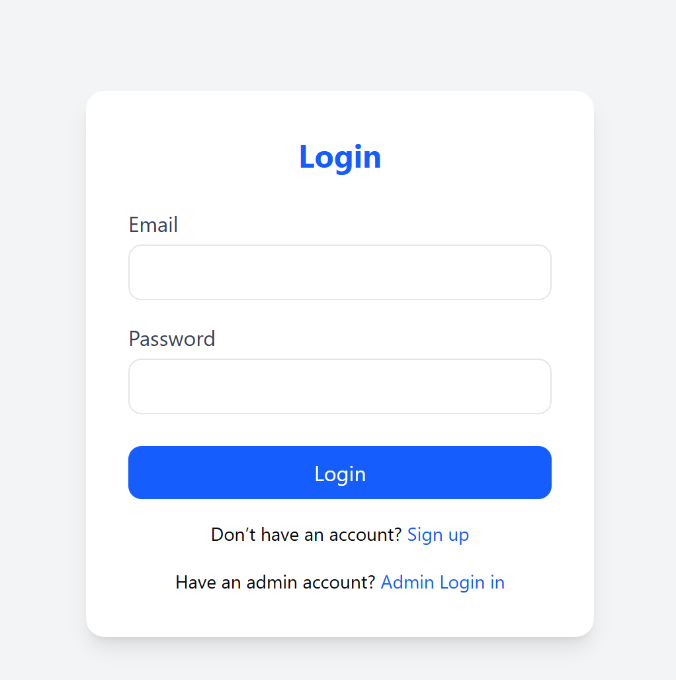
Figure 9.1: First Page (Admin/User Login)
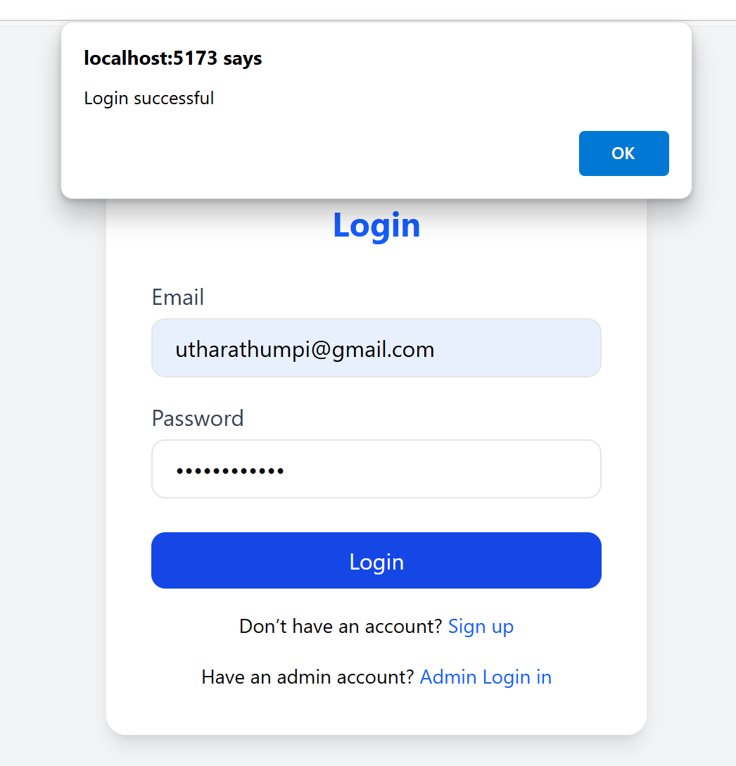
Figure 9.2: User Login Successful
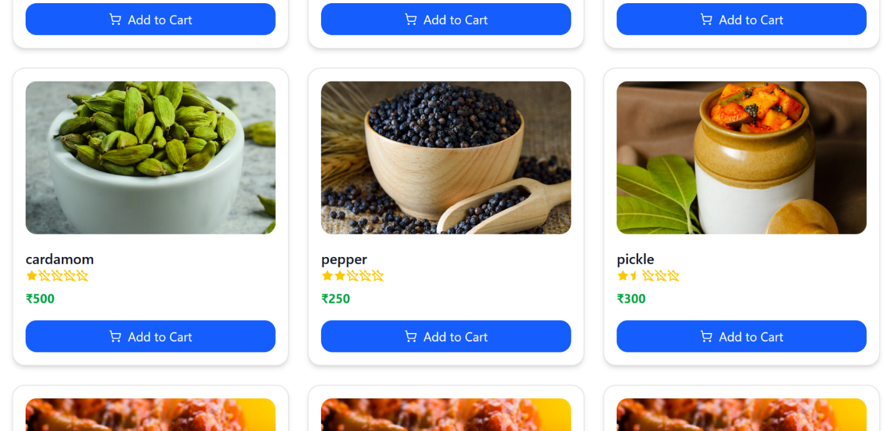 Figure 9.3: Products Display

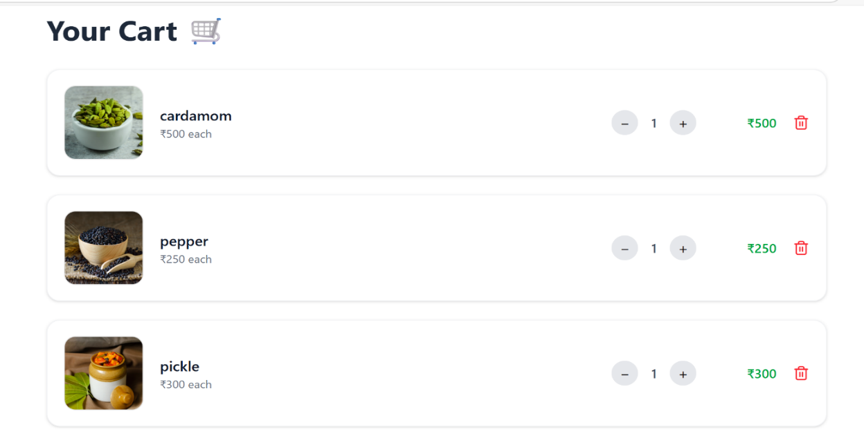Figure 9.4: Cart page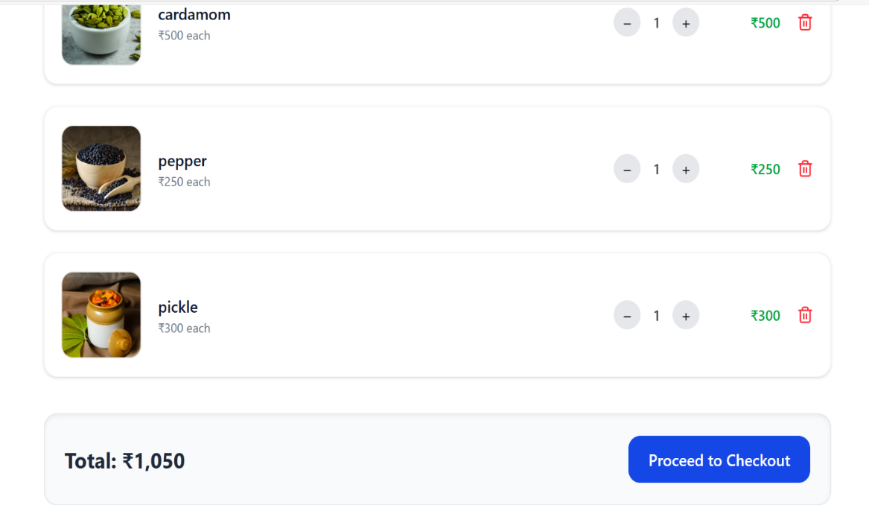Figure9.5: Cart Page

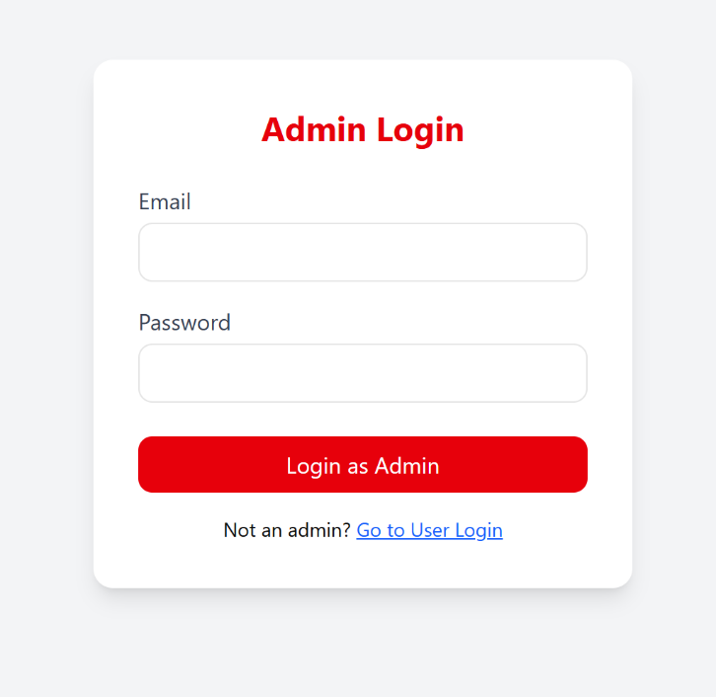
Figure 9.6: Admin Login

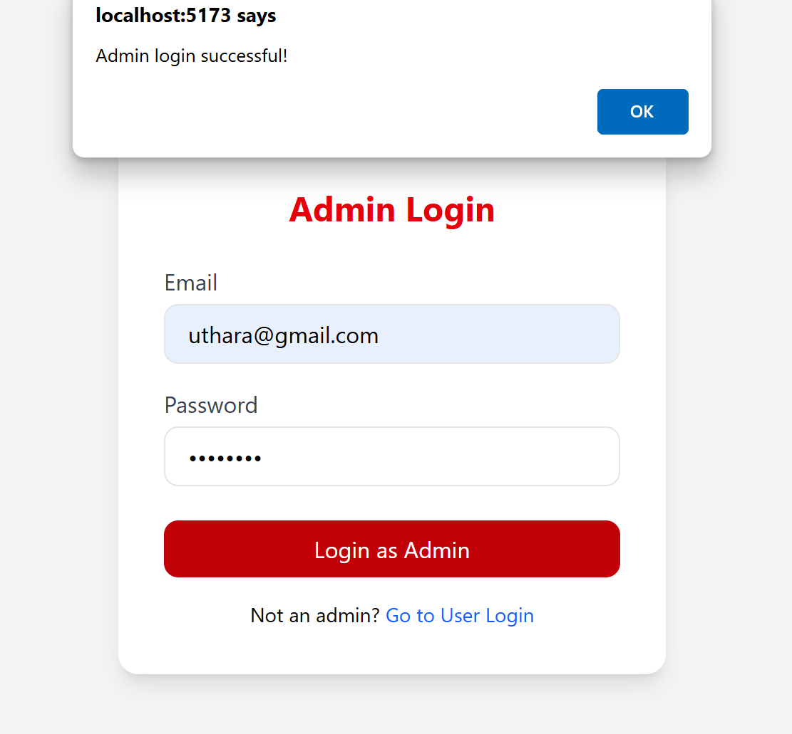
Figure 9.7: Admin Login Successful
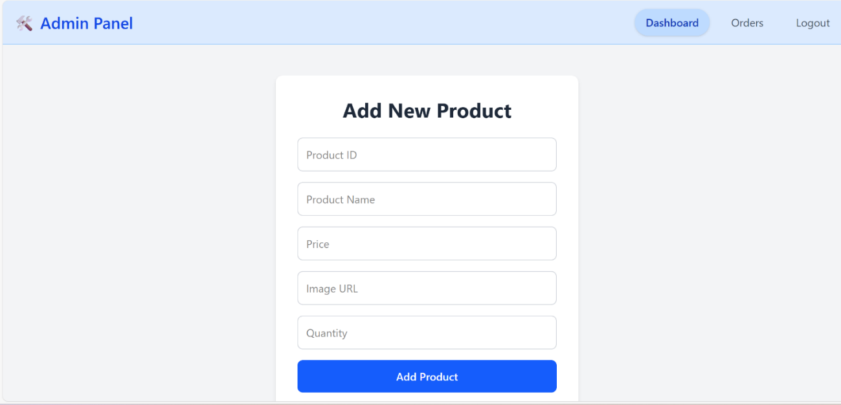
Figure9.8: Admin Dashboard
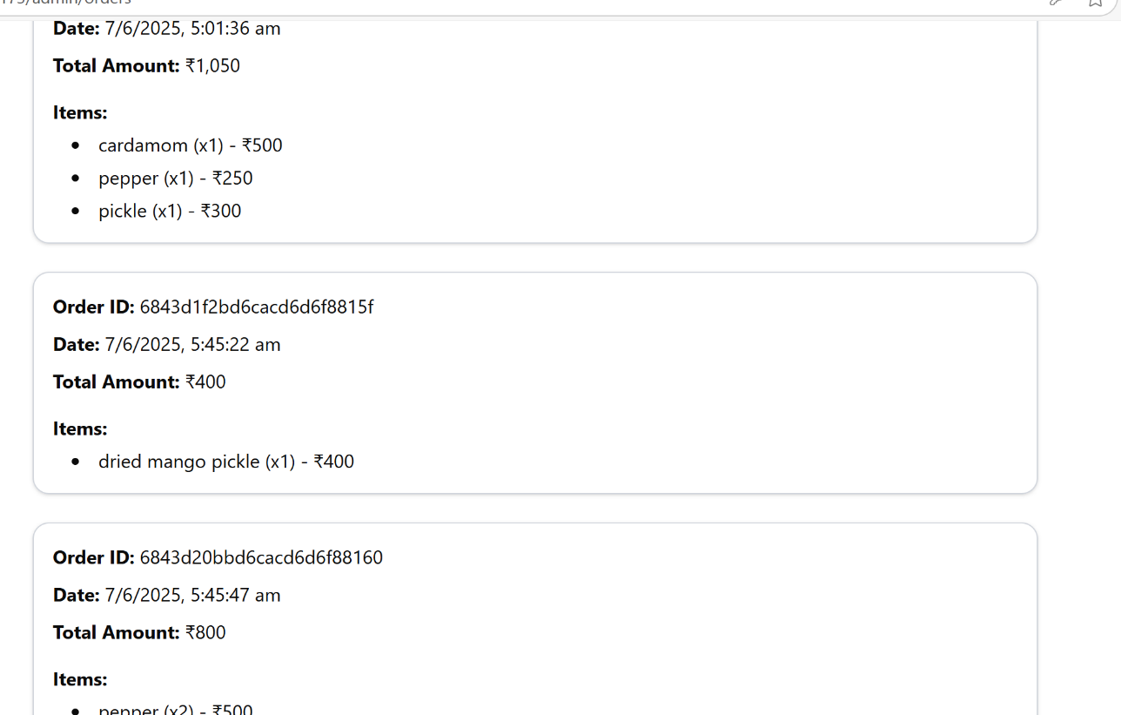
Figure 9.9: Order Summary

Bibliography
- Laudon, K. C., & Traver, C. G. (2021). E-commerce 2021: Business, Technology, Society. Pearson Education.
- Pressman, Roger S. Software Engineering: A Practitioner’s Approach. McGraw-Hill Education, 2014. Amman, Jordan mohammad.alauthman@uop.edu.jo
- Shklar, Leon, and Rich Rosen. Web Application Architecture: Principles, Protocols, and Practices. Wiley, 2009.
- Sommerville, Ian. Software Engineering. Pearson, 2015.
- https://developers.google.com/web/fundamentals
- MongoDB, Inc. (n.d.). MongoDB Documentation. Retrieved from: https://www.mongodb.com/docs
- ReactJS Documentation. (n.d.). Retrieved from: https://react.dev
- FastAPI Developers. (n.d.). FastAPI Documentation. Retrieved from: https://fastapi.tiangolo.com
- https://github.com/

