AN INVESTIGATION OF THE INSECT
DIVERSITY IN A HOUSEHOLD
ENVIRONMENT


Dissertation submitted to
MAHATMA GANDHI UNIVERSITY, KOTTAYAM
In partial fulfilment of the requirement for the degree of
BACHELOR OF SCIENCE IN ZOOLOGY

Submitted by
APSARA T A(210021037691)

Under the supervision of
Dr . Sonia john

Assistant Professor , Department of Zoology

BHARATA MATA COLLEGE, THRIKKAKARA
(Affiliated to Mahatma Gandhi University Accredited by NAAC with A+ Grade)
2021-2024

BHARATA MATA COLLEGE

THRIKKAKARA

2023-2024

Date:

CERTIFICATE
This is the certify that the project entitled
“AN INVESTIGATION OF THE
DIVERSITY IN A HOUSEHOLD
ENVIRONMENT’
work done by Apsara T.A
Register No:210021037691 during
2023-2024 in partial fulfillment of
the requirement for the award
of the Bachelor Degree of science in
Zoology of Mahatma Gandhi
University ,Kottayam

Head of the Department
Dr.Simi Joseph P

DECLARATION

I ,APSARA. T.A (210021037691) ,herwby declare that the dissertation that the disseration
work entitled “An INVESTIGATION OF THE INSECTS DIVERSITY IN A HOUSEHOLD
ENVIRONMENT” submitted for the award of a Bachelor Mata college ,Thrikkakara
is a partial fulfillment of the requirement This work was done by me during the period
from December 2023to February 2024 under the supervision and guidance of Dr.sonia john
Assistant professor (contract) Zoology Department I affirm that this thesis is original
and has not been submitted for any degree,fellowship,or similar qualification by any
other candidate to any university

Date:

Place:Thrikkakara

signature:

APSARA.T.A

ACKNOWLEDGEMENT
First and foremost I thank the almighty whose blessings have enabled in the sucessful
Accomplishment of this dissertation I take immense pleasure to express my profound
gratitude and sincere thanks to our inspiring guide and mentor Dr.sonia John , assistant
professor (contract) Bharata Mata college for her sustained enthusiasm,splendid suggestions , constant patience and exemplary supervision in the sucessful completion
of our dissertation it was her valuable discussions and endless efforts through which
I have gained a lot more information
I convey our gratitude to Dr.simi joseph p , Assistant .prof and Head ,Department of zoology ,Bharata Mata college , for being such an inspiring teachers ,role model and a
pillar of support throughout the completion of our heartfelt thanks for letting us explored
the world of life sciences .without her able guidance this work would not have been possible
I extend my sincere thanks to Dr.Johnson k.m ,principle ,Bharata Mata college for his constant support
I express my fathomless thanks to the entire staff of Department of zoology
Dr.sherin Antony ,Mr.Jithin Johnson for their kind co-operation in carring
out our work
I express my sincere thanks to all our lab assistant Ms . Siji for her esteemed
help and supervision throughout the course of project work ,I am also thankful to all
other non-teaching staff I also extend my sincere gratitude to the lab assistant at the
instrumentation room
I feel privileged to thank all our coolleagues who have been a strong support and a source
of inspiration for us during the toughest times
it would be inappropriate without thanking the biggest source of my strength
my parents and siblings for their moral support and providing us
the resources to finish my work

APSARA.T.A

AN INVESTIGATION OF THE INSECT DIVERSITY IN A HOUSEHOLD ENVIRONMENT

ABSTRACT
This study was conducted from January to March 2024 aimed to comprehensively analyze the diversity and ecological significance of insect species within a household environment. Meticulous observation during both daylight and nighttime hours was undertaken, resulting in the identification and documentation of 30 insect species. Collection methods employed included field surveys using insect nets and pointed blunt forceps, followed by preservation of the specimens in 70 percent alcohol. Species identification was ensured through the utilization of online tools such as Insect ID and Google Lens.The documented species represented various orders and families, each contributing uniquely to the household ecosystem. Noteworthy findings included the presence of Metalmark moths, which significantly impact plant health by consuming leaves, and the Fig borer and mango stem borer serving as vital food sources for predators and parasites. Additionally, Twin-flagged jumping spiders were observed contributing to insect population control, while Tussock moths were found to play a role in seed production.Furthermore, Yellow spotted millipedes and bagworms were identified for their crucial roles in decomposition and nutrient cycling, respectively, highlighting their ecological importance within the household ecosystem. Other species, such as May beetles and Black kneed, were recognized for their potential as indicators of forest ecosystem diversity and their contribution to nutrient cycling through interactions with their environment.This study offers valuable insights into the intricate interactions between insect species and their environment within household settings.
INTRODUCTION
The diversity of animals and insects is a marvel of nature, spanning an incredible array of species, forms, and functions. From the vastness of the oceans to the highest peaks, and even in our own backyards, these creatures inhabit nearly every corner of the Earth. They come in myriad shapes, sizes, colors, and behaviors, each uniquely adapted to its environment and ecological niche. The sheer diversity of animals and insects is staggering, with estimates of millions of species worldwide, many of which remain undiscovered or poorly understood. This diversity is not only captivating but also fundamental to the health and stability of ecosystems, playing crucial roles in nutrient cycling, pollination, pest control, and countless other ecological processes. In this exploration of animal and insect diversity, we will delve into the various categories of organisms, from the microscopic to the gargantuan, and examine their adaptations, behaviors, and ecological significance. We will marvel at the intricacies of their biology, from the smallest insects to the largest mammals, and ponder the interconnectedness of life on Earth.
Biodiversity, encompassing the richness of life forms and ecosystems on Earth, is fundamental to the health of our planet and the well-being of humanity. It includes the multitude of species, from microorganisms to mammals, and the variety of habitats they inhabit, such as forests, oceans, and grasslands.Essentially, biodiversity serves as the foundation of ecosystems, providing essential services like pollination, nutrient cycling, and climate regulation, which are vital for human survival. Moreover, it is deeply intertwined with cultural diversity, shaping traditions and livelihoods of indigenous peoples and local communities worldwide.However, human activities such as deforestation, overfishing, pollution, and climate change are accelerating the loss of biodiversity at an alarming rate. This poses significant threats to ecosystem stability, food security, and human well-being.To address this crisis, urgent action is needed to conserve and restore biodiversity. This requires implementing sustainable practices, protecting natural habitats, and fostering international collaboration to ensure the preservation of biodiversity for future generations. By recognizing the value of biodiversity and taking collective action, we can safeguard the intricate web of life that sustains us all.
Biodiversity offers a wide array of values and uses that are crucial for human well-being and the health of our planet. These include:
Medicinal Resources : Biodiversity provides a rich source of medicinal compounds derived from plants, animals, and microorganisms, forming the basis of pharmaceutical drugs that treat various illnesses.
Food Security and Nutrition : Diverse species contribute to global food security by offering a range of crops, livestock, and marine resources, ensuring nutritional diversity and sustainable food production.
Ecosystem Services : Biodiversity supports essential ecosystem services such as pollination, soil fertility, water purification, and climate regulation, which are vital for agriculture, water management, and climate resilience.
Cultural Heritage : Biodiversity is deeply intertwined with the cultural heritage of communities worldwide, shaping traditions, languages, and spiritual beliefs, and providing livelihoods for indigenous peoples.
Economic Value : Biodiversity drives economic development through industries like agriculture, fisheries, pharmaceuticals, and ecotourism, contributing to employment and revenue generation.
Climate Change Mitigation : Biodiversity plays a crucial role in mitigating climate change by storing carbon, regulating the water cycle, and influencing weather patterns, thereby enhancing ecosystem resilience.
Aesthetic and Recreational Value : Biodiversity enriches human life by providing aesthetic enjoyment and recreational opportunities, promoting mental and physical well-being through access to green spaces and natural landscapes.
Recognizing and conserving the diverse values and uses of biodiversity is essential for ensuring a sustainable future for generations to come.
Since the inception of settled human communities, there have coexisted various organisms in close proximity to us. Dwellers of our living spaces range from large vertebrates like pets and livestock to microorganisms, encompassing a broad spectrum of life forms (Martin et al., 2015). Arthropods constitute the most diverse and abundant category of multicellular life encountered within households, as well as globally on Earth. Insects, spiders, and related organisms have coevolved with humans throughout our existence. It has been postulated that numerous arthropod species currently associated with human residences were originally inhabitants of caves (e.g., bed bugs: Cimicidae) (Balvín et al., 2012). Discoveries of arthropod vectors in caves previously occupied by ancient societies around 26,000 years ago indicate the cohabitation of vexatious arthropods, such as blood-sucking kissing bugs (Reduviidae: Triatominae), alongside our forebears (Araújo et al., 2009). Among the earliest instances of cave art is a depiction of a camel cricket (Rhaphidophoridae) (Chopard, 1928; Belles, 1997). As human civilization evolved over time, arthropods adeptly—and swiftly—exploited our bodies and resources for sustenance and refuge. The advent of constructed dwellings, animal domestication, agriculture, and the practice of food preservation (e.g., grains) introduced diverse arthropod species into human habitats and daily routines. Arthropods are prevalent fauna in domestic archaeological sites across regions such as Egypt (dating back to 1353 B.C.E), Israel, and various parts of Europe (Switzerland, Greenland, and the UK) (Nielsen, Mahler & Rasmussen, 2000; Panagiotakopulu, 2001; Panagiotakopulu, 2003; Kislev, Hartmann & Galili, 2004; Panagiotakopulu, 2004; Kenward & Carrott, 2006), with certain species being indicative of stored food supplies and livestock, while others mirror the local wildlife.
In the present study, an attempt was made to document the different types of insect species seen in an around the household.

AIM AND OBJECTIVES
AIM
To analyse the different insect species seen in my household
OBJECTIVES
- To identify the insect species seen in my household
- To document the list of species seen in the household.

REVIEW OF LITERATURE
Biodiversity encompasses the full range of living organisms, encompassing plants, animals, and micro-organisms inhabiting terrestrial, aquatic, and marine environments. The quantification of biodiversity is commonly based on the variety of biological species present, reflecting species as the fundamental unit of biological diversity. Species are ubiquitous components of landscapes, with forest ecosystems typically exhibiting a greater species richness compared to farmlands, semi-urban, and urban areas. The distribution of species varies across different ecosystems and ecological zones, creating a mosaic of domesticated crops, farm animals, and wild species within landscapes. Biological organisms serve as vital natural resources with diverse applications such as food, medicine, shelter, and recreational or aesthetic purposes, supporting the livelihoods of many rural populations. The intrinsic value of biodiversity in terms of culture, aesthetics, and recreation transcends monetary considerations, highlighting the crucial role of biodiversity knowledge in ensuring future survival. Numerous plants and animals in our surroundings play essential roles in maintaining nutrient cycles, hydrological processes, and providing ecosystem services crucial for sustaining food chains. Despite their significance, there is often an unawareness or disregard for the contributions of these organisms to ecosystem functioning, underscoring the importance of recognizing and valuing all biological species equally. Particularly noteworthy is the necessity to understand the biological resources in our proximity, given the increasing instances of biopiracy occurring worldwide.
Insects, spiders, and their relatives have coexisted and undergone evolutionary changes alongside humans throughout our history. Some researchers have suggested that many arthropod species currently found in human dwellings originally inhabited caves, like bed bugs from the family Cimicidae as discussed by Balvín et al. (2012). Evidence of arthropod vectors present in caves inhabited by ancient humans approximately 26,000 years ago indicates that troublesome arthropods, such as blood-feeding kissing bugs (Reduviidae: Triatominae), coexisted with our ancestors, as noted by Araújo et al. (2009). Notably, one of the earliest instances of cave art depicts a camel cricket (Rhaphidophoridae), highlighting the historical interaction between arthropods and humans, as described by Chopard (1928) and Belles (1997).
As human societies evolved, arthropods quickly adapted to utilize human bodies and resources for sustenance and shelter. The development of permanent structures, animal domestication, agriculture, and food storage practices introduced various arthropod species into human habitats. Arthropods are frequently found in domestic archaeological sites across different regions, including Egypt (dating back to 1353 B.C.E), Israel, and various European countries like Switzerland, Greenland, and the UK, showcasing species associated with stored food and livestock, as well as local fauna, according to Nielsen, Mahler & Rasmussen (2000), Panagiotakopulu (2001, 2003, 2004), Kislev, Hartmann & Galili (2004), and Kenward & Carrott (2006).
In contrast to the primitive shelters of early humans, modern western homes are often perceived as environments largely devoid of animal life. However, arthropods thrive in domestic settings, evident by the substantial pest control industry today. Contemporary houses harbor many of the same pest groups found in archaeological sites, but the arthropod communities also reflect societal advancements. For instance, indoor plumbing has reduced the presence of dung beetles indoors, while drain-dwelling moth flies are likely more common. Additionally, globalization through travel and trade has facilitated the worldwide distribution of arthropod species closely associated with humans and their habitats, like the house fly, German cockroach, and fruit fly, as discussed by Legner & McCoy (1966), Keller (2007), Roth (1985), and Booth et al. (2010). The impact of human society and changing living spaces on the evolution of specific arthropod lineages is evident.
Research on indoor arthropod communities has predominantly focused on pest species, particularly those of medical and economic significance such as cockroaches, termites, bed bugs, fleas, and mosquitoes, as highlighted by Committee on Urban Pest Management et al. (1980) and Robinson (2005). Conversely, little is known about the multitude of other arthropod species that coexist with humans, many of which are inconspicuous and understudied. The true nature of interactions between these lesser-known species and humans, whether beneficial, neutral, or harmful, remains largely unexplored, including their prevalence and distribution. Surprisingly, a comprehensive examination of arthropod diversity in contemporary human residences has never been undertaken.
Insects, which are the most diverse invertebrate fauna of the class Insecta belonging to the phylum Arthropoda, are widely distributed across all ecological niches on Earth, exhibiting dominance in water, land, and air alike. Numerous publications provide insights into the diversity of insects in India; for instance, Maxwell and Howlett (1909) reported 25,700 species, while Ghosh (1996) documented 51,011 species from the region. The global scenario is equally impressive, with approximately 0.9 million insect species described worldwide, and in India alone, 59,353 species across 619 families have been identified (Varshney 1998). Insects, representing 29 orders of the class Insecta, play a crucial role in maintaining ecological balance. Many of these insects are beneficial to humans, such as honey bees, lac insects, and silk-producing insects, which support small-scale agro-industries. They serve as pollinators, predators, or parasites, while others, like certain larvae or adult insects, pose significant threats to households, agricultural crops, public health, and domestic animals. Household pests can cause various troubles, including acting as carriers of diseases, damaging buildings and furniture, or feeding on blood. Some insect pests may not cause direct harm but are considered nuisances due to their mere presence at home (Henderson 1952).
Numerous studies have been undertaken to explore the diversity of insects within households. Researchers have delved into the insect fauna found in household biocomposts, as evidenced by the work of Sagade and Pajewar (2010). Furthermore, Khan et al. (2013) conducted an analysis of insect species present in various households in Karjat City, Maharashtra, shedding light on the insect diversity within residential settings. These studies contribute valuable insights into the intricate relationships between insects and human habitats, highlighting the importance of understanding and managing insect populations for both ecological balance and human well-being.
In the present study, an investigation was carried out to identify and document various insect species seen in an around my household.

MATERIALS AND METHODS
For the present study, I keenly looked around my household premises both during day and night time during the months of January to March, 2024. The insects were collected using insect net and pointed blunt forceps. Collected insects were preserved in 70 percent alcohol. The preserved insects were further identified and classified by using online identification Tools are namely insect ID and Google lens.
Further, documentation of the identified insects was carried out.

RESULTS
A number of 26 Insect species was found during my period of observation.
Sl.No | Insect-Common Name | Scientific Name | Family | Order | Ecological Significance
1 | Metalmark moths | choreutidae | Choreutidae (insects) | lepidoptera | A great impact on plants by eating their leaves
2 | Fig borer and mango stem borer | Batocera  rufomaculata | cerambycidae | coleoptera | It serves as a food sources for predators and parasites
3 | Twin-flagged jumping spider | Anasaitis canosus | salticidae | araneae | Helping to control insects populations in their habitats
4 | Tussock moth | Nygmiini | erebidae | lepidoptera | Helping in the seed production
5 | bagworms | Taleporia | psychidae | lepidoptera | They play a major in nutrients cycling by breaking down orangic matter
6 | May beetles | phyllophaga | scarabaeidae | coleoptera | Indicators of forests ecosystem diversity
7 | Black kneed | Conocephalus melaenus | tettigoniidae | orthoptera | Nutrients cycling through their interactions with other organisms and their environment
8 | Ivory marked borer | Eburia quadrigeminata | cerambycidae | coleoptera | They are small and most active in summer season they are flying around hot days
9 | Larger pygmy mole | Tridactylidae brulle | Tridactylidae | orthoptera | Maintaining the health and balance of the ecosystem
10 | Long horned beetle | pterolophia | cerambycidae | coleoptera | Nutrient recycling pollination
11 | Eggplant fruit or brinjal fruitfly | leucinodes | crambidae | lepidoptera | The role is herbivores to the plant populations and ecosystem on their feeding habitats
12 | Daddy long legs spider | Pholcus phalangioides | pholcidae | araneae | Control insects populations
13 | Two –striped jumping spider | Telamonia dimidiata | salticidae | araneae | Balance of various ecosystem by feeding of insects
14 | Carpenter ant | camponotus | Formicidae | Hymenoptera | Play a major role in decomposers and ecosystem engineers
15 | Red palm weevil | Rhynchophorus ferrugineus | curculionidae | coleoptera | The most damaging insects pest of palms
16 | housefly | Musca domestica | muscidae | diptera | Breaking down and recycling organic matter
17 | Thin legged wolf spider | paradosa | Lycosidae | araneae | Reduce the number insects pests in farm fileld
18 | Oak bush-cricket | Meconema thalassinum | tettigoniidae | orthoptera | Help nutrient cycling by breaking down organic matter
19 | Ghost spider | Anyphaena | anyphaenidae | araneae | Feeding on small insects and control populations
20 | Wasp with nest stock | vespidae | Vespidae latreille | hymenoptera | Role in ecosystems as pollinators and pest controllers and feeding other animals also
21 | Pupa butterfly | chrysalis | nymphalidae | lepidoptera | Maintaining biodiversity and ecosystem balance
22 | Green crabspider | Olios milleti | sparassidae | araneae | Its helps control populations and food sources for various predators and overall food web
23 | Flower chafer beetle | Protaetia aurichalcea | scarabaeidae | coleoptera | They feed on flower nectar and pollen and contributes to health and balance to the ecosystem
24 | cockroach | Blattodea | blattidae | blattodea | Role of decomposers and breaking down organic matter in environments
25 | Small zebra jumper | Plexippus petersi | salticidae | araneae | Control insects populations and maintaining balance ecosystem and riching the fod web
26 | Wolf spider | Lycosidae | lycosidae | araneida | Control populations and prey for various birds reptiles and other predators and overall biodiversity of habitats
2

BIBLIOGRAPHY
- Balvín, O., Munclinger, P., Kratochvíl, L., & Vilímová, J. (2012). Mitochondrial DNA and morphology show independent evolutionary histories of bedbug Cimex lectularius (Heteroptera: Cimicidae) on bats and humans. *Parasitology Research, 111*(6), 457-469.

- Araújo, A., Ferreira, L. F., & Guidon, N. (2009). *Revisiting the evidence of arthropods in paleoamerican archaeological contexts.* Springer.

- Chopard, L. (1928). Les orthoptères cavernicoles. *Annales de Spéléologie, 6*, 60-86.

- Belles, X. (1997). Insect morphology and phylogeny. *Trends in Ecology & Evolution, 12*(9), 364-369.

- Nielsen, E. T., Mahler, V. A., & Rasmussen, F. N. (2000). *The Greenland mummies.* Smithsonian Institution Press.

- Panagiotakopulu, E. (2001). *Archaeology and entomology of the Egyptian Fayum.* Peeters Publishers.

- Panagiotakopulu, E. (2003). *New archaeoentomological data from Amarna, Egypt.* British Museum Press.

- Panagiotakopulu, E. (2004). *Insect fauna from the Amarna and Petrie excavations.* British Museum Press.

- Kislev, M. E., Hartmann, A., & Galili, E. (2004). *Archaeobotanical and archaeoentomological evidence from a well at Atlit-Yam indicates colder, more humid climate on the Israeli coast during the PPNC period.* Archaeozoology of the Near East, 7, 189-209.

- Kenward, H. K., & Carrott, J. (2006). *England’s medieval navy, 1066-1509: Ships, men and warfare.* Seaforth Publishing.

- Legner, E. F., & McCoy, C. W. (1966). *Flies associated with humans: A review of medical entomology records.* University of California, Division of Agricultural Sciences.

- Keller, J. C. (2007). *The colonization of the Pacific islands by the Polynesian rat: The archaeological and zoological evidence.* University of Hawaii Press.

- Roth, L. M. (1985). Arthropod infestations of man and his animals. *Bulletin of the Entomological Society of America, 31*(2), 38-44.

- Committee on Urban Pest Management, & National Research Council. (1980). *Urban pest management: An environmental perspective.* National Academies Press.

- Robinson, W. H. (2005). *Urban insects and arachnids: A handbook of urban entomology.* Cambridge University Press.

- Henderson, C. F. (1952). *Handbook of experimental pharmacology.* Springer Science & Business Media.

- Sagade, J., & Pajewar, S. (2010). *Ecology and diversity of insects of biocompost produced at various household levels.* Discovery Publishing House.

- Khan, S. H., Ansari, N. A., Ahmed, S., & Siddique, A. (2013). *Study on Insect Fauna Associated with Human Dwellings of Karjat City, Maharashtra, India.* International Journal of Advanced Biological Research, 3(1), 128-133.

- Maxwell, J. C., & Howlett, B. G. (1909). *Indian Insect Life: A Manual of the Insects of the Plains (Tropical India) (Vol. 1).* Thacker, Spink & Company.

- Ghosh, S. K. (1996). Insecta: Hexapoda. *State Fauna Series, Zoological Survey of India, Kolkata, 7*(5), 401-538.

- Varshney, R. K. (1998). *Insecta: Lepidoptera.* Zoological Survey of India, Kolkata.

IMAGES
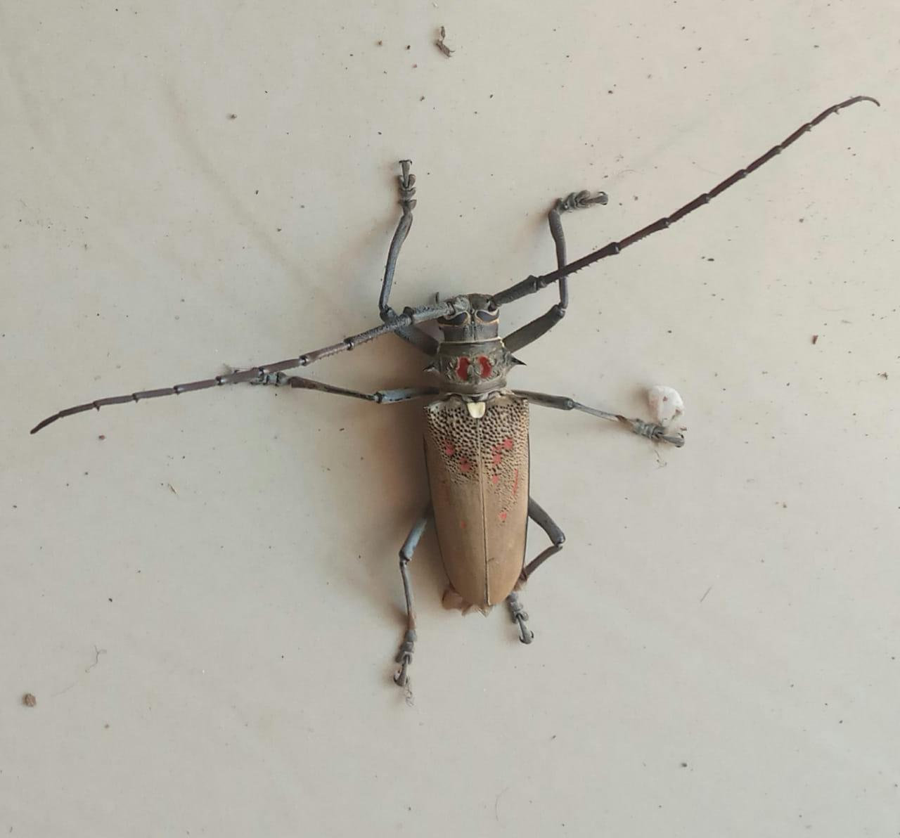
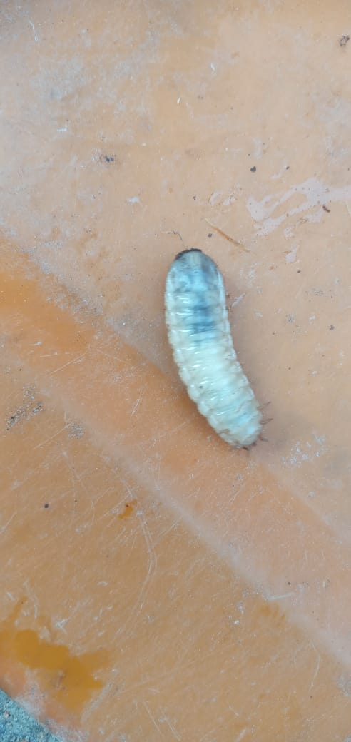
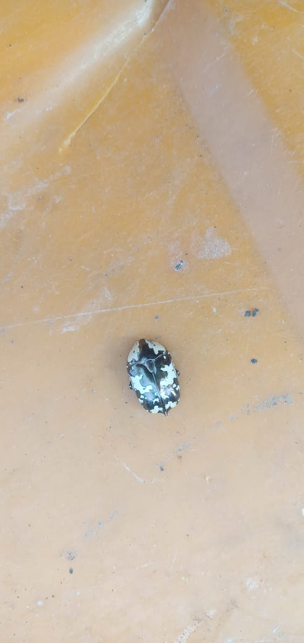

(1) FLOWER CHATER (2) PUPA (3) MANGO STEM BORER
BEETLE

(4) BLACK KNEED (5)YELLOW SPOTTED (6) RUSTY MILLIPEDE
MILLIPEDE
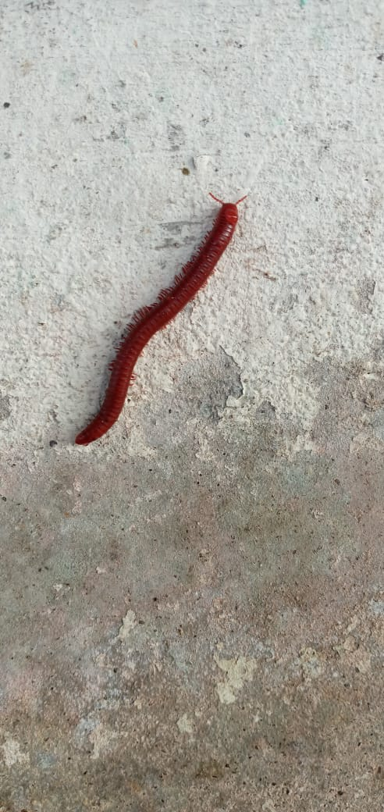
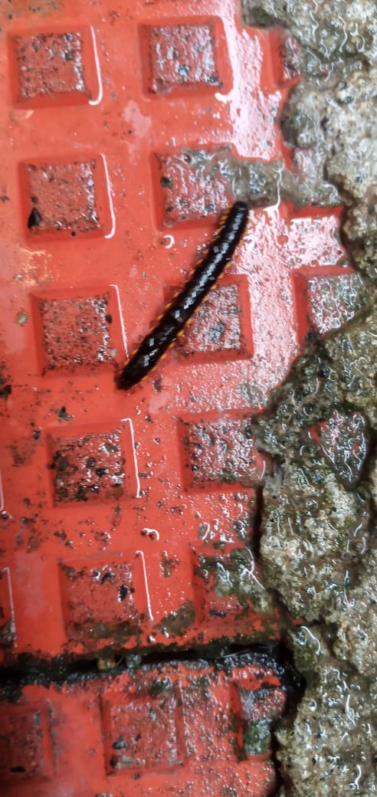
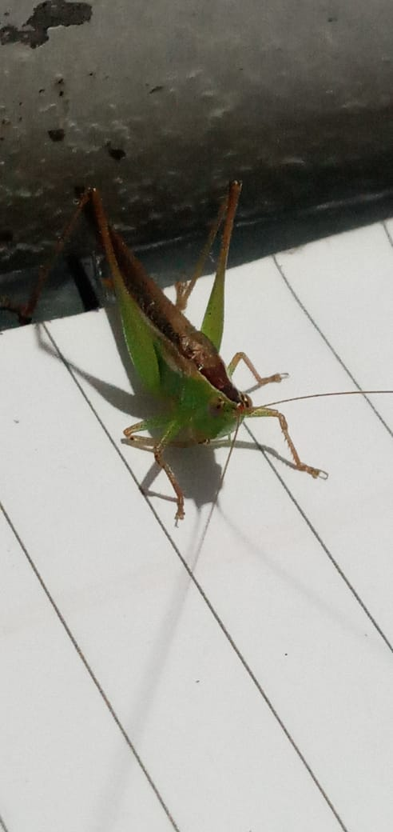

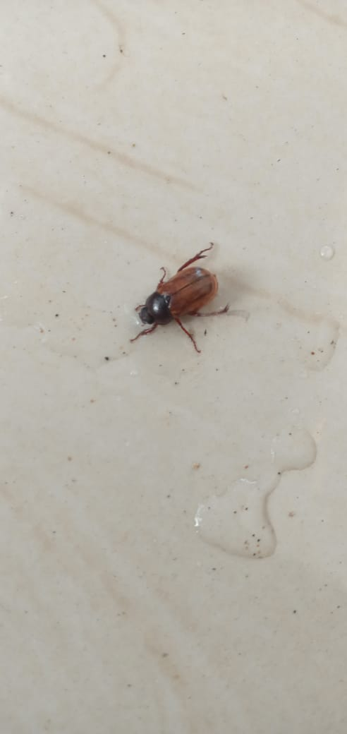
(7) MAY BEETLES

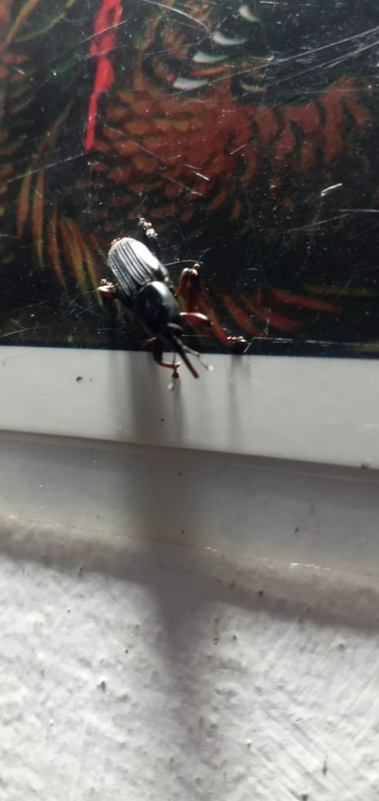
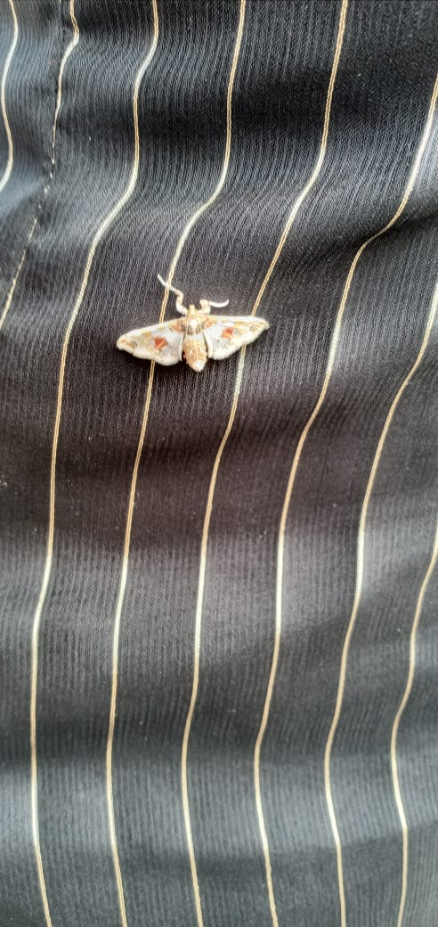


(8) EGG PLANT FRUIT (9)RED PALM WEEVIL (10)BRAHMINY BLIND
SNAKE

(11)CARPENTER ANT (12)SMALL ZEBRA JUMPER
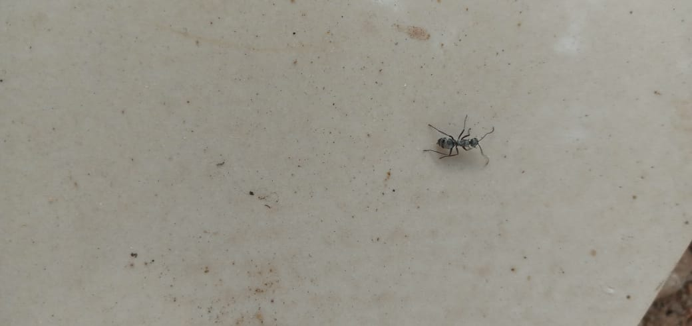
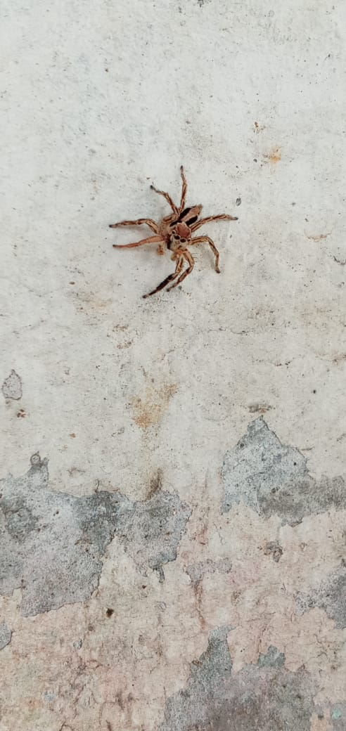

(14)BLACK FILED CRICKET
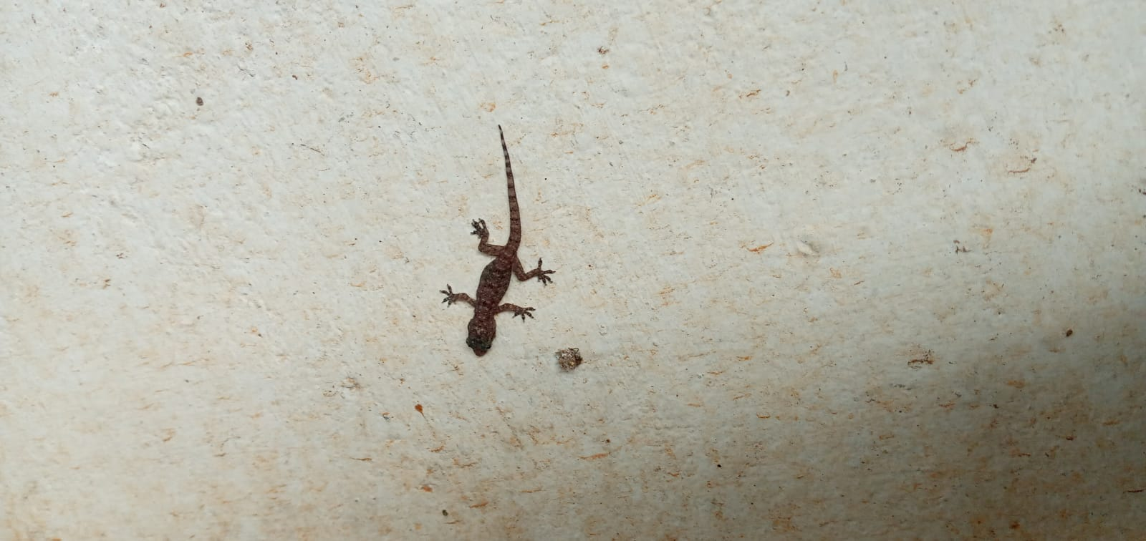
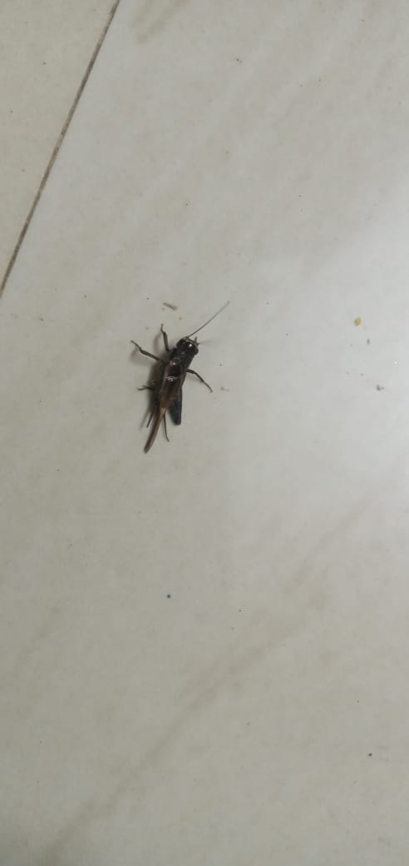
(13) HOUSE GECKOS

(15)DADDY LONG LEGS SPIDER
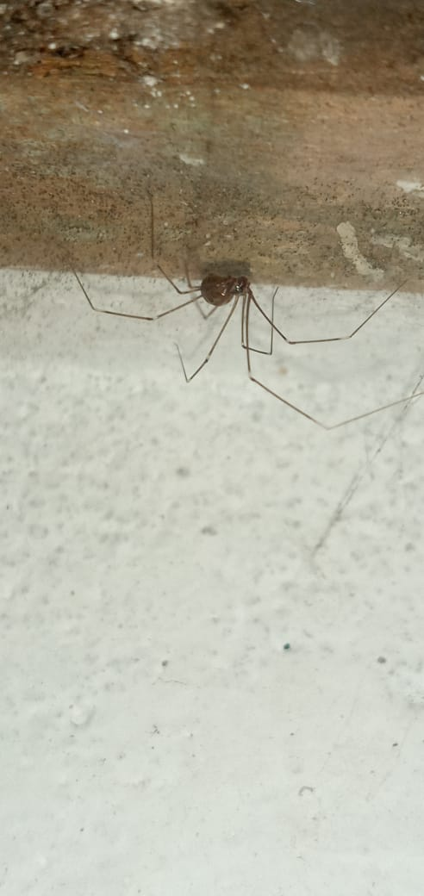
(16)WOLF SPIDER



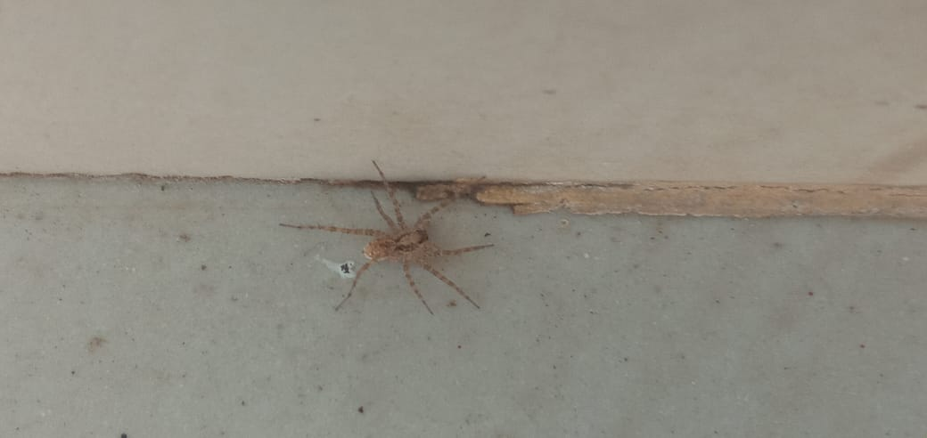
(17) GHOST SPIDER

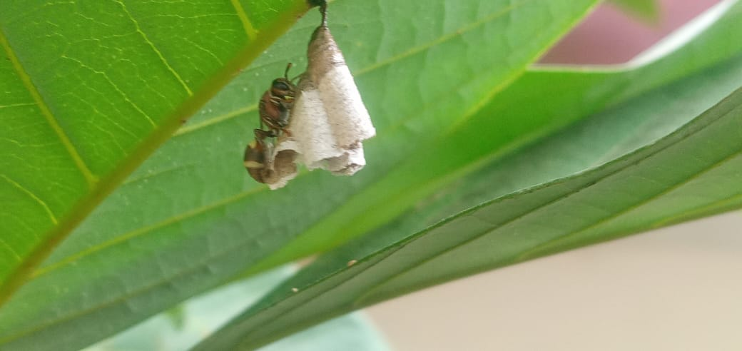
(18)WASH WITH NEST STOCK (19) HOUSEFLY
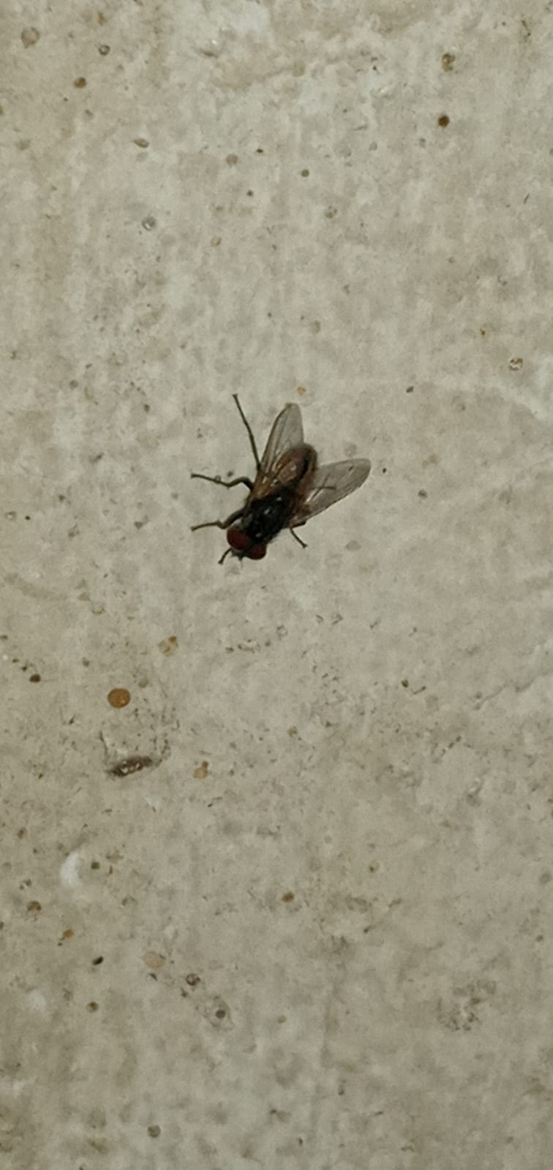

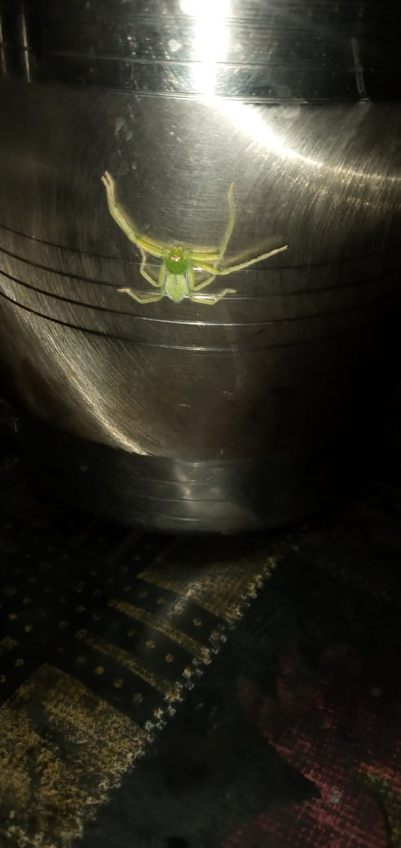
(20)GREEN CRABSPIDER (21)OAK BUSH
CRICKET

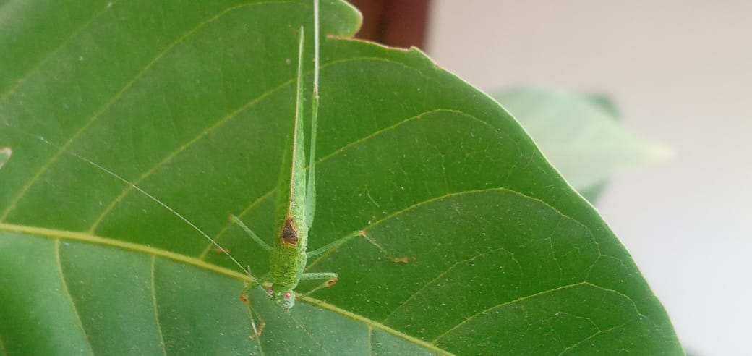

(22)METALMARK MOTHS
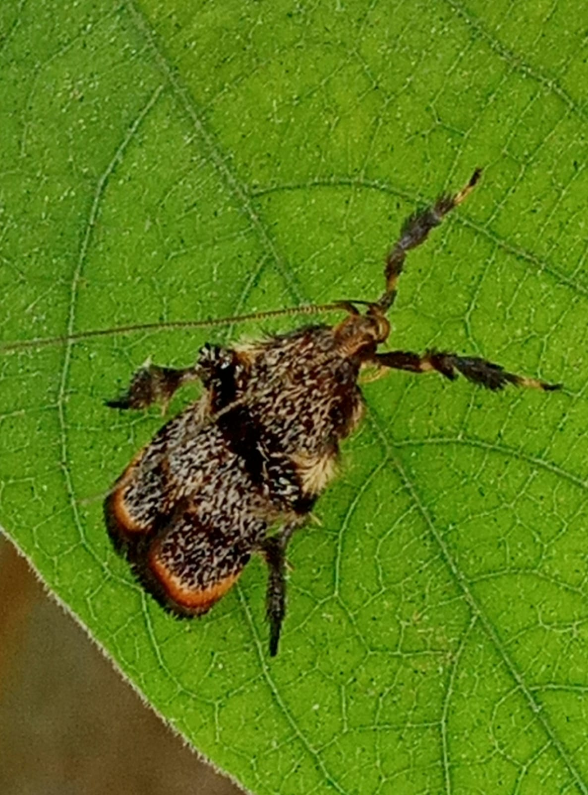

(23)COCKROACH

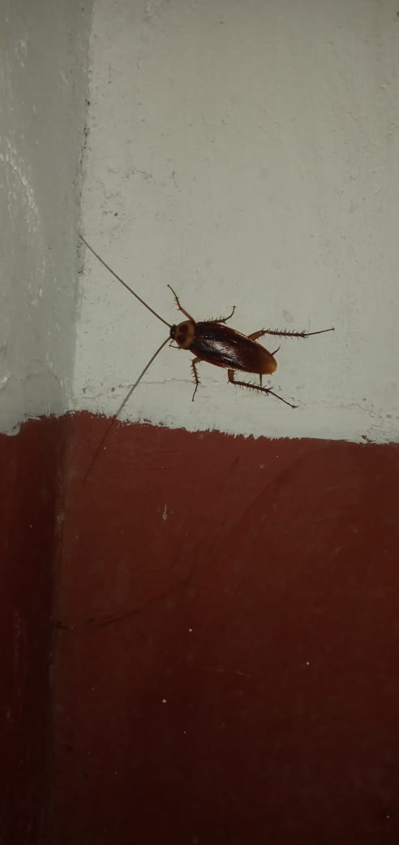

(24)TWIN FLAGGED JUMPING
SPIDER

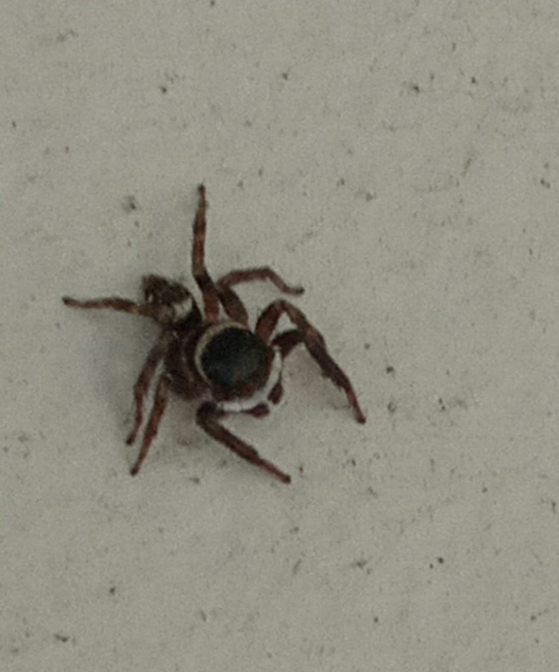
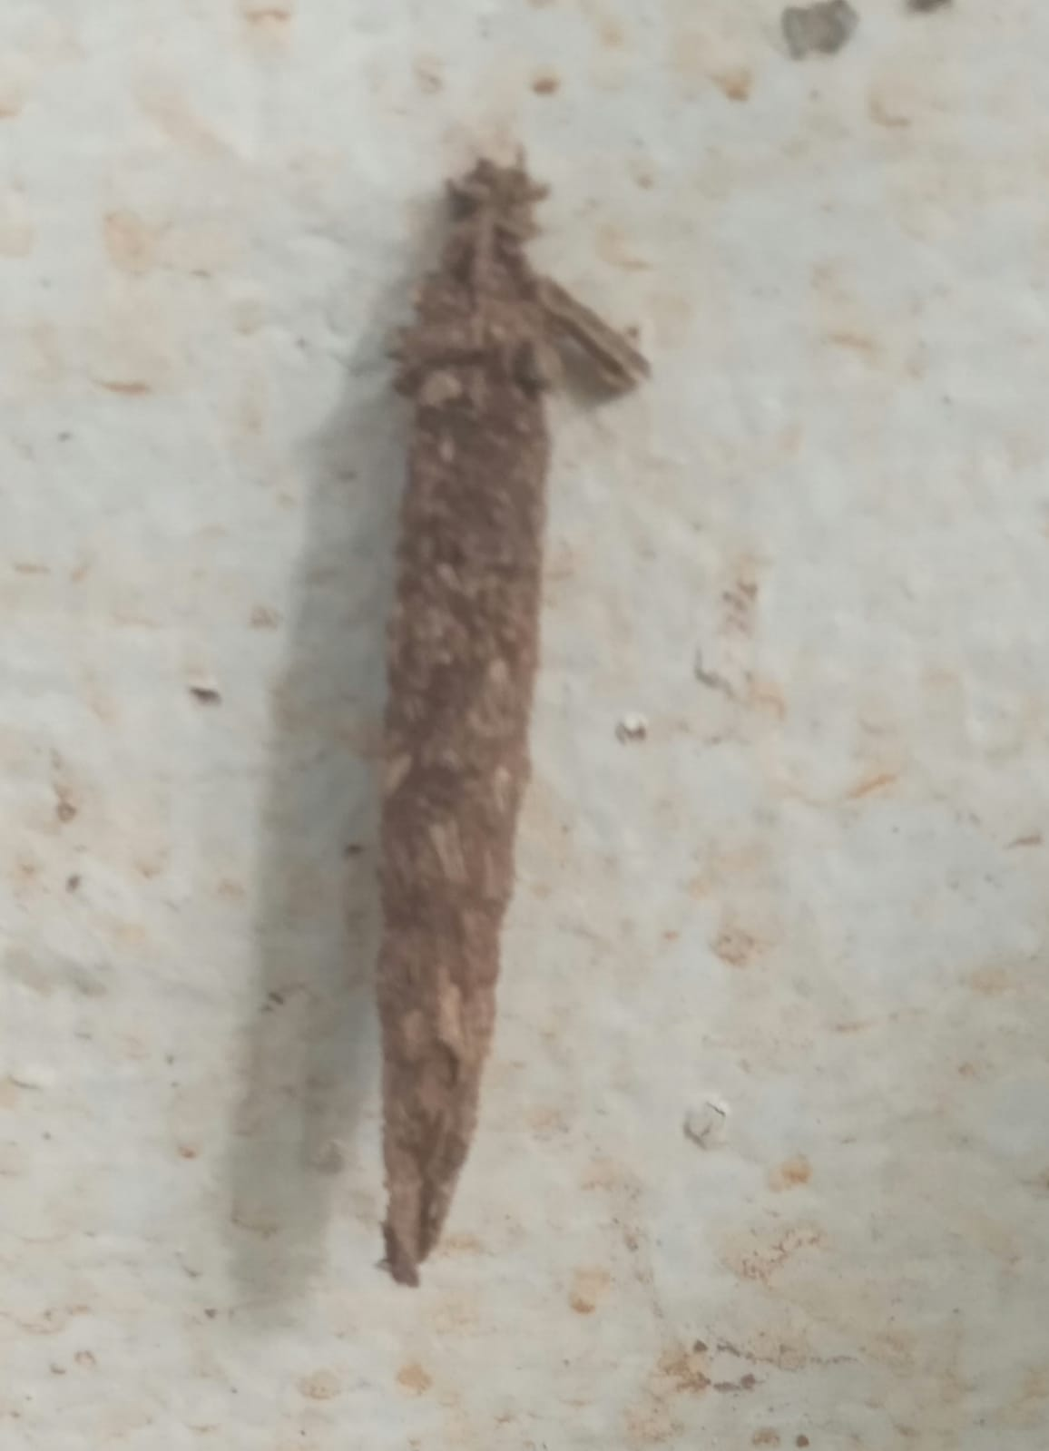
(25)BAG WORMS

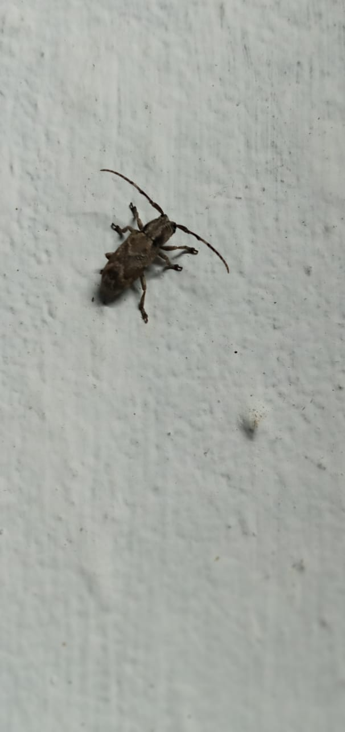
(26) LONG HORNED BEETLE

(27) LARGER PYGMY MOLE GRASSHOPPER
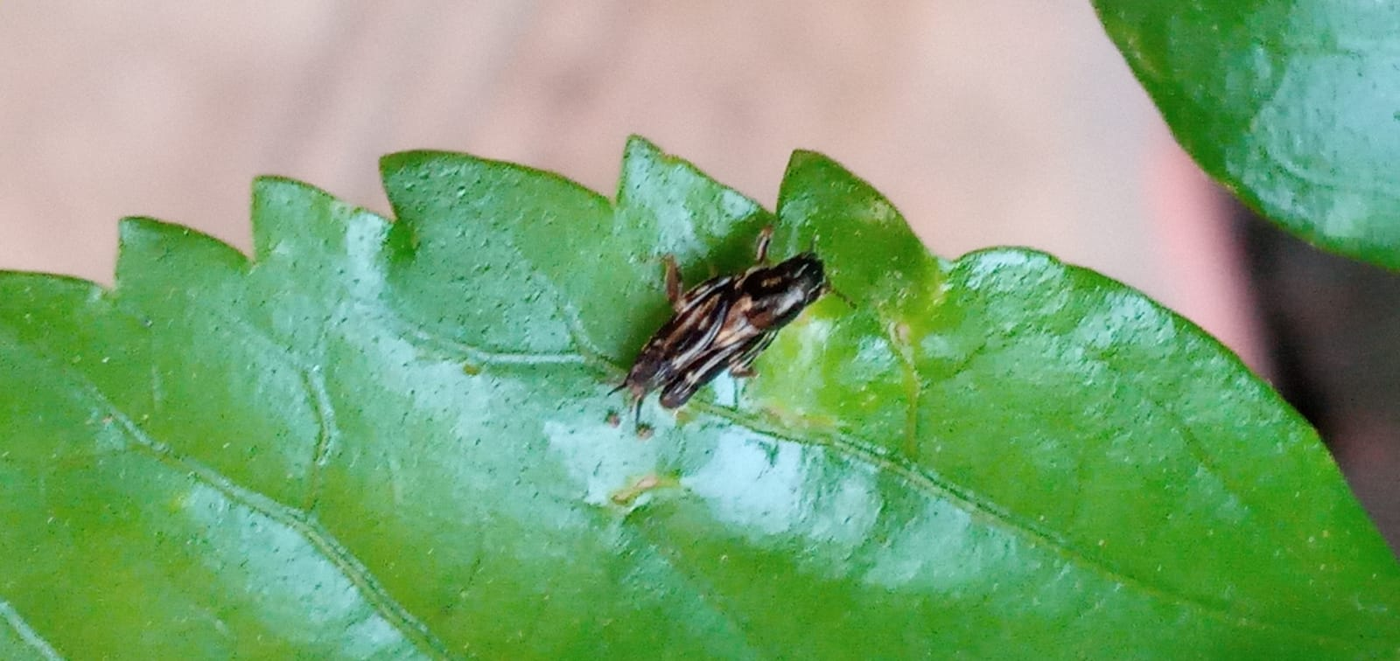

(28)TWO STRIPED JUMPING
SPIDER (29) TUSSOCK MOTH (30) IVORY MARKED
BORER
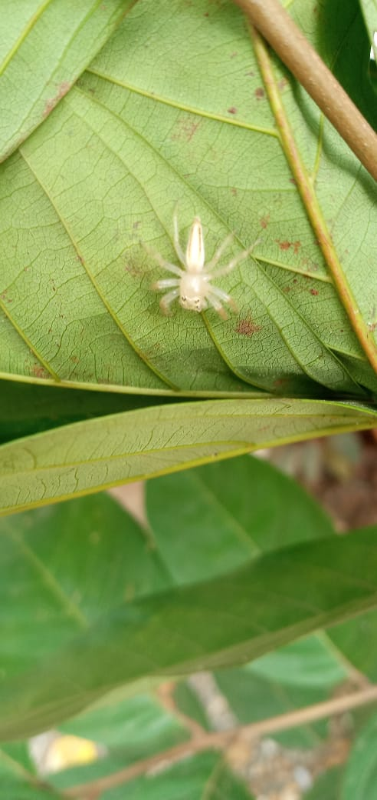
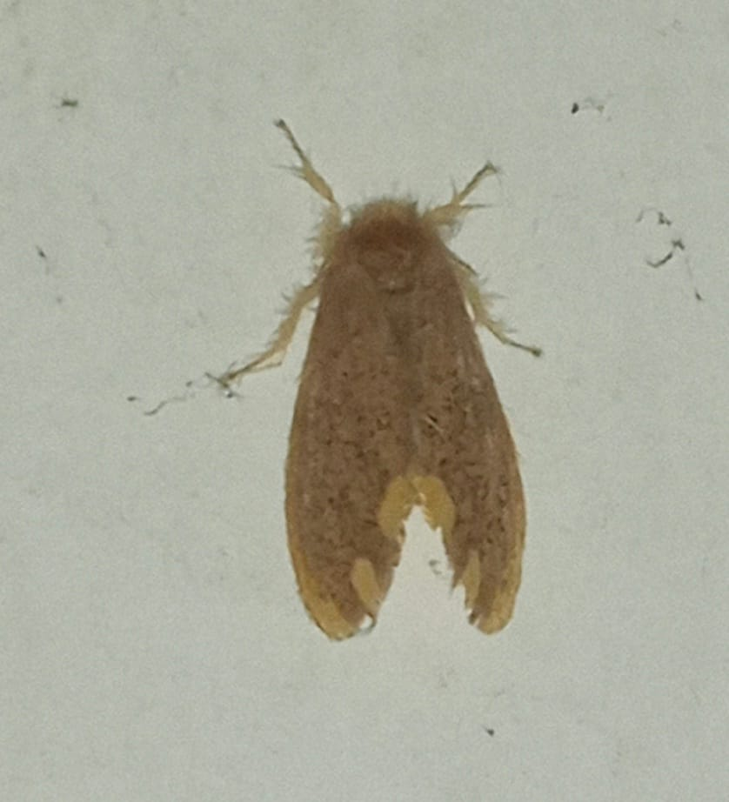
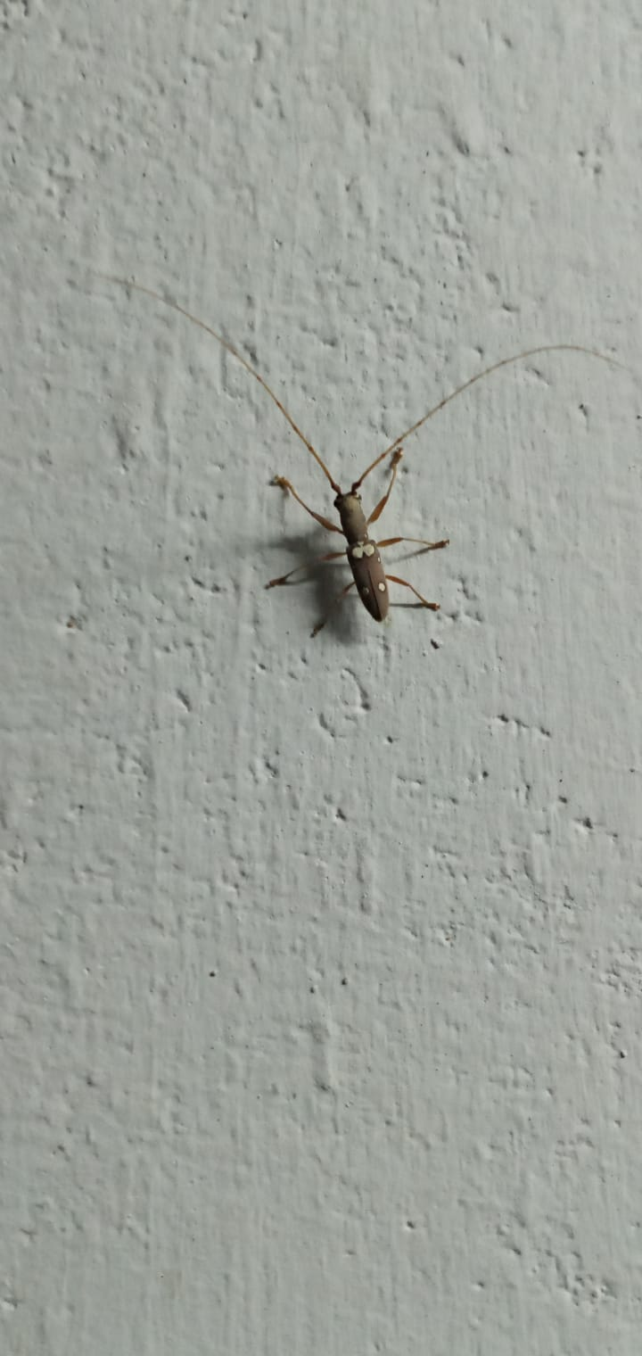

DISCUSSION
Numerous arthropods and various types of insects inhabit and reproduce in disrupted and man-made settings. This phenomenon is notably conspicuous in urban regions. The scarcity of pertinent ecological research can be primarily ascribed to our lack of knowledge in this field. The urban landscape is a direct consequence of human actions, where human activities have left a significant mark on the natural environment. In the past, urban development typically followed extensive clearing of indigenous vegetation, often after a phase of agricultural use. The remaining plant life underwent substantial changes due to the introduction of new plant species. Likewise, urbanization has significantly altered non-living elements of the environment, particularly in large metropolitan areas. Concerning insects, the process of urbanization has created numerous new habitats and transformed existing ones, providing a unique ecological niche for these organisms (Frankie & Ehler, 1978).
Arthropods are common and move around a lot, thus they can be useful microbiota agents. However, they also form a rich indoor community of their own, with many species having functional implications for homes, people, or pets (Förster et al.,2007). The present study also reported around 25 insect species thriving in a single household environment. Among these, few of the species are household pests while some of them are biological control agents that can help reduce the pest infestation in households. Each of the species reported in the study have a role to play in their ecosystem. Noteworthy findings included the presence of Metalmark moths, which significantly impact plant health by consuming leaves, and the Fig borer and mango stem borer serving as vital food sources for predators and parasites. Additionally, Twin-flagged jumping spiders were observed contributing to insect population control, while Tussock moths were found to play a role in seed production. Furthermore, Yellow spotted millipedes and bagworms were identified for their crucial roles in decomposition and nutrient cycling, respectively, highlighting their ecological importance within the household ecosystem. Other species, such as May beetles and Black kneed, were recognized for their potential as indicators of forest ecosystem diversity and their contribution to nutrient cycling through interactions with their environment.
Urban areas have a higher biodiversity than previously believed, and our research indicates that this type of indoor habitat actually supports a higher diversity than previously believed (McKinney,2008).. The spread of indoor insects within homes and their neighborhood are now better understood thanks to these discoveries. The variety and prevalence of arthropods in our homes come from a combination of closely synanthropic species and a wide range of species that inadvertently come indoors. Numerous species that we discovered were unanticipated, went unobserved by locals until they were gathered, and don't pose a threat to human habitations. To fully comprehend the possible economic and health effects of the species that have evolved to live in such close proximity to humans, more study of the ecological dynamics of the indoor biome is nevertheless required.

SUMMARY
The aim of this study was to analyze the insect species present in a household, with specific objectives of identifying and documenting these species. Systematic observations were conducted over three months, from January to March 2024, during both day and night. Using insect nets and blunt forceps, 26 insect species were collected and preserved in 70 percent alcohol. Further identification and classification were carried out using online tools like Insect ID and Google Lens. These documented species varied in ecological significance, belonging to different orders and families, and played diverse roles from serving as food sources for predators to contributing to nutrient cycling and ecosystem balance.

CONCLUSION
In conclusion, this study successfully achieved its objectives by comprehensively identifying and documenting the diverse insect species within the household environment. The findings emphasize the rich biodiversity even within residential settings and underscore the importance of understanding the ecological roles of these insects. Recognizing their contributions to ecosystem functioning, including pest control, nutrient cycling, and pollination, allows homeowners to appreciate the intricate interactions within their surroundings. Future research could delve deeper into the specific ecological impacts and interactions of these insect species, providing valuable insights for conservation and pest management strategies.

